**Appendices U**

**System Testing**

As the system I developed has a broad functionality range, I decided to split my testing into a number of areas focusing on the priority functionality from the system, this meant I looked at testing the below areas:

* Login functionality
* Password reset functionality
* User permissions functionality
* Home Screen – Tenancy/Lease/Rent Account live feed functionality
* Create functionality
* Update functionality
* Delete functionality
* Search functionality
* Reporting Functionality
* Document Management functionality
* Advertise Services through website
* Service Request through website

Furthermore, as I developed a GUI for the user of the system to interact with the system I am going to document my results through print screens of the GUI demonstrating that system functionality is working.

1. **Login Functionality**

As explained in the report, the system functionality requirements include implementing a login system which requires the user of the system to input a username and password combination, along with system server settings to enable login to the system, and if the information entered did not match then entry to the system would be refused.

As I have adopted a client server architecture, I firstly have to run the server, which the client will connect to, and to do this I need to supply the server parameters which include the environment (LIVE, TEST, TRAIN), the MySQL IP address, username and password.

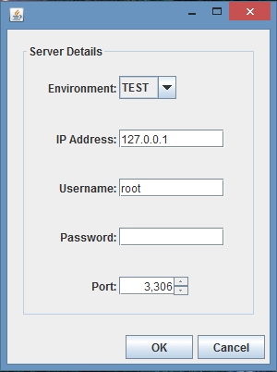Fig. 1 – Server Login Dialog

As you can see from Fig.1 (above), Once I compile and run the MSc Properties Server package I am presented with a server login dialog, in which I have to enter the server details explained above. For this session I have selected the TEST environment, and as the MySQL database is running on localhost I have entered localhost IP address, along with the Port 3306 and the database username and password.

Once I select OK the server will start running, unless there are errors with the information supplied, if I click Cancel the dialog will close and the application ends.

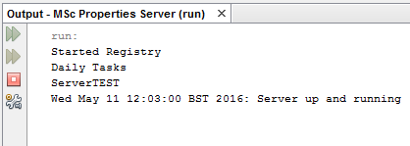

Fig. 2 – Server Output

As you can see from Fig. 2 (left), once the Server has been run a message will be output to the terminal stating the Server run information.

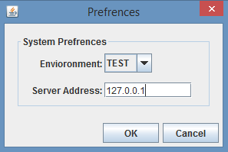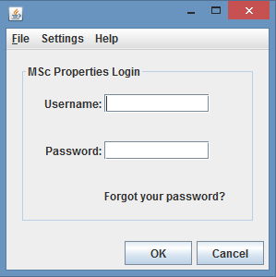Now the server is running, I can run the MSc Properties Client package to connect to the server.

Fig. 4 – Client Preferences Dialog

Fig. 3 - – Client Login Dialog

As you can see from Fig. 3, when the MSc Properties Client package is run I am presented with a Client Login dialog, where I can enter the username and password combination to log in, however the system environment and server IP address also needs to be provided to enable the login process to be successful.

The system developed has system preferences for the server details and on first log in the system preferences is set to default values, but once I change the settings, these will be stored locally (on the same computer) even once the client application ends, which means I do not need to keep providing the system details, unless the system details change, or I want to log in to a different environment. Once the information is correctly entered, and I click OK, the application will register the client with the server, and one of two screens will be presented depending on the user account state, if I click cancel then the client login dialog will close and the application ends.

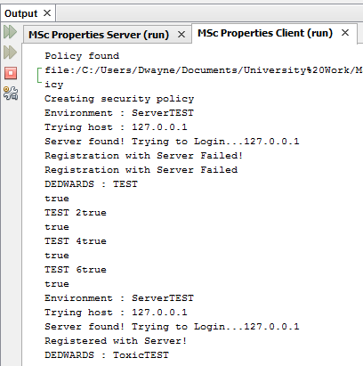Fig. 5 – Successful Login Terminal Output

As you can see from Fig. 5, the terminal output, when the correct login information is supplied the Server is found and Registration with the Server is Successful, the login dialog will then disappear and either the home screen or the Employee Security Update screen will appear depending on the state of the user.

Fig. 6 – Failed Login Dialog

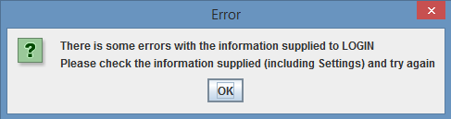

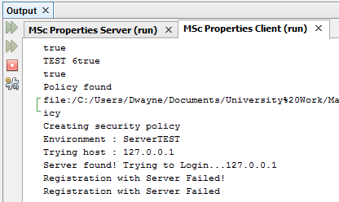

Fig. 7 – Failed Login Terminal Output

As you can see from Fig. 6, if the Client parameters are incorrect then an Error dialog will appear telling the client that there are errors with the information supplied, and that the client needs to check information supplied and try again, also Fig. 7, the terminal output which shows that the Server was found and login process is being attempted, but then registration with server failed.

This testing shows that the login functionality is working as expected, as the login functionality prevents a user from logging in to the system unless the username or password combination matches and existing user, and the server details are correct. Additionally, once I set the server settings and logged out of the application the, settings were retained and when I logged back in these did not have to be amended again.

1. **Password Reset Functionality**

As explained in the report, the system functionality requirements include implementing a password reset functionality, which has two aspects to the functionality, being that a user is able to update their own password by providing their employee details and an email is then sent with the new password to the user, or by an employee that has sufficient privileges to update another employee’s password, amending the employee password.

* 1. **Reset own Password**

For a user to reset their own password it requires the user to provide information which includes username, email address, memorable location (set up by the user), their employee ref, and as well as the same information required when logging in normally, which is the server IP address and environment.

As you can see from Fig. 3 the Client Login Dialog, there is a “forgot your password?” link which takes me to a Forgot your Password dialog, where I need to input the above listed information, which is shown in Fig. 8 below.

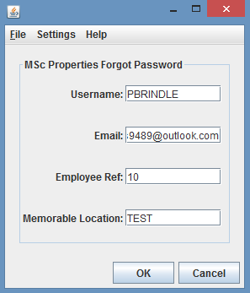

Fig. 8 – Forgot Password Dialog

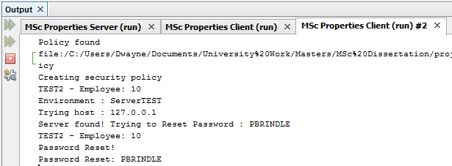

Fig. 9 – Password Reset Successful Terminal Output

If I click OK and the information supplied is correct then the server will then reset my account password and send an email to the registered email account, containing the updated password. The Forgot Password dialog then disappears and the Login dialog appears for the me to then login with the new password provided through the email. The email is shown in Fig. 10, which shows the amended password.

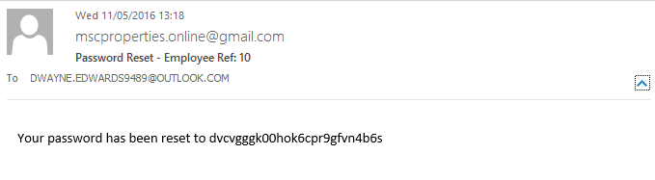

Fig. 10 – Password Reset Email

As you can see from Fig. 10, an email has arrived from [mscproperties.online@gmail.com](mailto:mscproperties.online@gmail.com) to my registered email address of [Dwayne.edwards9489@outlook.com](mailto:Dwayne.edwards9489@outlook.com) stating that the password has been reset and providing the new password, this can then be used to log in to the system.

If I click OK and the information supplied is incorrect then an Invalid User Exception is thrown, and I can amend the information and try and submit the information again.

If the client clicks Cancel, then the Forgot Password dialog disappears and the Login dialog reappears.

This test shows that the reset your own password functionality is working correctly as upon submitting the correct forgot your password details, my password was reset and an email was sent to my email address stating the amended password, for me to attempt to log in, which was successful with the password in the email.

* 1. **Update another Employee Password**

For a user to reset another employee’s password it requires the user to go to the Employee Details of the employee in question, and select the Actions menu, and the Update Employee Security menu item, an update employee password dialog appears where the user can enter the new password, and once the user selects OK the password is updated. The user can then forward the amended password on to the user to allow them to log in.

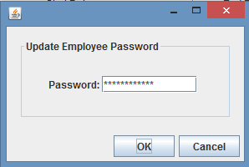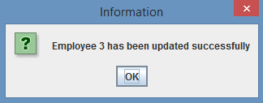

Fig. 12 – Confirm Dialog

Fig. 11 – Update Employee Password Dialog

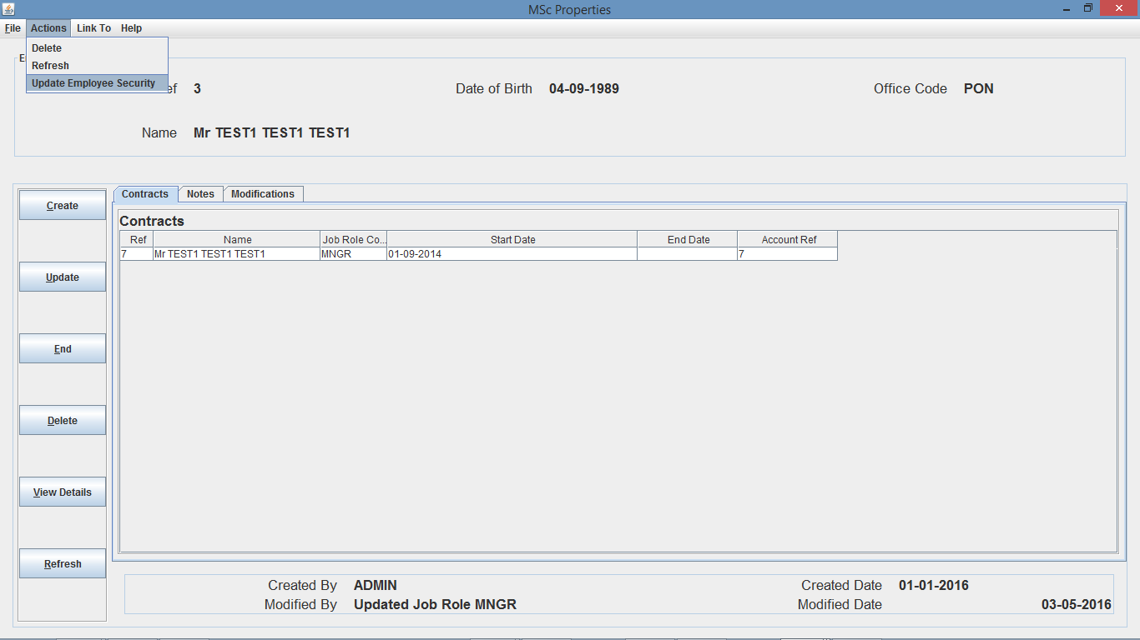

Fig. 13 – Employee Details Frame (with Actions menu open)

I can then login in with the username and amended password combination successfully. This test shows that the reset another employee password functionality is working correctly as upon me amending the user’s password, and clicking OK, I was then able to log in with the user’s username and amended password.

Additionally, to improve the security of the system, if a user’s password is amended in any of the two ways tested above, when the user tries to log in for the first time after the password amendment, the user will be presented with the update employee security dialog, shown in Fig. 14, which prompts the user to amend their password before moving on to the home screen which was successfully tested during this process.

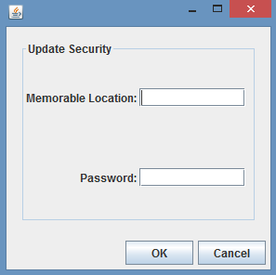Fig. 14 – Update Employee Security

1. **User Permissions Functionality**

As explained in the report, the system functionality requirements include implementing user restrictions, which restrict users from performing functions that they do not have permission to perform. The user permissions functionality works on the creating, reading, updating and deleting non-employee information or employee information, which is assigned to the user through their Job Role. So an employee can have 8 different permission rights.

* 1. **Create non-employee information**

All users with the permission to create non-employee information can create data within the system relating to anything other than employees, meaning that if I am logged in as a user with create privileges for non-employee information I will be able to create a system element for the title of a person.

To do this I navigated to the System Configuration area by clicking the System Config button from the home screen, and then navigate to the Titles area within the left pane of the System Configuration area, which will open up a Titles branch to the System Configuration area, where I can select Create Title. Whether the user I am logged in with has the permission to create a title or not, the create title dialog will open, and the user is able to enter the information to create a title.

If the user I am logged in with enters correct information and clicks OK then a dialog will appear asking to confirm the creation even if the user does not have permission, and if I select OK then this is where the system will throw an Exception if I do not have permission to invoke this method, stating “User does not have privileges to invoke this method – username” and does not invoke the method on the server, which is shown in the terminal output as shown in Fig. 15. If I do have permission, then the system will return a dialog saying the title was created successfully as shown in Fig. 16.

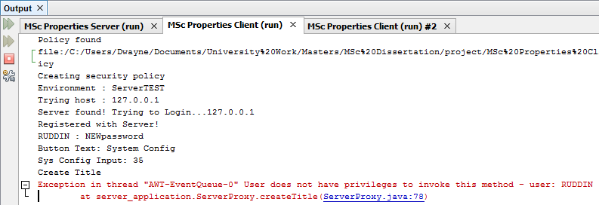

Fig. 15 – Create Title Unsuccessful Terminal Output

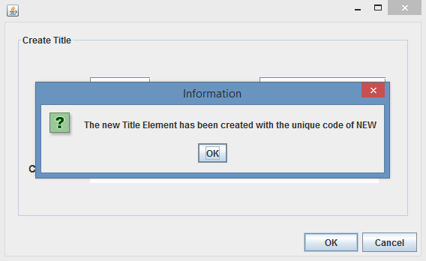

Fig. 16 – Create Title Successful Dialog

* 1. **Read non-employee information**

All users with the permission to read non-employee information can read data within the system relating to anything other than employees, meaning that if I am logged in as a user with read privileges for non-employee information I can view system element details for a title of a person.

To do this I navigated to the System Configuration area by clicking the System Config button from the home screen, and then navigate to the Titles area within the left pane of the System Configuration area, which will open up a Titles branch to the System Configuration area, where I can select View Titles.

If the user I am logged in as does not have permission to invoke this method, then an Exception is thrown, outlining the same exception as previously outlined, and the method is not invoked on the server, which is shown in the terminal output as shown in Fig. 17. If the user I am logged in as does have permission then this will open up a table of titles, where the I can perform actions on a title and is shown in Fig. 18.

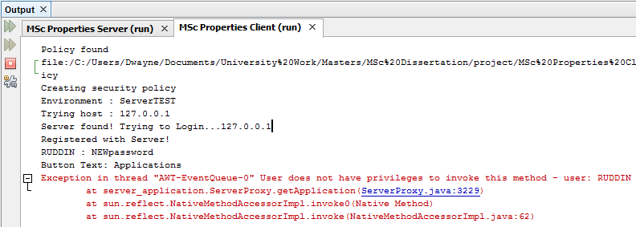

Fig. 17 – Update Title Unsuccessful Terminal Output

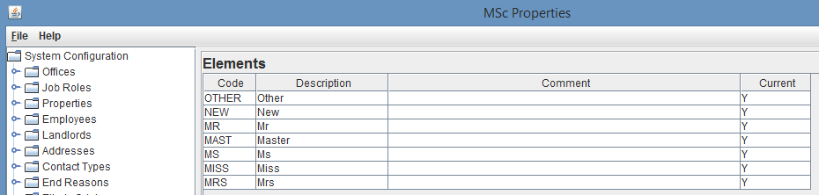

Fig. 18 – Successful Read Titles

* 1. **Update non-employee information**

All users with the permission to update non-employee information can update data within the system relating to anything other than employees, meaning that if I am logged in as a user with update privileges for non-employee information I will be able to update a system element for the title of a person.

To do this I navigated to the System Configuration area by clicking the System Config button from the home screen, and then navigate to the Titles area within the left pane of the System Configuration area, which will open up a Titles branch to the System Configuration area, where I can select View Titles. This will then open up a table of titles, where the user can right click on a title and select view Element, and then select update from the Actions menu. This will open up an update title dialog, where the user can amend information of the title.

If I enter correct information and click OK then a dialog will appear asking to confirm the creation even if the user I am logged in as does not have update permission, and if I select OK then this is where the system will throw an Exception if I do not have permission to invoke this method, stating “User does not have privileges to invoke this method – username” and does not invoke the method on the server, which is shown in the terminal output as shown in Fig. 19. If I do have permission to invoke the method then the system will return a dialog saying the title was updated successfully as shown in Fig. 20.

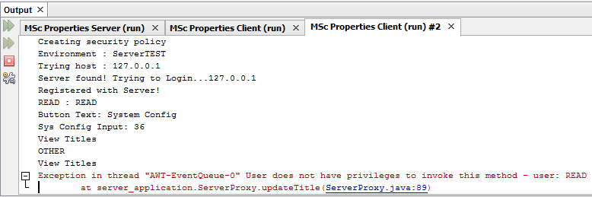

Fig. 19 – Unsuccessful Terminal Output

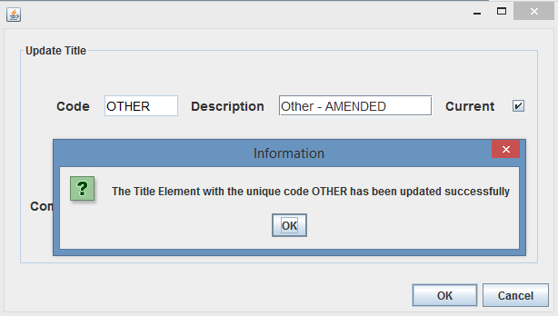

Fig. 20 – Successful Update Title

* 1. **Delete non-employee information**

All users with the permission to delete non-employee information can update data within the system relating to anything other than employees, meaning that if I am logged in as a user with delete privileges for non-employee information I will be able to delete a system element for the title of a person.

To do this I navigated to the System Configuration area by clicking the System Config button from the home screen, and then navigate to the Titles area within the left pane of the System Configuration area, which will open up a Titles branch to the System Configuration area, where I can select View Titles. This will then open up a table of titles, where I can right click on a title and select view Element, and then select delete from the Actions menu. This will open up a Yes/No dialog, asking me to confirm deletion of the title.

If I do not have permission and select yes then the system will throw an Exception, stating “User does not have privileges to invoke this method – username” and does not invoke the method on the server, which is shown in the terminal output as shown in Fig. 21. If I do have permission, then a dialog box will appear confirming deletion of the title as shown in Fig. 22.

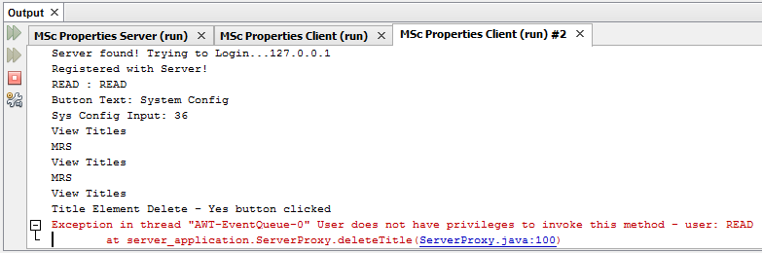

Fig. 21 - Unsuccessful Terminal Output

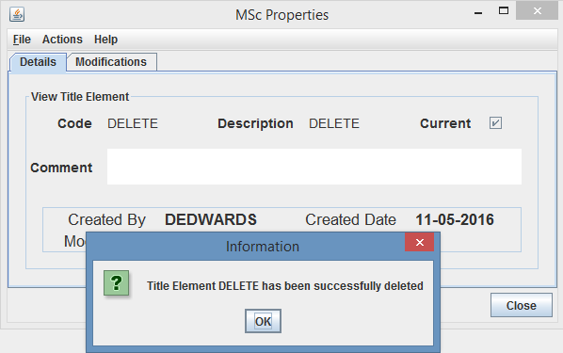

Fig. 22 – Successful Delete Title

* 1. **Create employee information**

All users with the permission to create employee information can create data within the system relating to employees, meaning that if I am logged in as a user with employee create privileges then I will be able to create a contract for an employee.

I can do this from a few different areas, such as the contract search screen or employee details, I am going to show my testing through the contract search screen route. So I navigate to the contract search screen by clicking the Contracts button from the home screen, and then select the create button. A create contract dialog will open and the user will have to provide the create contract parameters, employee ref, length, start date, office code and job role code.

If I enter correct information and do not have permission to create employee information then upon clicking on the OK button a yes/no create dialog will open for me to confirm creation of contract, and if I select yes, an Exception will be thrown stating “User does not have privileges to invoke this method – username” and does not invoke the method on the server, which is shown in the terminal output in Fig. 23. If I do have permission, then a dialog will appear confirming the creation of the contract as shown in Fig. 24.

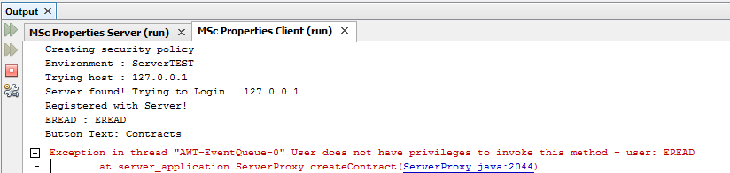

Fig. 23 – Unsuccessful Terminal Output

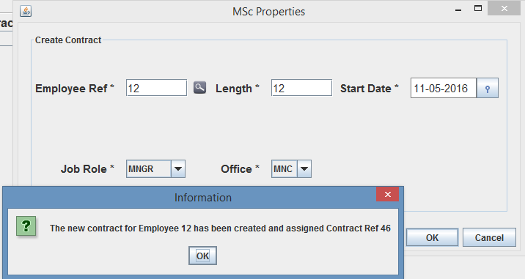

Fig. 24 – Successful Contract creation

* 1. **Read employee information**

All users with the permission to read employee information can read data within the system relating to employees, meaning that if I am logged in as a user with read employee privileges, I will be able to view contract details for an employee.

To do this I have to navigate to the Contracts search screen by clicking the Contracts button from the home screen, and either use the advanced or standard search to search for a contract, if there is a contract that meets the search criteria, then I can right click on a contract returned and select view details. This will then bring up the contract details screen.

If the user I am logged in as does not have permission to read employee information then upon clicking on the search button either through the advanced or standard search, an Exception will be thrown stating “User does not have privileges to invoke this method – username” and does not invoke the method on the server, which is shown in the terminal output as shown in Fig. 25. If the user does have permission, then contracts will return in the search results screen and the user can then go to the contracts details screen as shown in Fig. 26.

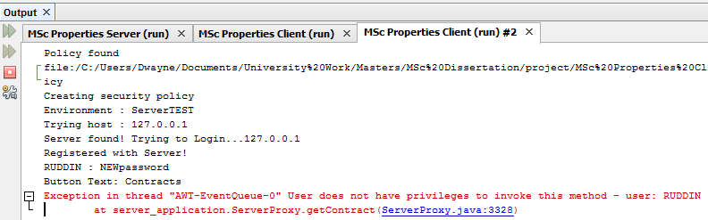

Fig. 25 – Unsuccessful Terminal Output

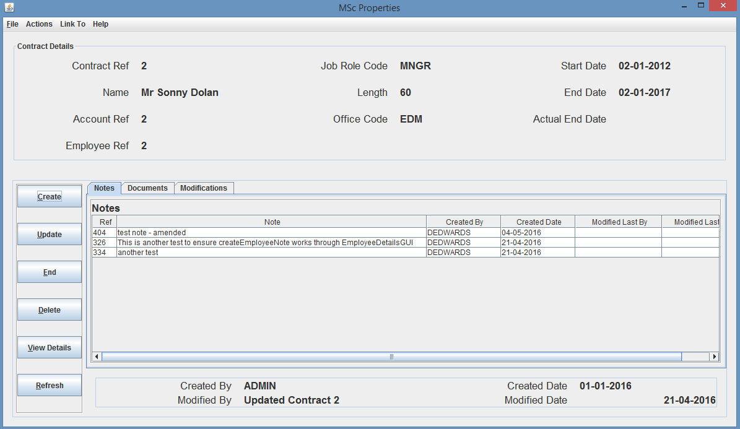

Fig. 26 – Successful viewing of contract details

* 1. **Update employee information**

All users with the permission to update employee information can update data within the system relating to employees, meaning that if I am logged in as a user with employee update privileges I will be able to update contract details for a contract.

To do this I have to navigate to the Contracts Details screen as shown before and then I can select Update from the Actions menu, where an update contract dialog will open allowing me to amend the contract information.

If the user I am logged in as does not have permission to invoke this method, but amends the information as required and clicks the OK button, then a yes/no confirm dialog appears asking to confirm the update, if I select yes, then an Exception will be thrown stating “User does not have privileges to invoke this method – username” and does not invoke the method on the server, which is shown in the terminal output as shown in Fig. 27. If the user does have permission, then a confirmation dialog appears confirming the update of the Contract as shown in Fig. 28.

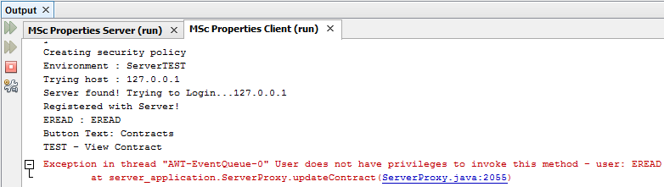

Fig. 27 – Unsuccessful Terminal Output

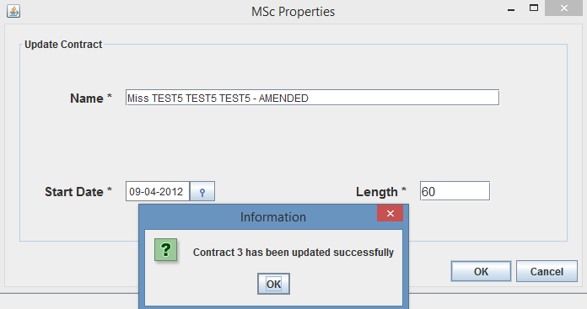

Fig. 28 – Successful Contract Update

* 1. **Delete employee information**

All users with the permission to delete employee information can delete data within the system relating to employees, meaning that if I am logged in as a user with employee delete privileges I will be able to delete a contract providing there is no dependent records relating to the contract.

To do this I have to navigate to the Contracts Details screen as shown before and I can then select Delete from the Actions menu, where a yes/no dialog will appear asking me to confirm deletion of the contract.

If the user I am logged in as does not have permission to invoke this method, but selects yes, then an Exception will be thrown stating “User does not have privileges to invoke this method – username” and does not invoke the method on the server, which is shown in the terminal output as shown in Fig. 28. If the user does have permission to invoke the method, then a confirmation dialog appears confirming the deletion of the Contract as shown in Fig. 29.

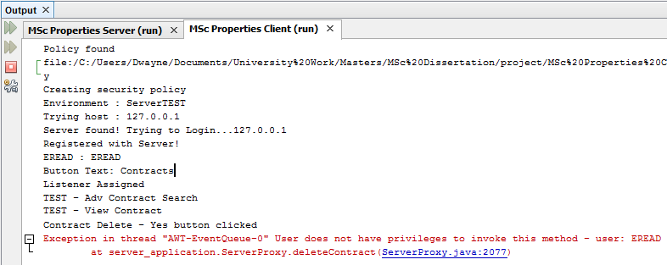

Fig. 28 – Unsuccessful Terminal Output

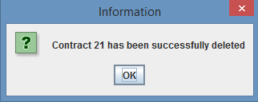

Fig. 29 – Successful Contract Deletion

From the above testing around user permissions, I believe this shows that the functionality has been successfully implemented and is working correctly, because all employees who will have been assigned a user account to login, will be restricted to the user privileges assigned by the employer, ensuring the users are unable to carry out functions that they do not have the correct privileges to perform.

1. **Home Screen – Tenancy/Lease/Rent Account live feed**

As explained in the report, the system functionality requirements include implementing a home screen which provides a live feed of tenancies, leases and rent accounts for the office the logged in user works for. The live feed will provide a list of 10 tenancies and 10 leases in descending order of expected end date, and a list of 10 rent accounts in descending order of balance.

The home screen will update when any tenancy, lease or rent account is created, amended or deleted from the user’s office, providing up-to-date lists at all times.

To carry out testing on the home screen it required me to test with users from different offices, ensuring that updates are not propagated to users from an incorrect office, and ensure that changes to the home screen are working correctly.

Firstly, I had to start the server, as shown in previous testing, and then run 3 different clients, logging in as different users for each client session, of which 2 users have to be of different offices and have to have read privileges, the third client needs to have write, update and delete privileges to ensure the user can create, update and delete a tenancy, lease or rent account, to initiate a user home screen update.

Before I started testing I took some print screens of two users home screens from different offices, as you can see from Fig. 30 and Fig. 31 I have logged in to two clients from office “MNC” and “EDM” respectively.

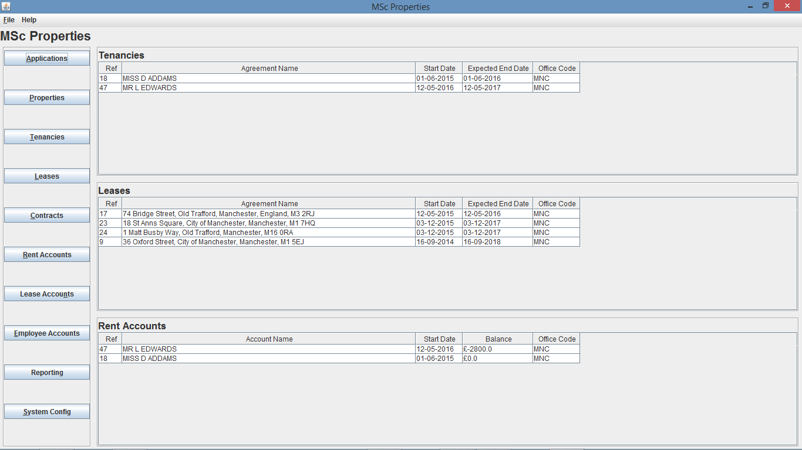

Fig. 30 – Home Screen of user from “MNC” office

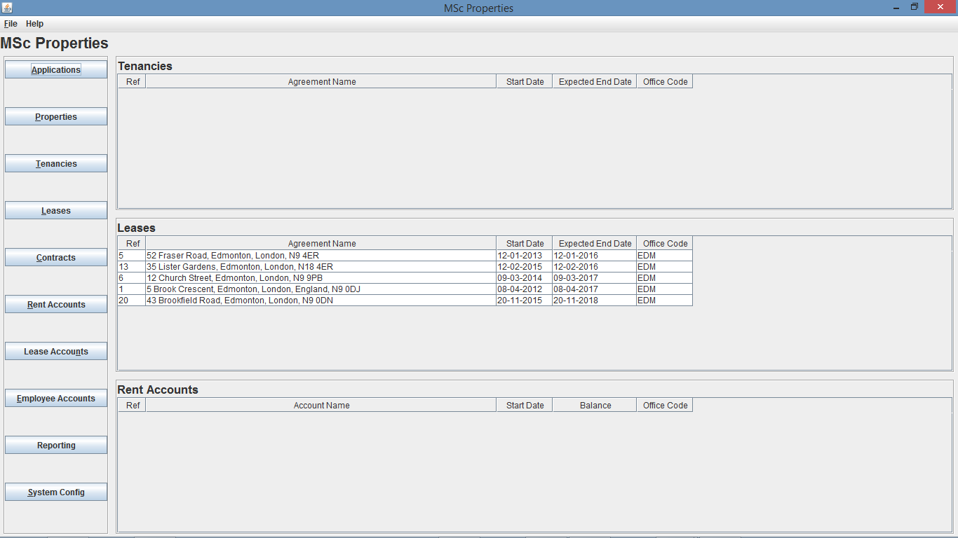

Fig. 31 – Home Screen of user from “EDM” office prior to tenancy creation

* 1. **Create, Update, Delete – Tenancy**

My first test is going to be to create a new tenancy using the 3rd user account that has read, write, update and delete privileges, and due to rent accounts being created off the back off tenancy creations, this test will also result in a rent account update, and therefore will update the rent accounts table as well as the tenancies table.

To create a tenancy, I navigated to the Tenancies search page by clicking on the Tenancies button from the home screen, I then clicked create from the tenancy search screen, where a tenancy create dialog box opens, I can then use the app search button to search for the required application ref if not known.

If I enter all of the correct information ensuring the office I assign the tenancy to, is one of the offices I expect the update to occur on, for this test I decided to use the “MNC” office. Once I click the OK button, a yes/no create dialog will open for me to confirm creation of the tenancy, in which if I select yes a confirm dialog will appear confirming creation of the Tenancy, as you can see in Fig. 32.

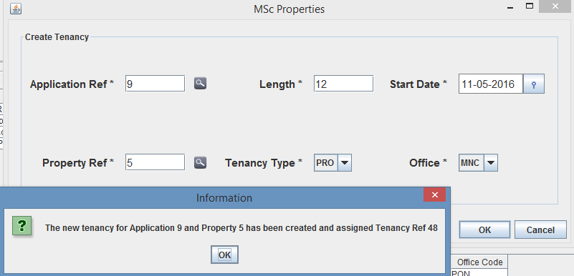

Fig. 32 – Tenancy creation Dialog

As you can see from Fig. 32, I selected “MNC” as the office and the newly created tenancy was assigned Tenancy Ref 48. So I am now expecting the user from office “MNC” to now show the newly created Tenancy along with the Rent Account on the home screen, however I will not see the creation on the home screen of the user from office “EDM” and this is shown in Fig. 33 and Fig. 34.

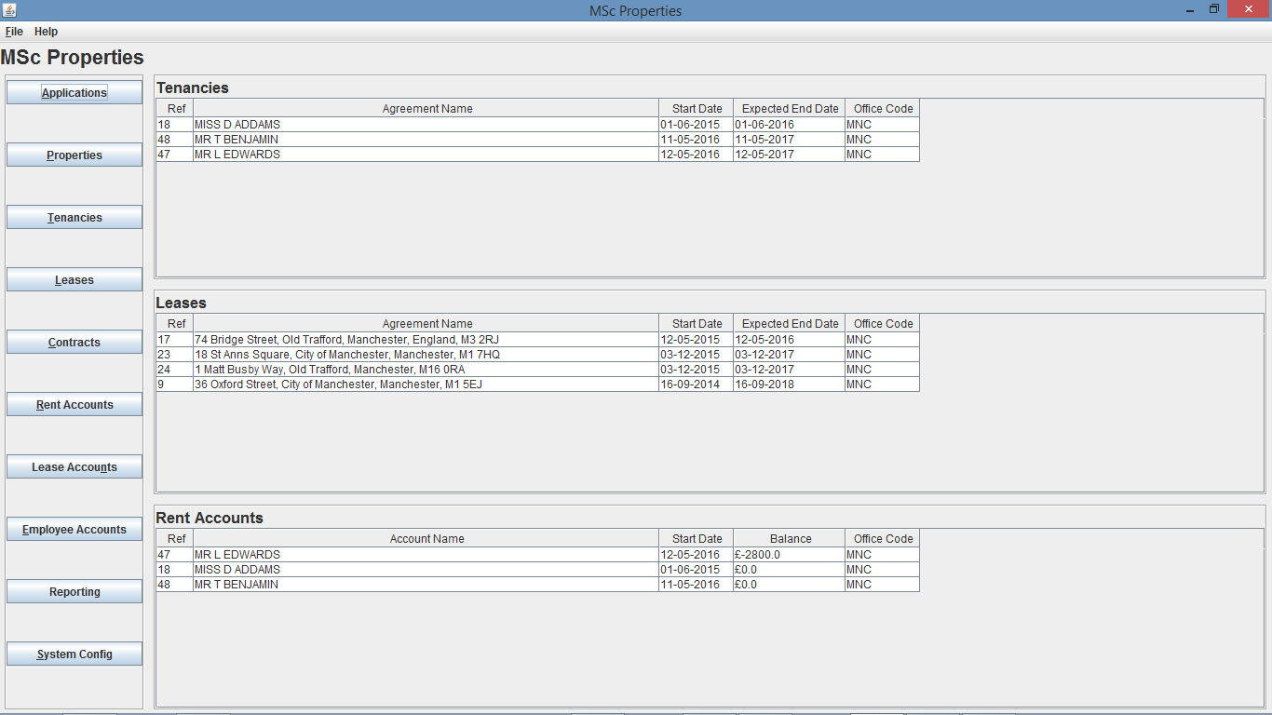

Fig. 33 - Home Screen of user from “MNC” office after creation of Tenancy Ref 48



Fig. 34 - Home Screen of user from “EDM” office after creation of Tenancy Ref 48

My second test is going to be to update a tenancy, again using the 3rd user account, and due to rent accounts receiving certain updates like name, these updates will be reflected in both the tenancy and rent account tables.

I can update a tenancy through two ways, either by going to the tenancy details screen, or from the tenancy search screen. For this testing I am going to update a tenancy through the tenancy search screen, again by navigating to it from the home screen by clicking the Tenancies button. Once I am there I have to search for the tenancy, and again as I need to select a tenancy from a particular office I decide to use the standard search and search for tenancy 18, as this is from office “MNC”, but any search method could have been used.

I then need to right click on the tenancy I want to update, and select Update Tenancy, and as explained for testing I decided to update Tenancy Ref 18 from both Fig. 30 and Fig. 33. As you can see from Fig. 34, I updated the agreement name to “MISS D ADAMS – AMENDED” and the length of the tenancy to 36 months, meaning the expected end date should change to 01-06-2018 resulting in the tenancy dropping to the bottom of the list due to the tenancy being the last to potentially end out of the 3 tenancies for office “MNC”.

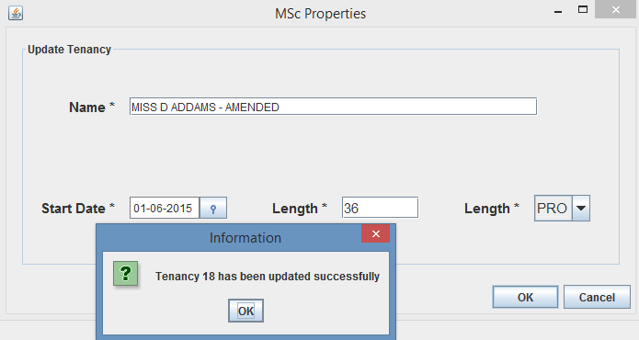

Fig. 35 – Tenancy Amendment Dialog

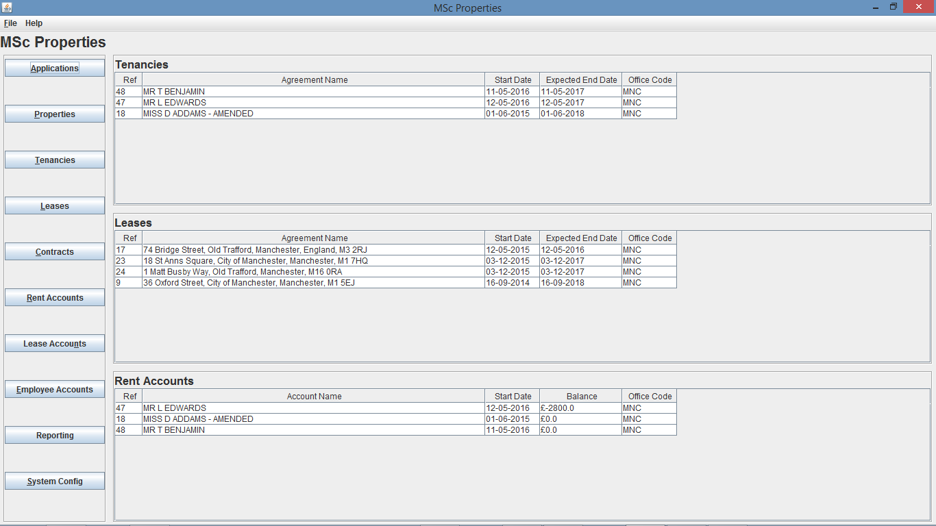

Fig. 36 - Home Screen of user from “MNC” office after amendment of Tenancy Ref 18



Fig. 37 - Home Screen of user from “EDM” office after amendment of Tenancy Ref 18

As explained I was expecting the user from office “MNC” to now show the amended Tenancy along with the amended Rent Account on the home screen, as well as the updated list position in the Tenancies table (Rent Accounts list positions has not changed as that is down to the balance amount, as a pose to expected end date for Tenancies list). Also as expected I will not see the amendment on the home screen of the user from office “EDM” and this is shown in Fig. 36 and Fig. 37.

My third test is going to be to delete a tenancy, again using the 3rd user account, and due to rent accounts being dependent on the tenancy, meaning the rent account cannot exist without the tenancy existing, the deletion of a tenancy will be reflected in both the tenancy and rent account tables.

I can delete a tenancy through two ways, either by going to the tenancy details screen, or from the tenancy search screen. For this testing I am going to delete a tenancy through the tenancy search screen, again by navigating to it from the home screen by clicking the Tenancies button. Once I am there I have to search for the tenancy, and again as I need to select a tenancy from a particular office, but that does not have any dependent records, I decide to use the standard search and search for tenancy 48 which was created earlier, as this is from office “MNC”, but any search method could have been used.

I then need to right click on the tenancy I want to delete, and select Delete Tenancy, a yes/no dialog will then appear asking me to confirm the deletion of tenancy 48, and if I select yes this will then delete Tenancy 48 and a confirmation dialog will appear as shown in Fig. 38.

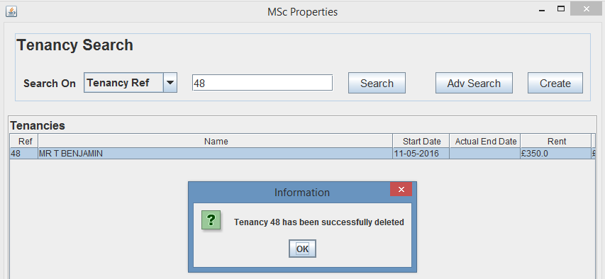

Fig. 38 – Tenancy Deletion Dialog

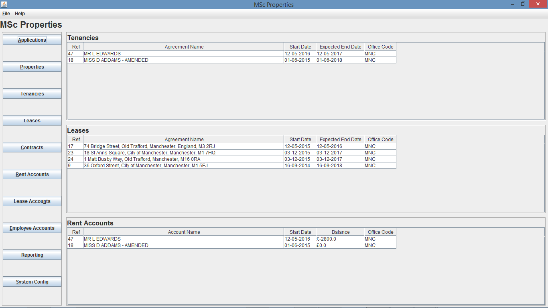

Fig. 39 - Home Screen of user from “MNC” office after deletion of Tenancy Ref 48

As you can see from Fig. 39 the deletion of Tenancy Ref 48 and Rent Account 48 occurred and are now not shown on the home screen of user from office “MNC”. Also as you can see from Fig.40 the home screen of the user from office “EDM” was not changed.



Fig. 40 - Home Screen of user from “EDM” office after deletion of Tenancy Ref 48

My final test is going to be to end a tenancy, again using the 3rd user account, and due to rent accounts being dependent on the tenancy, meaning the rent account cannot be current without the tenancy being current, so the ending of a tenancy will be reflected in both the tenancy and rent account tables.

I can end a tenancy through two ways, either by going to the tenancy details screen, or from the tenancy search screen. For this testing I am going to delete a tenancy through the tenancy search screen, again by navigating to it from the home screen by clicking the Tenancies button. Once I am there I have to search for the tenancy, and again as I need to select a tenancy from a particular office, I decide to use the standard search and search for tenancy 18, as this is from office “MNC”, but any search method could have been used.

I then need to right click on the tenancy I want to end, and select End Tenancy, a date entry dialog will then appear asking me for the end date, if I click OK, a yes/no dialog will then appear asking me to confirm the ending of tenancy 18, and if I select yes this will then end Tenancy 18 and confirmation dialog will appear as shown in Fig. 41.

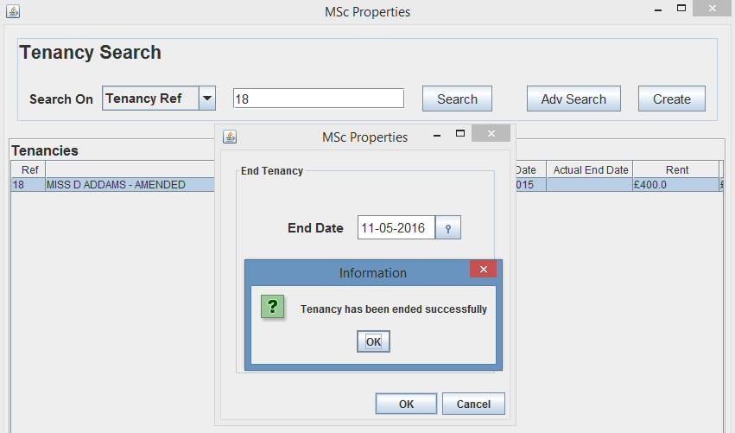

Fig. 41 – End Tenancy Dialog

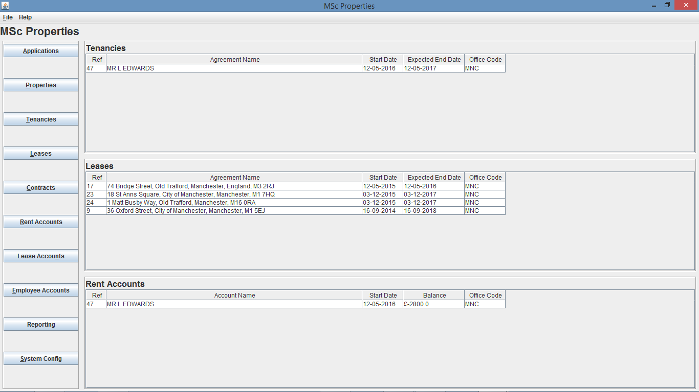

Fig. 42 - Home Screen of user from “MNC” office after ending Tenancy Ref 18



Fig. 43 - Home Screen of user from “EDM” office after ending Tenancy Ref 18

* 1. **Create, Update Delete – Lease**

The tests will continue on from the previous screens state in Fig. 42 and Fig. 43 and my first test is going to be to create a new lease using the 3rd user account that has read, write, update and delete privileges, which will update the leases table.

To create a lease, I navigated to the Leases search page by clicking on the Leases button from the home screen, I then clicked create from the lease search screen, where a lease create dialog box opens, I can then use the prop search button to search for the required property ref if not known.

If I enter all of the correct information ensuring the office I assign the lease to, is one of the offices I expect the update to occur on, for this test I decided to use the “MNC” office. Once I click the OK button, a yes/no create dialog will open for me to confirm creation of the lease, in which if I select yes a confirm dialog will appear confirming creation of the Tenancy, as you can see in Fig. 44.

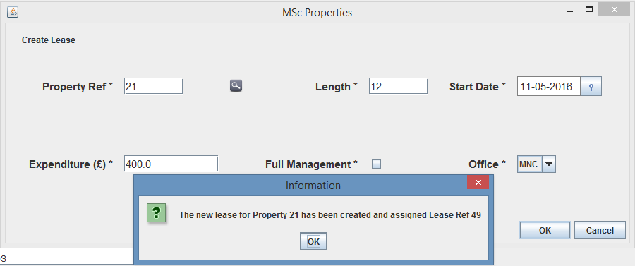

Fig. 44 – Lease creation Dialog

As you can see from Fig. 44, I selected “MNC” as the office and the newly created lease was assigned Lease Ref 49. So I am now expecting the user from office “MNC” to now show the newly created Lease on the home screen and in its correct position within the list depending on expected end date, however I will not see the creation on the home screen of the user from office “EDM” and this is shown in Fig. 45 and Fig. 46.

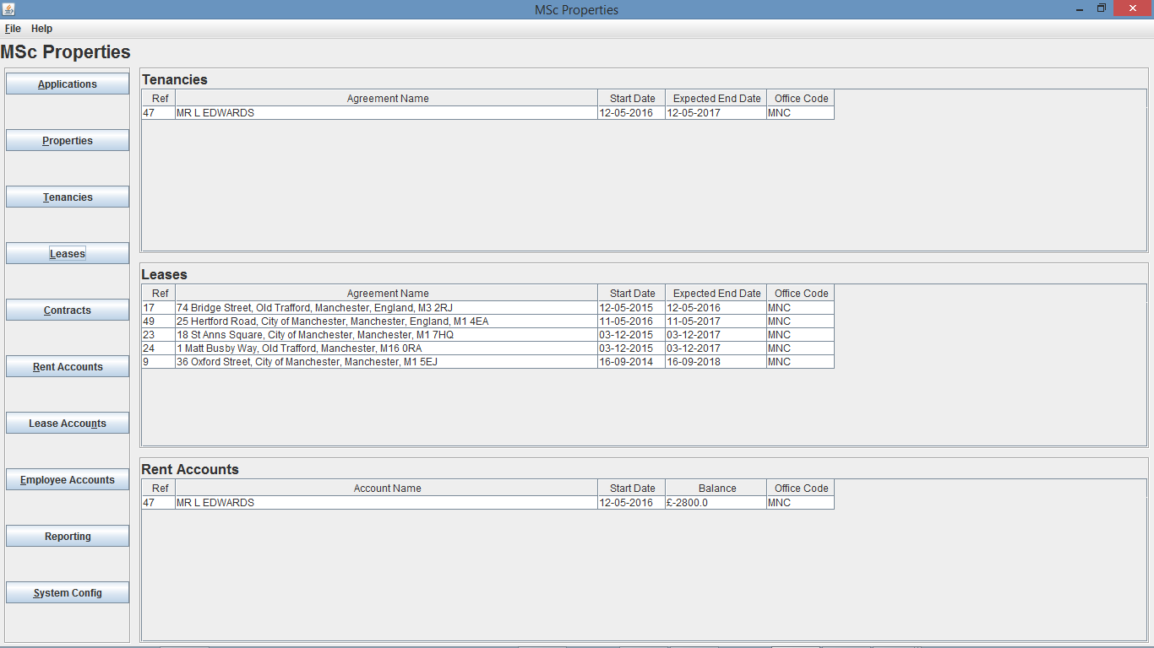

Fig. 45 - Home Screen of user from “MNC” office after creation of Lease Ref 49

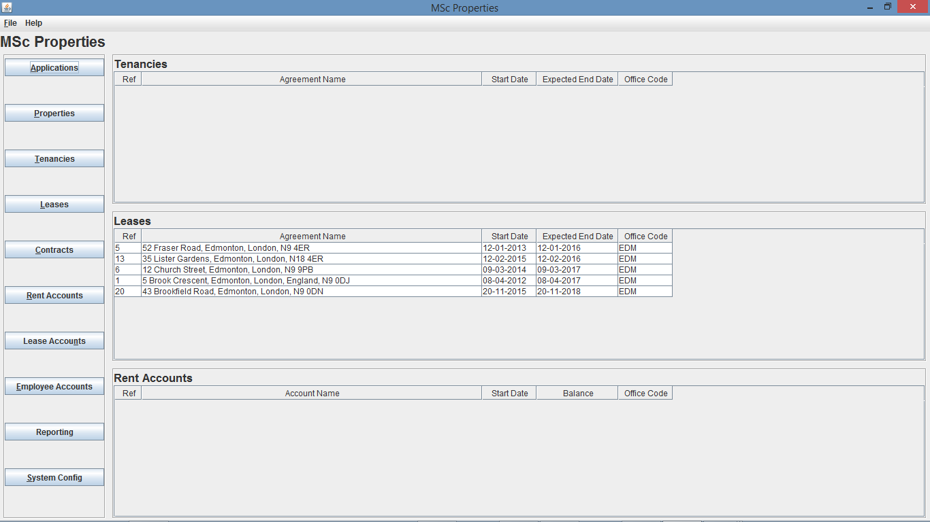

Fig. 46 - Home Screen of user from “EDM” office after creation of Lease Ref 49

My second test is going to be to update a lease, again using the 3rd user account which will be reflected in the leases table.

I can update a lease through two ways, either by going to the lease details screen, or from the lease search screen. For this testing I am going to update a lease through the lease search screen, again by navigating to it from the home screen by clicking the Leases button. Once I am there I have to search for the lease, and again as I need to select a lease from a particular office I decide to use the standard search and search for lease 17, as this is from office “MNC”, but any search method could have been used.

I then need to right click on the lease I want to update, and select Update Lease, and as explained for testing I decided to update Lease Ref 17 from both Fig. 45 and Fig. 46. As you can see from Fig. 47, I updated the length of the lease to 60 months, meaning the expected end date should change to 12-05-2020 resulting in the lease moving to the bottom of the list due to the lease being the last to potentially end out of the 5 leases for office “MNC”.

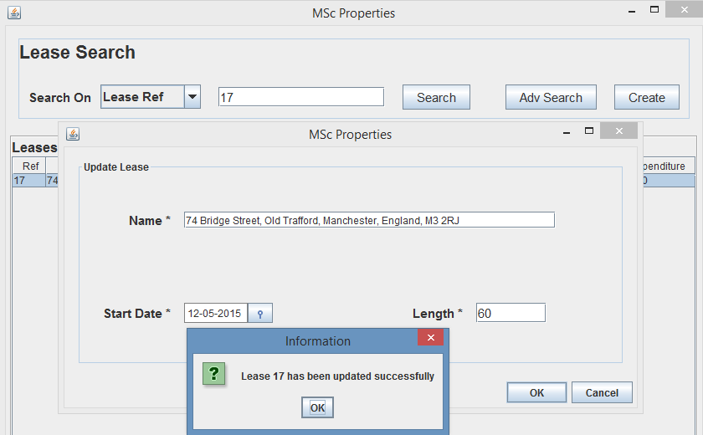

Fig. 47 – Lease Amendment Dialog



Fig. 48 - Home Screen of user from “MNC” office after amendment of Lease Ref 17



Fig. 49 - Home Screen of user from “EDM” office after amendment of Lease Ref 17

As explained I was expecting the user from office “MNC” to now show the amended Lease on the home screen, as well as the updated list position in the Leases and as expected I will not see the amendment on the home screen of the user from office “EDM” and this is shown in Fig. 48 and Fig. 49.

My third test is going to be to delete a lease, again using the 3rd user account, where the deletion of a lease will be reflected in the leases table.

I can delete a lease through two ways, either by going to the lease details screen, or from the lease search screen. For this testing I am going to delete a lease through the lease search screen, again by navigating to it from the home screen by clicking the Leases button. Once I am there I have to search for the lease, and again as I need to select a lease from a particular office, but that does not have any dependent records, I decide to use the standard search and search for lease 49 which was created earlier, as this is from office “MNC”, but any search method could have been used.

I then need to right click on the lease I want to delete, and select Delete Lease, a yes/no dialog will then appear asking me to confirm the deletion of lease 49, and if I select yes this will then delete Lease 49 and a confirmation dialog will appear as shown in Fig. 50.

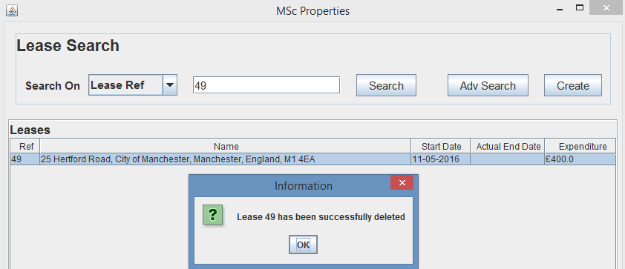 Fig. 50 – Lease Deletion Dialog

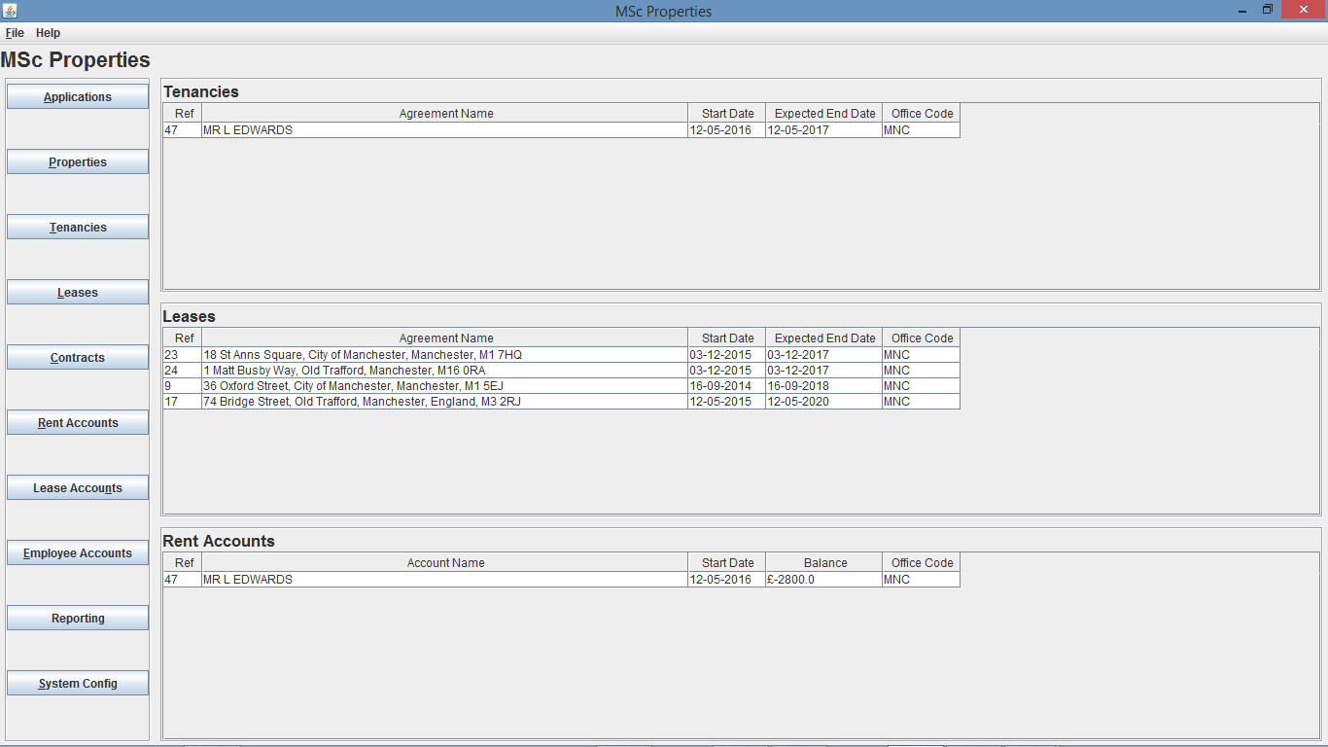

Fig. Fig 51 - Home Screen of user from “MNC” office after deletion of Lease Ref 49

As you can see from Fig. 51 the deletion of Lease Ref 49 occurred and are now not shown on the home screen of user from office “MNC”. Also as you can see from Fig.52 the home screen of the user from office “EDM” was not changed.



Fig. 52 - Home Screen of user from “EDM” office after deletion of Lease Ref 49

My final test is going to be to end a tenancy, again using the 3rd user account, and ending a lease will be reflected in the leases table.

I can end a lease through two ways, either by going to the lease details screen, or from the lease search screen. For this testing I am going to delete a lease through the lease search screen, again by navigating to it from the home screen by clicking the Leases button. Once I am there I have to search for the lease, and again as I need to select a lease from a particular office, I decide to use the standard search and search for lease 17, as this is from office “MNC”, but any search method could have been used.

I then need to right click on the lease I want to end, and select End Lease, a date entry dialog will then appear asking me for the end date, if I click OK, a yes/no dialog will then appear asking me to confirm the ending of lease 17, and if I select yes this will then end Tenancy 18 and a confirmation dialog will appear as shown in Fig. 53.

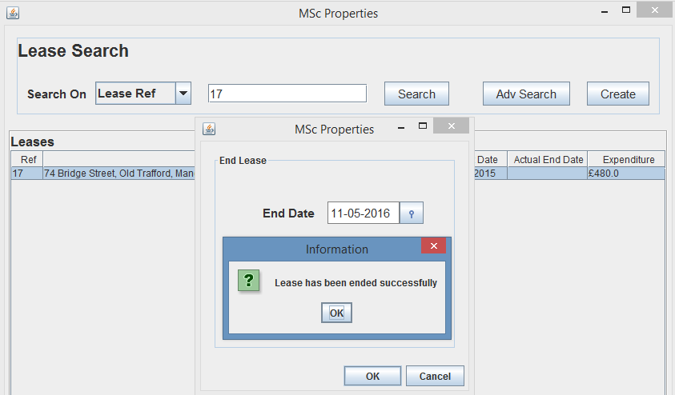

Fig. 53 – End Lease Dialog

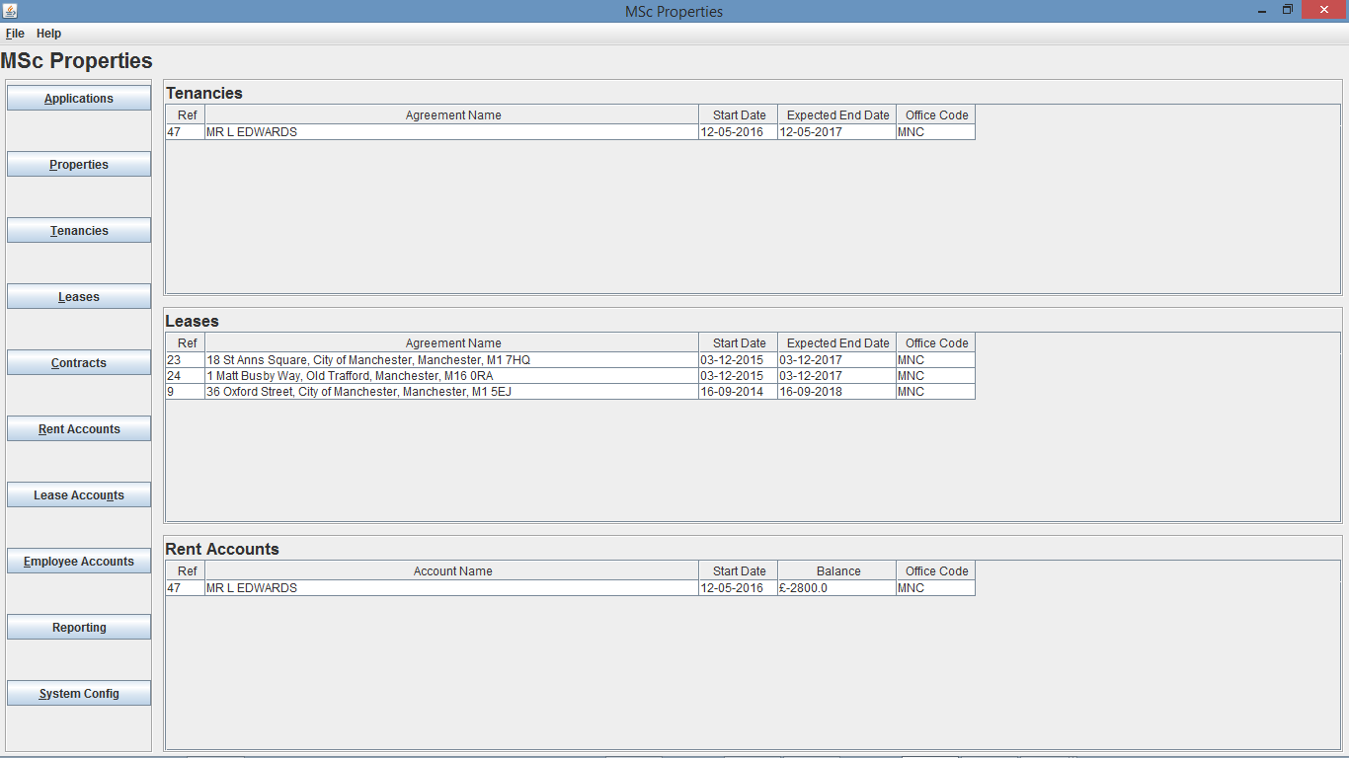

Fig. 54 - Home Screen of user from “MNC” office after ending Lease Ref 17



Fig. 55 - Home Screen of user from “EDM” office after ending Lease Ref 17

* 1. **Create/Delete Transaction**

My next testing of the home screen will cover creating and deleting rent transactions for rent accounts to ensure the home screen updates when a rent account balance is amended for a rent account from the user’s office, providing up-to-date rent account balances for the 10 balances in highest arrears at all times.

For the testing I will use a user who has read, write and delete privileges, to create and delete transactions, and have another user logged on from a particular office and ensure that the other rent transactions I am creating and deleting are for a rent account from that same particular office.

I decided to use the “PON” office rent accounts for testing, and selected Rent Account 19, which as you can from Fig. 56 and Fig. 58 Rent Account 19 is from office “PON” and the balance is currently at £0.0.

As you can see from Fig. 59 I create a transaction for an amount of £903.00 and the transaction is a debit transaction, meaning it should result in the balance being reduced. And from Fig. 56 you can see that this should result in Rent Account 19 staying at the top of the list due to the new balance of £-903.00 which is lower than Rent Account 36 balance of £0.0.

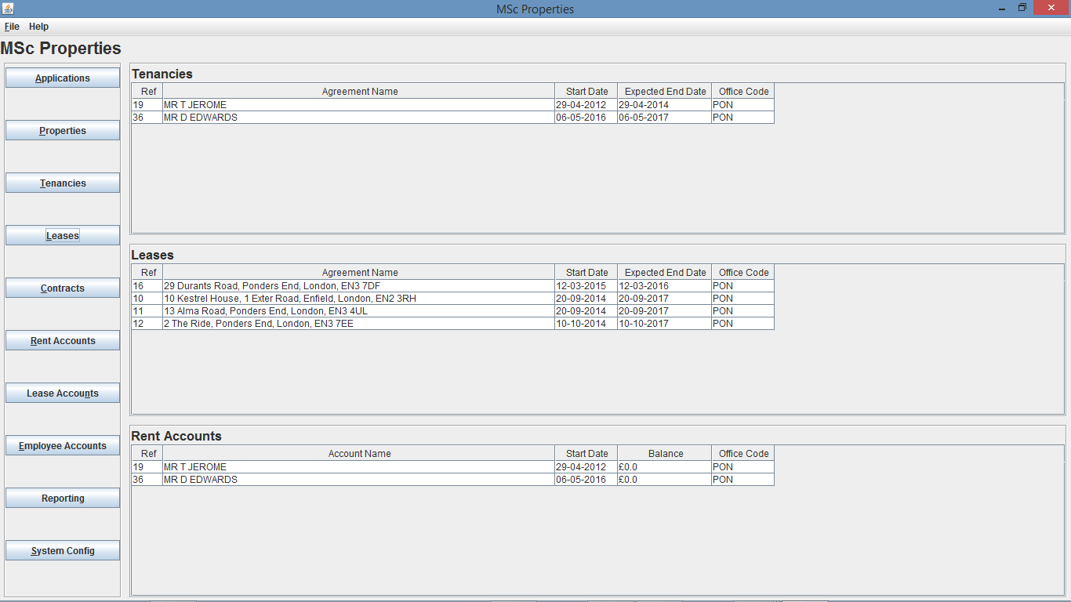

Fig. 56 – Home Screen of user from “PON” office prior to rent transaction creation

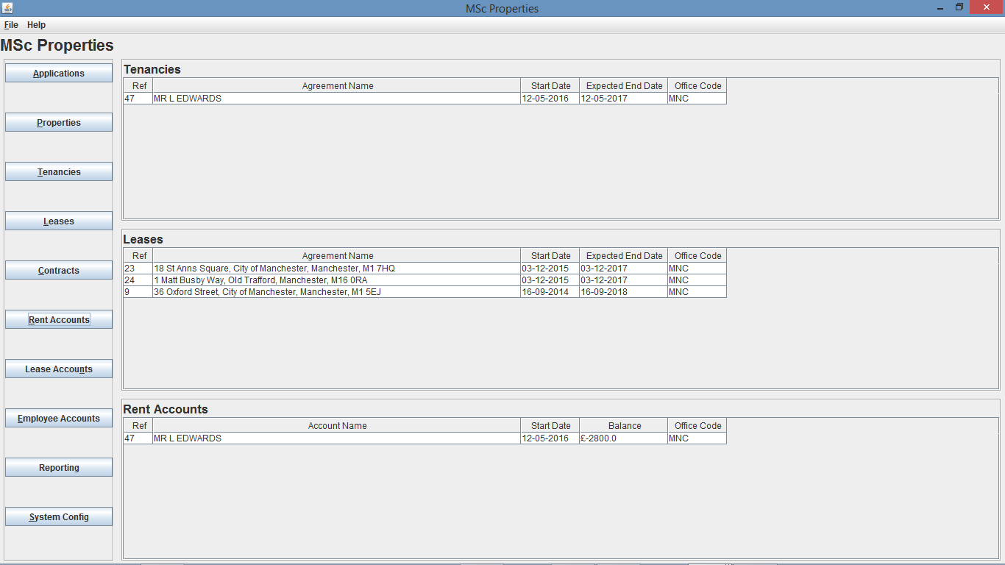

Fig. 57 – Home Screen of user from “MNC” office prior to rent transaction creation

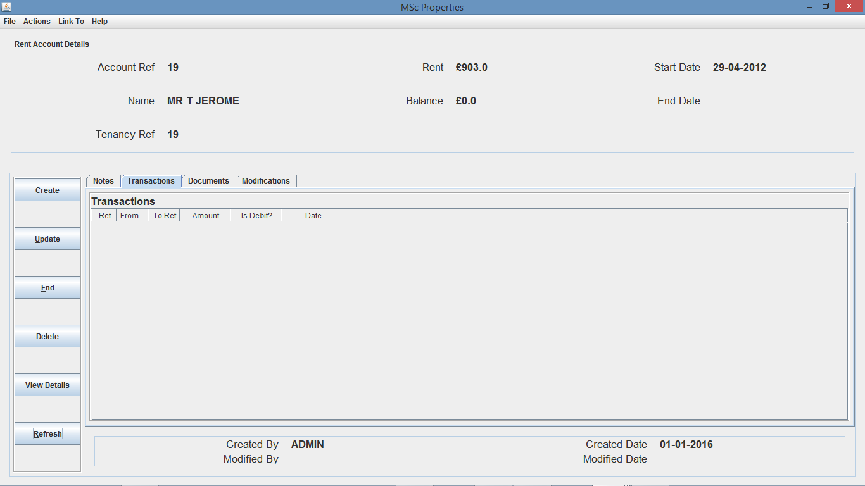

Fig. 58 – Rent Account Details Screen (on Transactions tab)

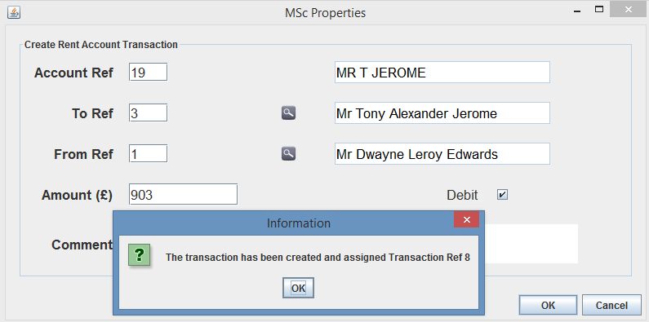

Fig. 59 – Create Transaction Dialog

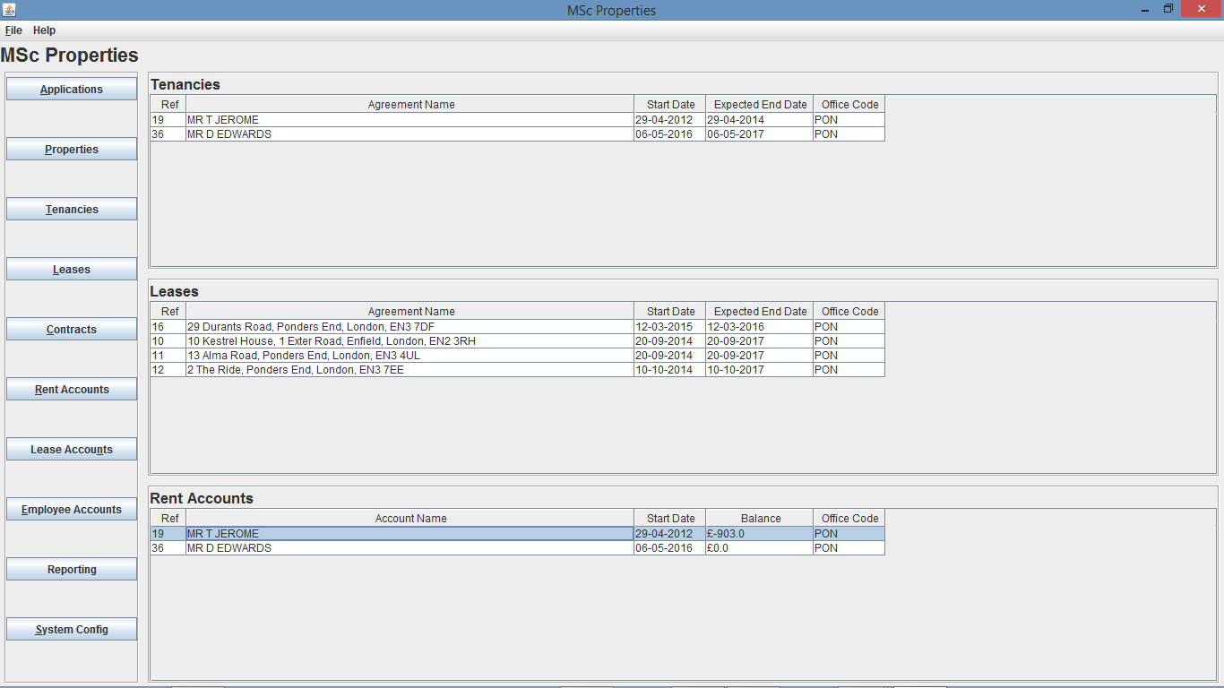

Fig. 60 - Home Screen of user from “PON” office after creation of rent transaction 8



Fig. 61 – Home Screen of user from “MNC” office after creation of rent transaction 8

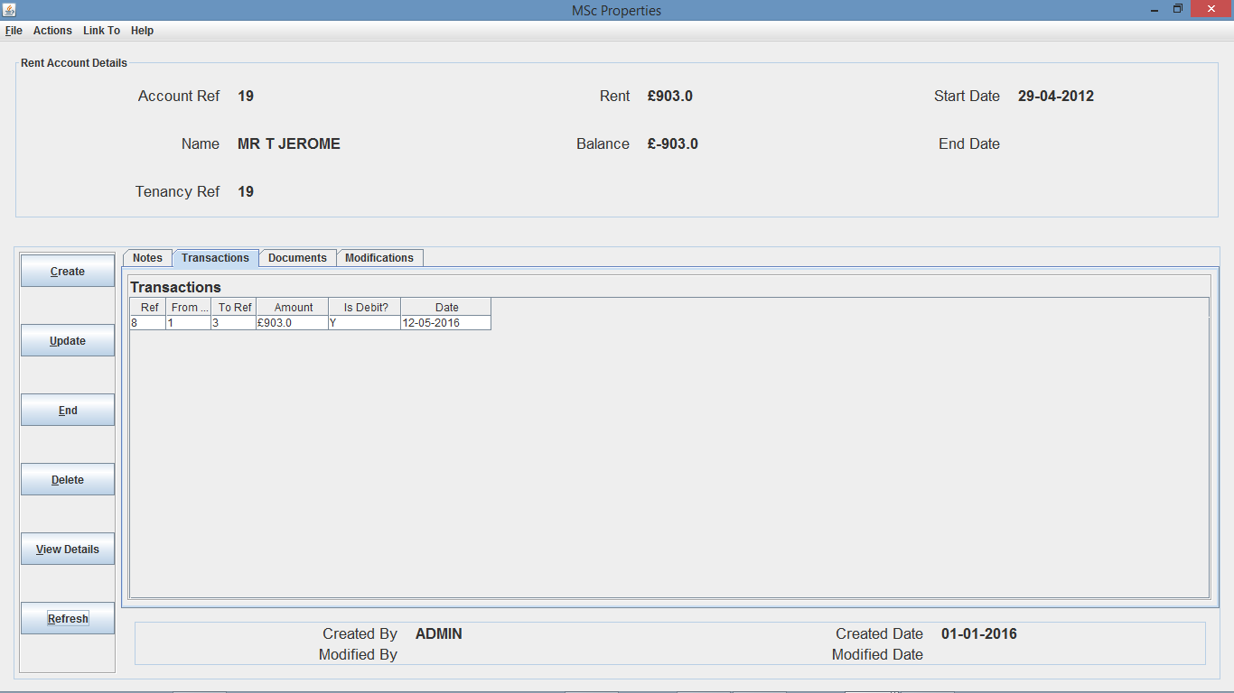

Fig. 62 - Rent Account Details Screen after creation of rent transaction 8 (on Transactions tab)

As you can see from Fig. 60 and Fig. 62 the balance of the account was successfully updated, which was propagated to the home screen of the “PON” office user, resulting in the Rent Accounts table being updated, however because Rent Account 19 list position was already 1, the account stayed in position one as it has the smallest balance.

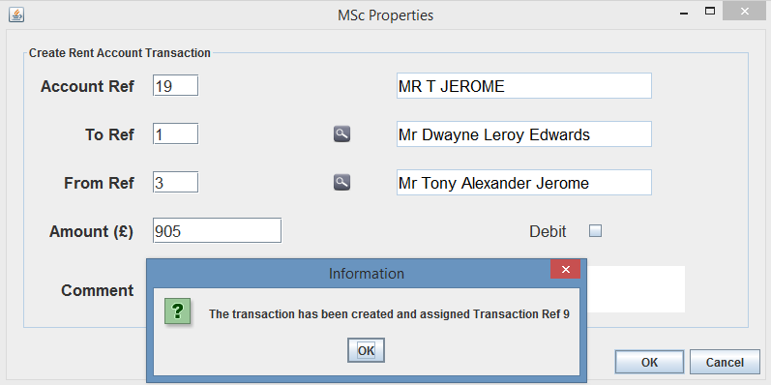

Fig. 63 – Create Transaction Dialog

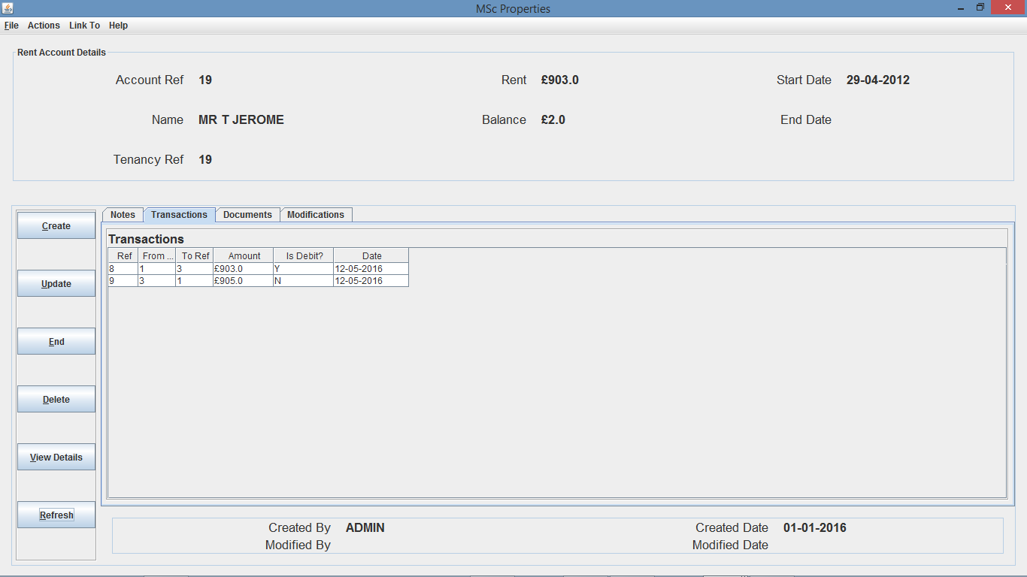

Fig. 64 – Rent Account Details screen after creation of rent transaction 9 (on transactions tab)

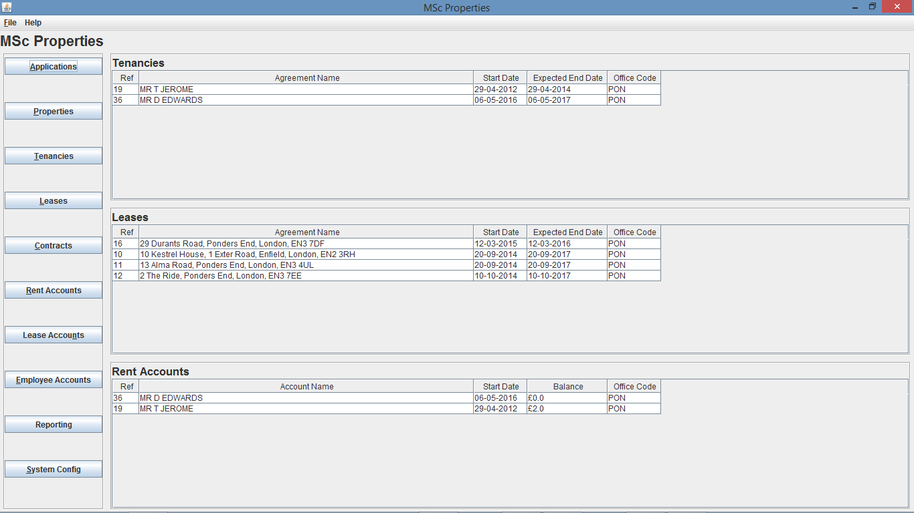

Fig. 65 – Home Screen of user from “PON” office after creation of rent transaction 9

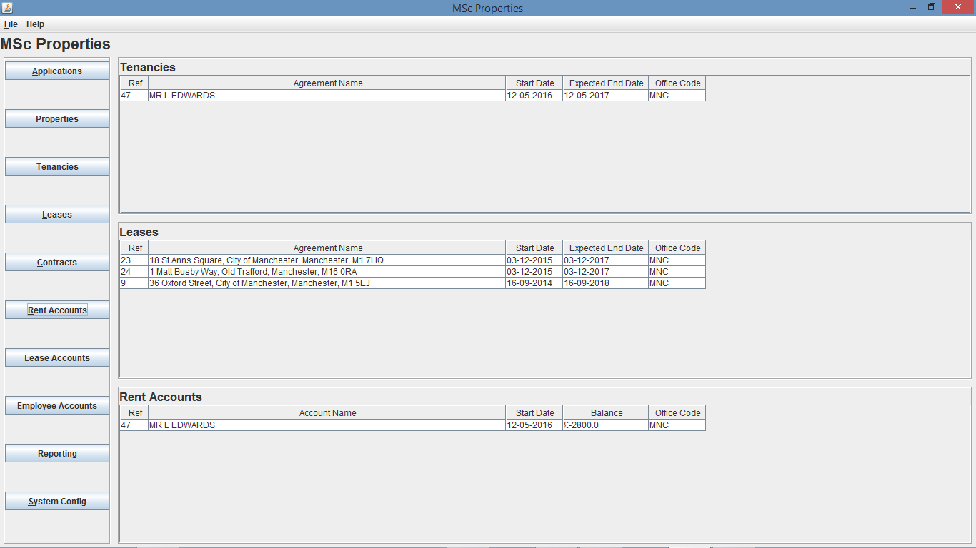

Fig. 66 – Home Screen of user from “MNC” office after creation of rent transaction 9

My second test will be to create a credit transaction, resulting in the balance to increase. As you can see from Fig. 63 and Fig. 64 I create a transaction for an amount of £905.00 which should amend the balance to £2 from £-903, which will result in Rent Account 19 list position changing from first in the list to second, and Rent Account 36 replaces Rent Account 19 in position 1, due to the lower balance amount.

My third test will be to delete a transaction, meaning the balance will increase or decreed depending on the details of the transaction deleted, in particular, whether it is a debit or credit, and if the amount is negative or positive.

For this test I decided to delete Transaction 9 that was created for Rent Account 19 in my previous test, this will mean that the balance will amend to £-903 resulting in the rent account to move back to position 1 in the rent accounts list due to the balance being the smallest amount. I also decided to create an additional tenancy and rent account (Ref 51) for office “PON”, and create a credit transaction of £502.01, bringing the balance to £502.01.

As you can see from Fig. 67 and Fig. 68, Transaction 9 was successfully deleted and the rent account balance has been amended to £-903 successfully, and as you can see from Fig. 69, the rent account list positions have also successfully updated, with Rent Account 19 now sitting in position 1, Rent Account 36 in position 2 and new Rent Account 51 in position 3.

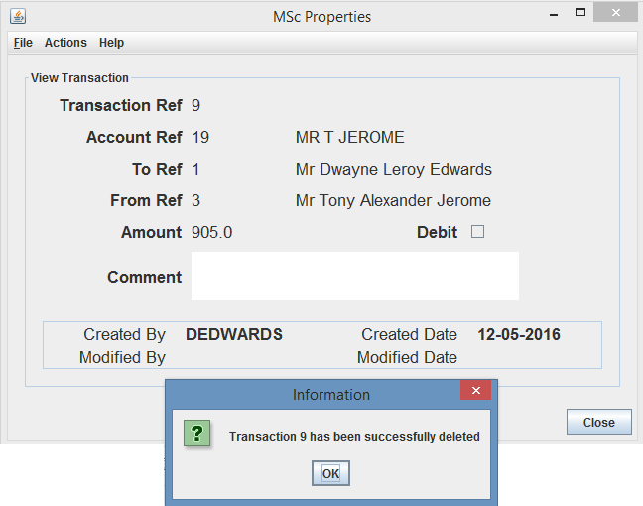

Fig. 67 – Transaction Deletion Dialog

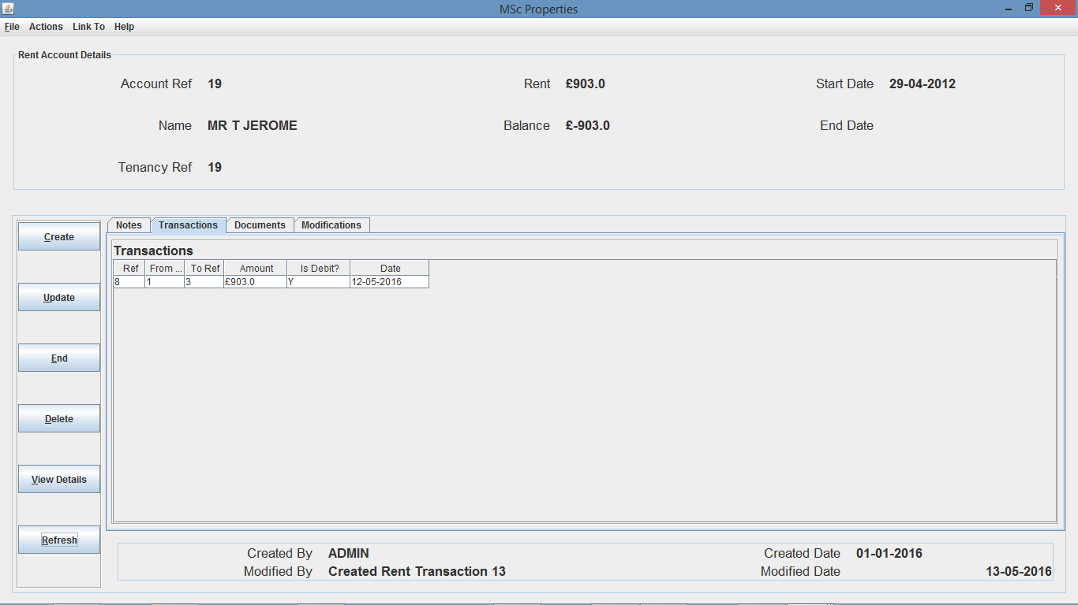

Fig. 68 - Rent Account Details screen after deletion of rent transaction 9 (on transactions tab)

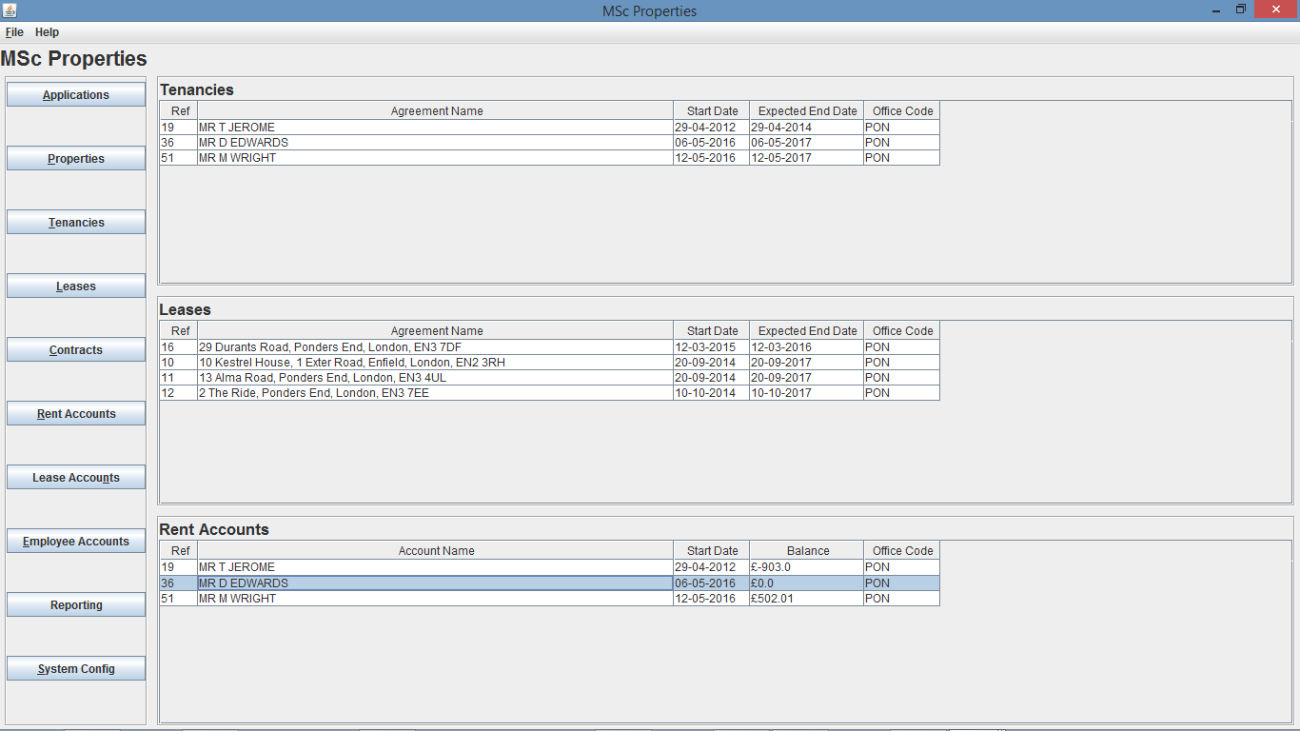

Fig. 69 – Home Screen of user from “PON” office after deletion of rent transaction 9

* 1. **Home Screen Limit**

As explained in the report, the home screen should restrict tenancies, leases and rent accounts to the top 10 tenancies and top 10 leases from their own office ordered by expected end date, and the top 10 rent accounts from their own office ordered by rent account balance.

For the final testing of the home screen am going to create a number of tenancies, leases and rent accounts to ensure that the above expected outcomes are occurring when a user logs in to the system and is viewing the home screen.

I decide to create 15 tenancies, 13 leases and 15 rent accounts for the ‘PON’ office, meaning that the limit for all 3 lists on the home screen will be met, and therefore the lists should be restricted to the limit of 10.

As you can see from Fig. 239 to Fig. 241, I have created 15 tenancies, 13 leases and 15 rent accounts for the PON office.

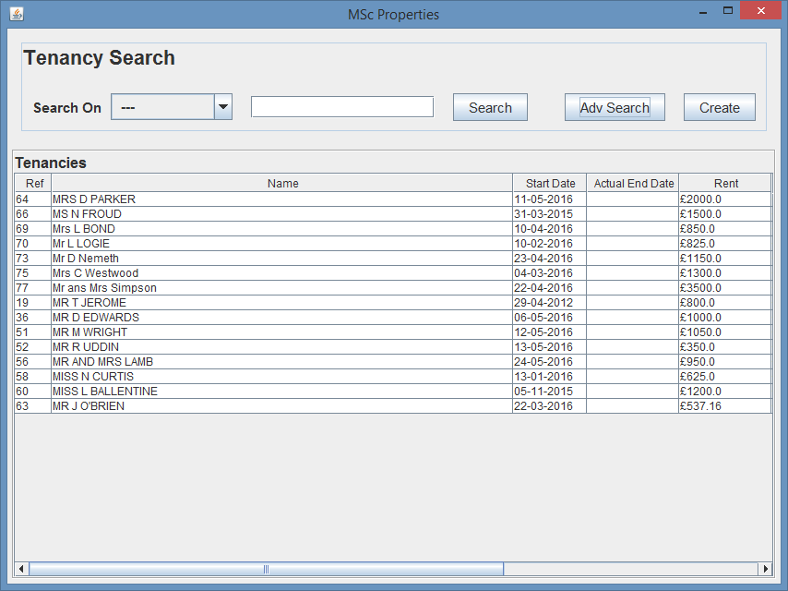Fig. 239 – Tenancy Search Results for ‘PON’ office

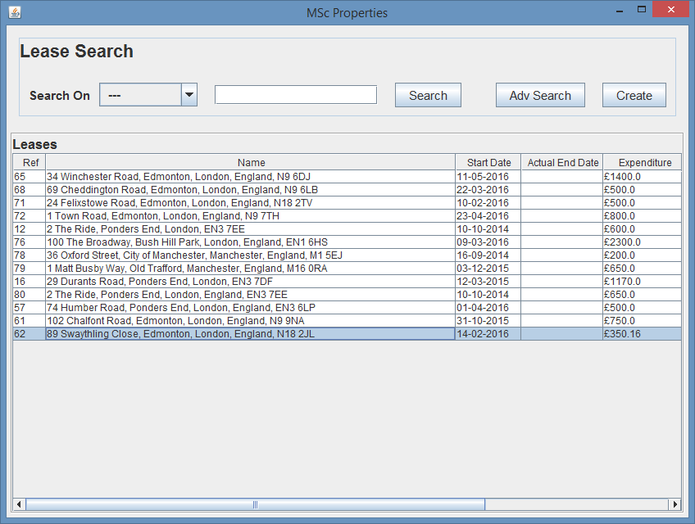

Fig. 240 – Lease Search Results for ‘PON’ office

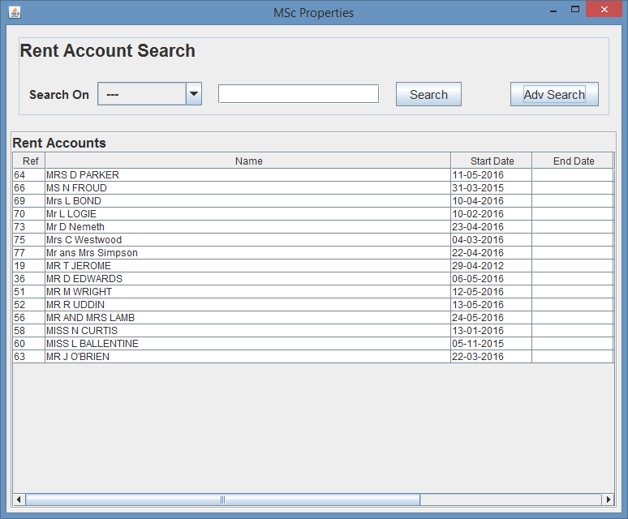

Fig. 241 – Rent Account Search Results for ‘PON’ office

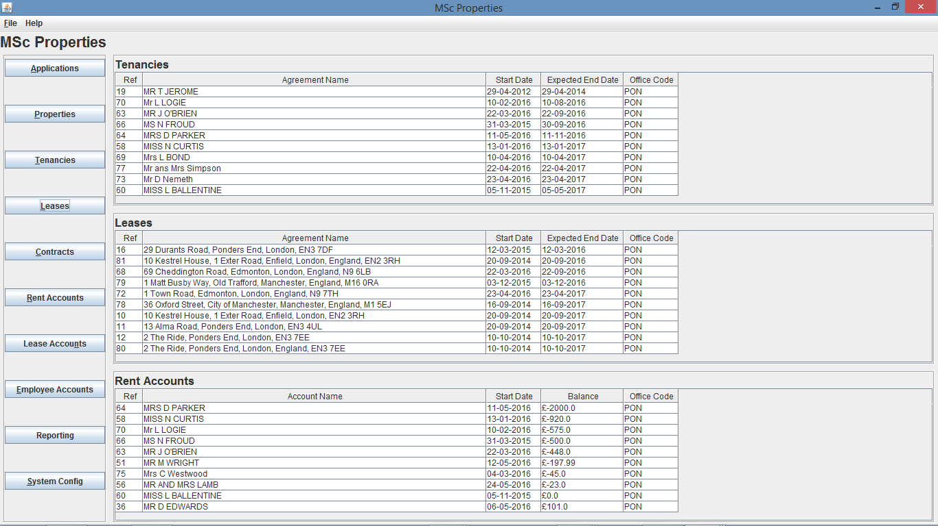

Fig. 242 – Home Screen of Employee from ‘PON’ office

As you can see from Fig. 242, although there are more than 10 tenancies, leases and rent accounts, the lists displayed on the home screen are limited to 10 with the tenancies and leases being order in expected end date and the rent accounts being ordered in balance.

Additionally, as you can see from the below figures, with each creation of a transaction, the rent accounts amend to be ordered by the balance.

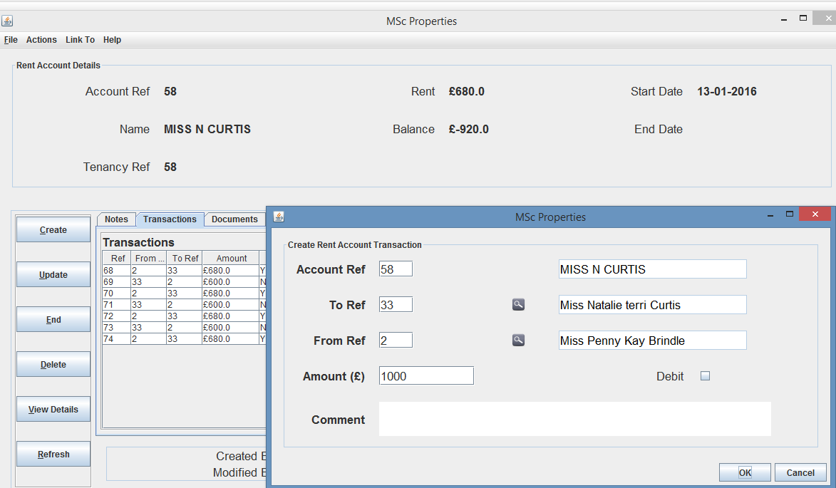

Fig. 243 – Rent Account 48 Details and Create Transaction screen

As you can see from Fig. 243 and Fig. 244, Rent Account 58 has a balance of £-920 and is second in the position, whereas upon creation of credit transaction of £1000, the balance should amend to £80 and the account should move to position 9 and all others should move up apart from position 10.

As you can see from Fig. 245, the rent accounts have reshuffled and the balance has been updated, which shows additionally to the home screen limit of 10 tenancies, leases and rent accounts being limited to 10 each, the lists are being correctly order depending on the rent account balances and agreement expected end dates.

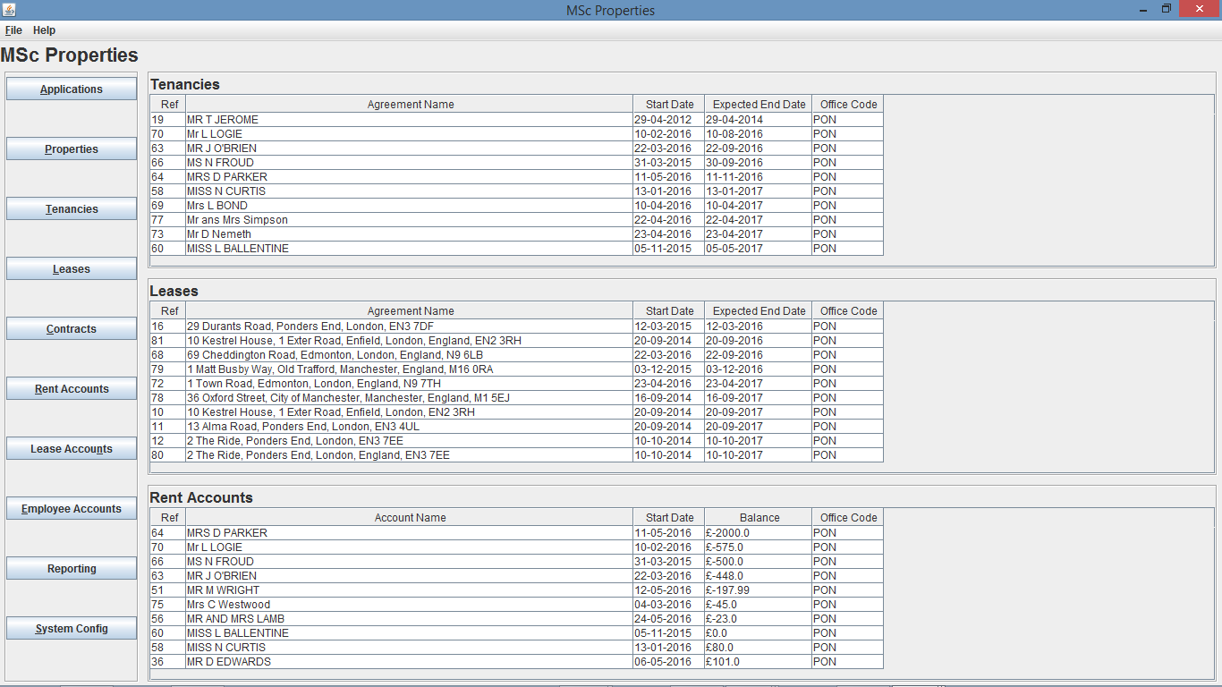

1. **Create Functionality**

As this system has a large number of functions available to the client, but there is a limited level of resources available for the project, I decided to test a the Create Tenancy function, but during the test create all of the elements that make up the tenancy such as application and property, and their related elements.

For the test I firstly navigate to the Tenancy search screen and select Create, which will open a create tenancy dialog. The create tenancy dialog will require the input of the tenancy creation details to enable to creation of the tenancy.

As explained, I will create the Application and Property for the tenancy and to do this I have to select the search icon for the App Ref, which will open the Application search dialog, where I select create, and a create App dialog opens, and I can enter the information for the application, where again I decided to use the search icons and create functions to create the person for the main applicant, the person address, and application address. This process is outlined in Fig. 70 to Fig. 96.

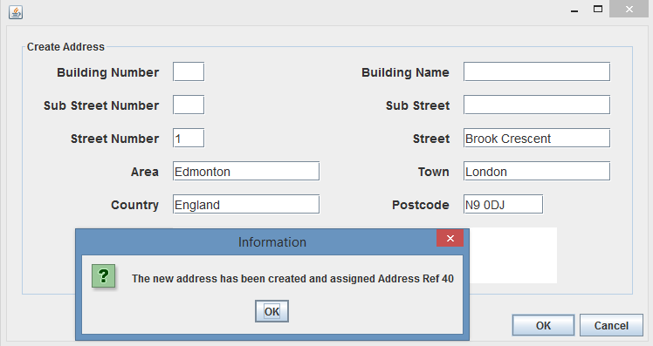

Fig. 70 – Create Address Dialog

N.B. Entered address details and selected OK.

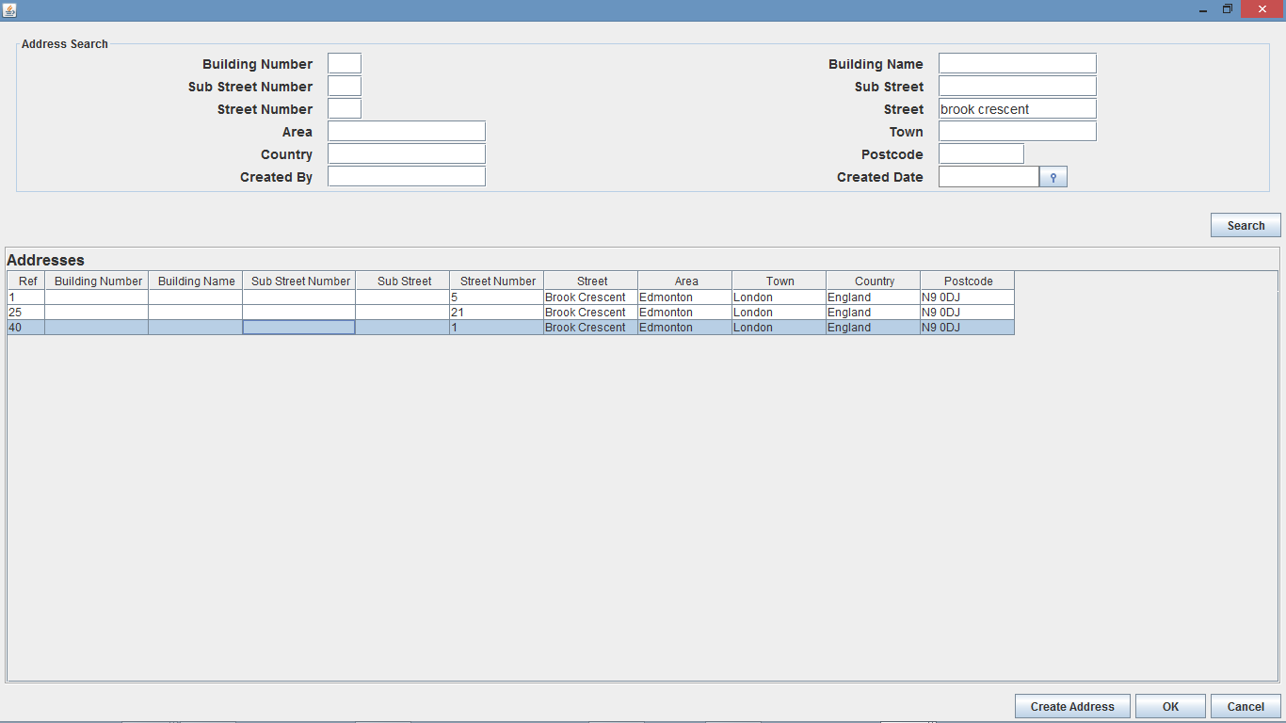Fig. 71 – Address Search Screen

N.B. Clicked Create Address to create new address, once created, entered search details and clicked Search, selected address and clicked OK.

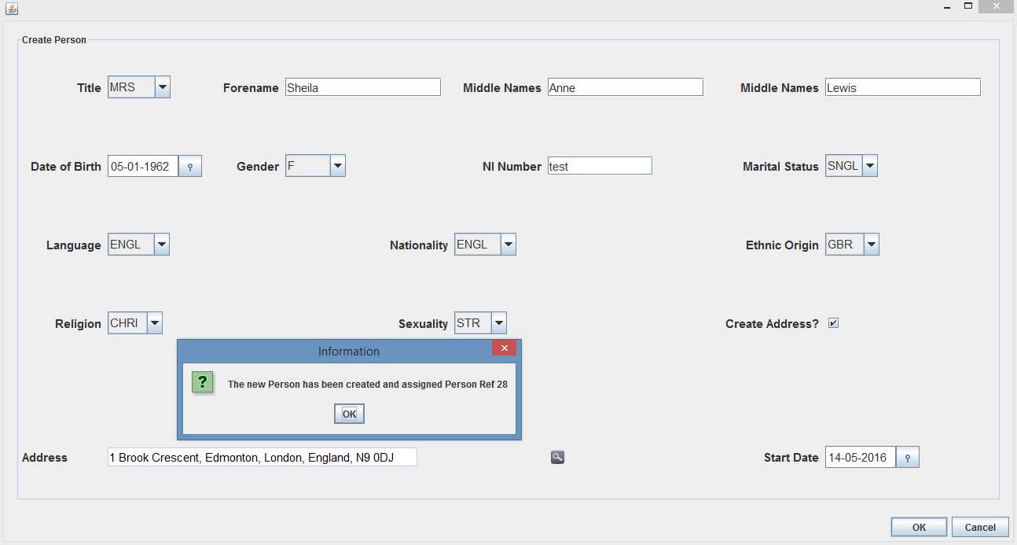

Fig. 72 – Create Person Dialog - N.B. Entered person details, searched for address with search icon (created address as shown in Fig. 70) and selected OK.

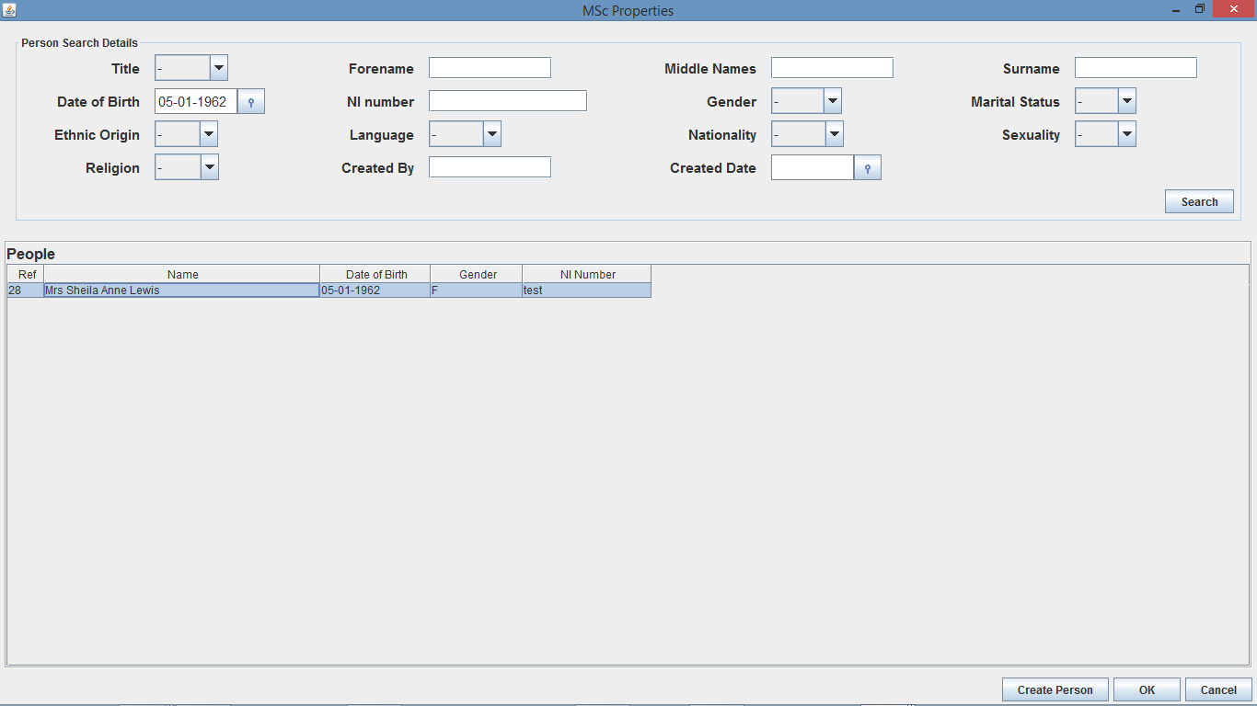

Fig. 73 – Person Search Dialog - N.B. Clicked Create Person to create new person, once created, entered search details and clicked Search, selected person and clicked OK.

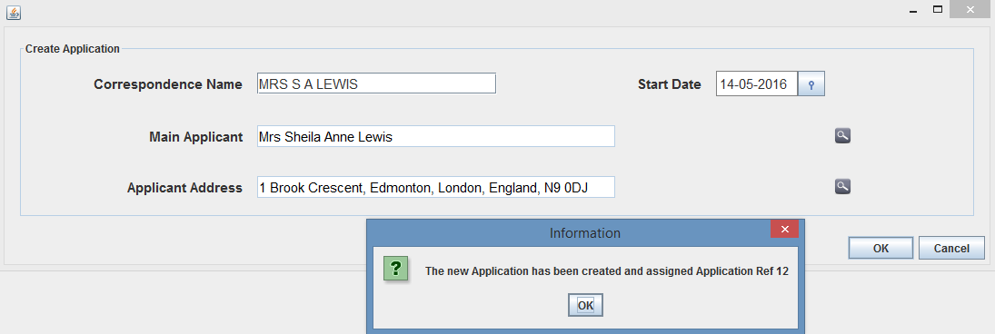

Fig. 74 – Create Application Dialog - N.B. Clicked Person Search icon to bring up Person search (created person as shown in Fig. 72), then clicked address search and searched and selected address, entered the other address details and selected OK.

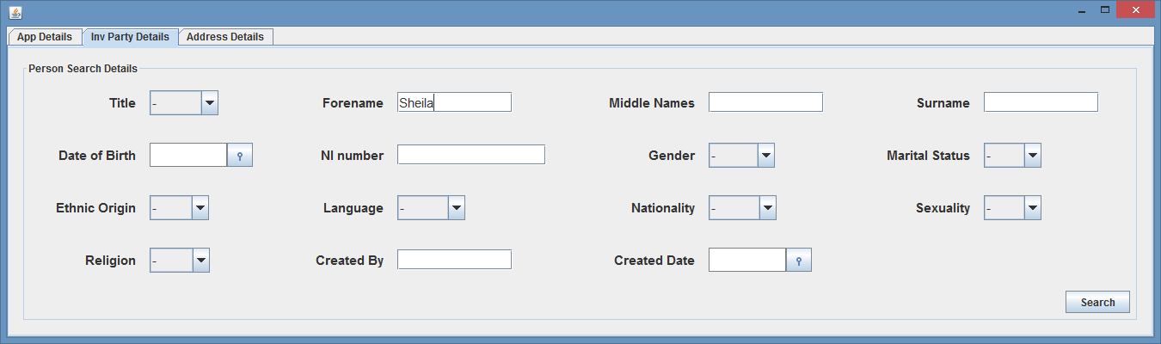

Fig. 75 – Application Advanced Search Dialog (on Inv Party Details tab) - N.B. Selected Adv Search from App Search dialog and went to Inv Party Details tab, entered Forename details of “Sheila” (forename of Person 28, who is main applicant for newly created Application 12).

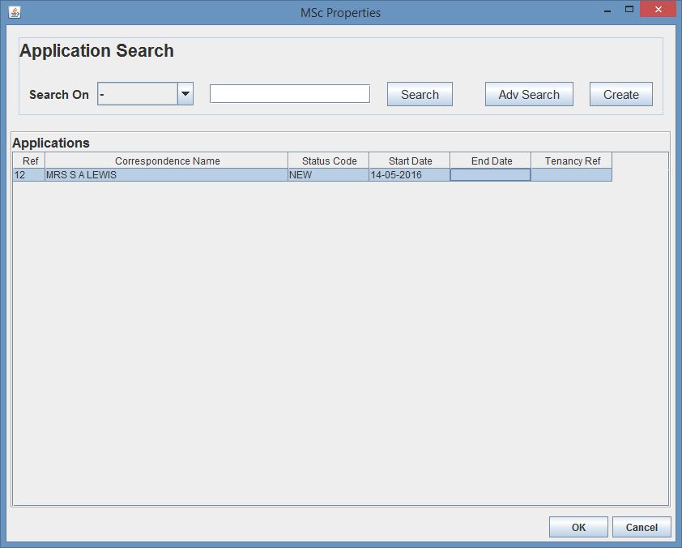Fig. 76 – App Search Dialog

N.B. Created Application as shown in Fig. 74 and then searched for app as shown in Fig. 75, with newly created app being returned, then clicked OK. Also Status Code is “NEW” and no Tenancy Ref number.

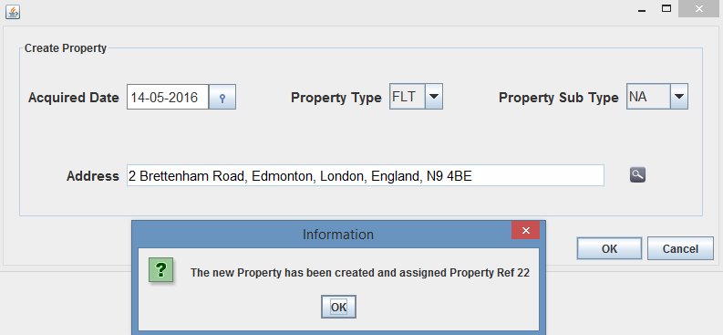

Fig. 77 – Create Property Dialog - N.B. Entered Property details, search and selected address and clicked OK.

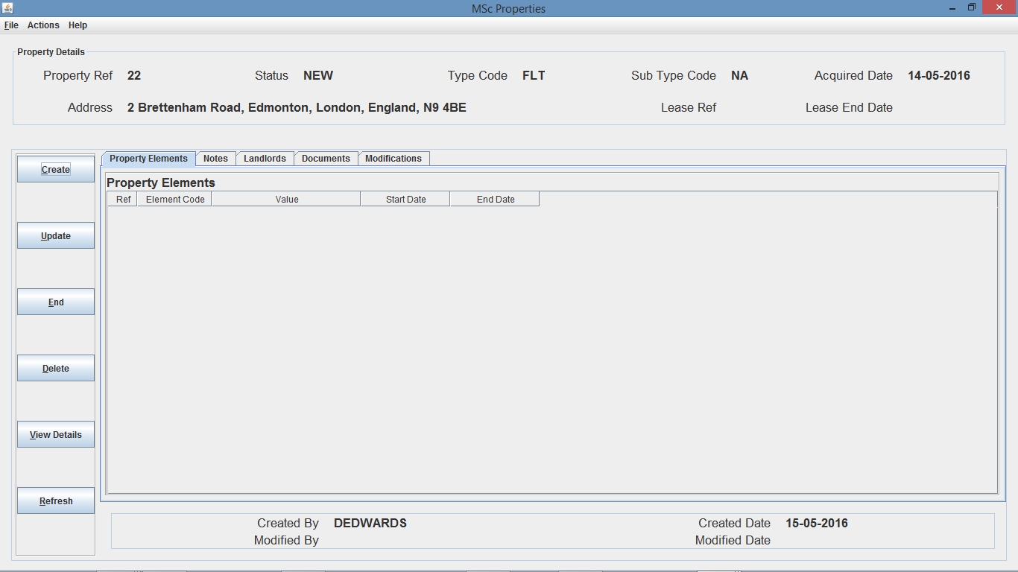

Fig. 78 – Property Details Screen - N.B. Newly created Property 22 with no Property Elements and Status of “NEW”.

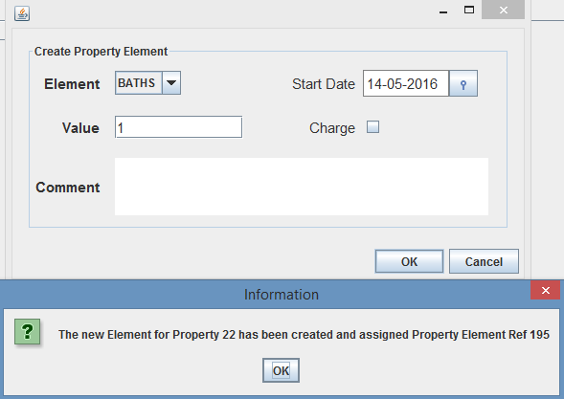

Fig. 79 – Create Property Element Dialog (Non Charge Property Element)

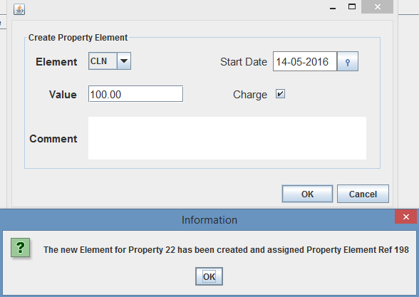

Fig. 80 – Create Property Element Dialog (Charge Property Element)

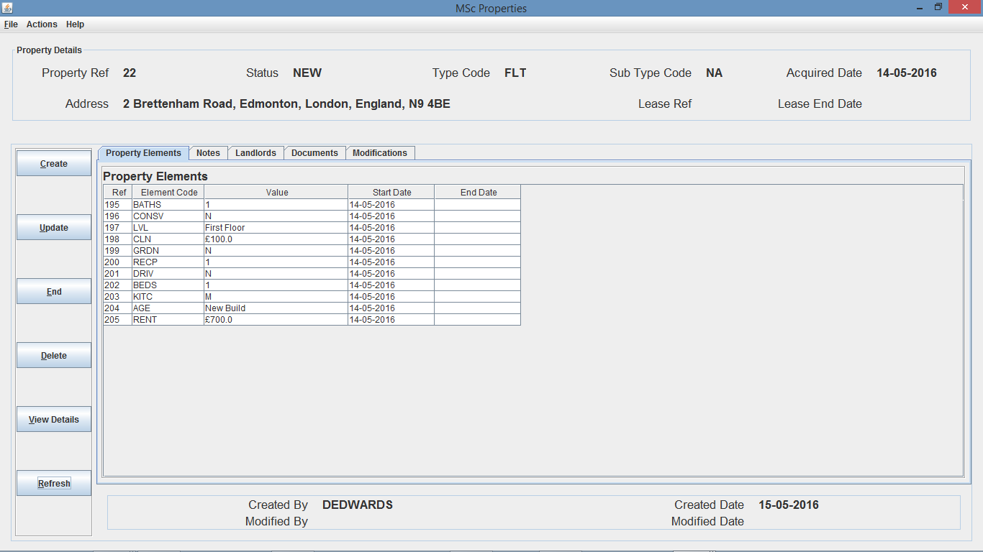

Fig. 81 – Property Details Screen - N.B. Property 22 with Property Elements. As you can see charge element “CLN” and “RENT” both have ‘£’ character prior to actual value. Also there is currently no lease for the Property.

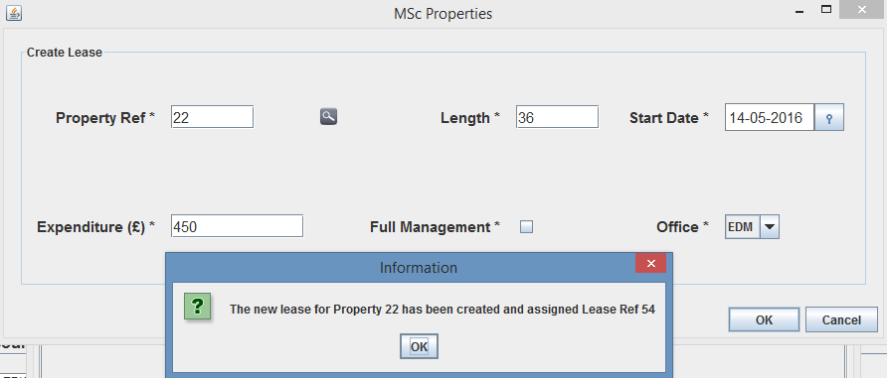

Fig. 82 – Lease Creation Dialog - N.B. Navigate to Contract Search, select Create and input Lease details and select OK. However, lease 54 has no Landlord assigned, so a Landlord needs to be created for the Lease.

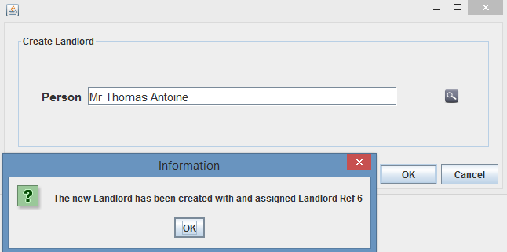

Fig. 83 – Create Landlord Dialog

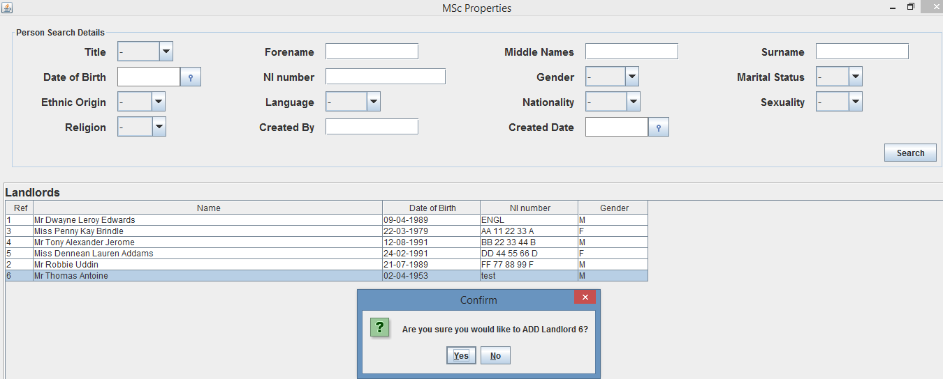

Fig. 84 – Add Landlord to Lease Dialog

Fig. 85 – Add Landlord to Lease Confirmation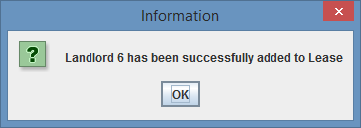

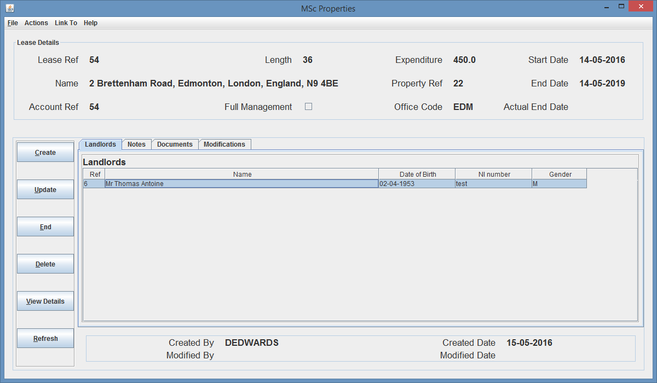

Fig. 86 – Lease Details Screen (after Landlord 6 was added to Lease)

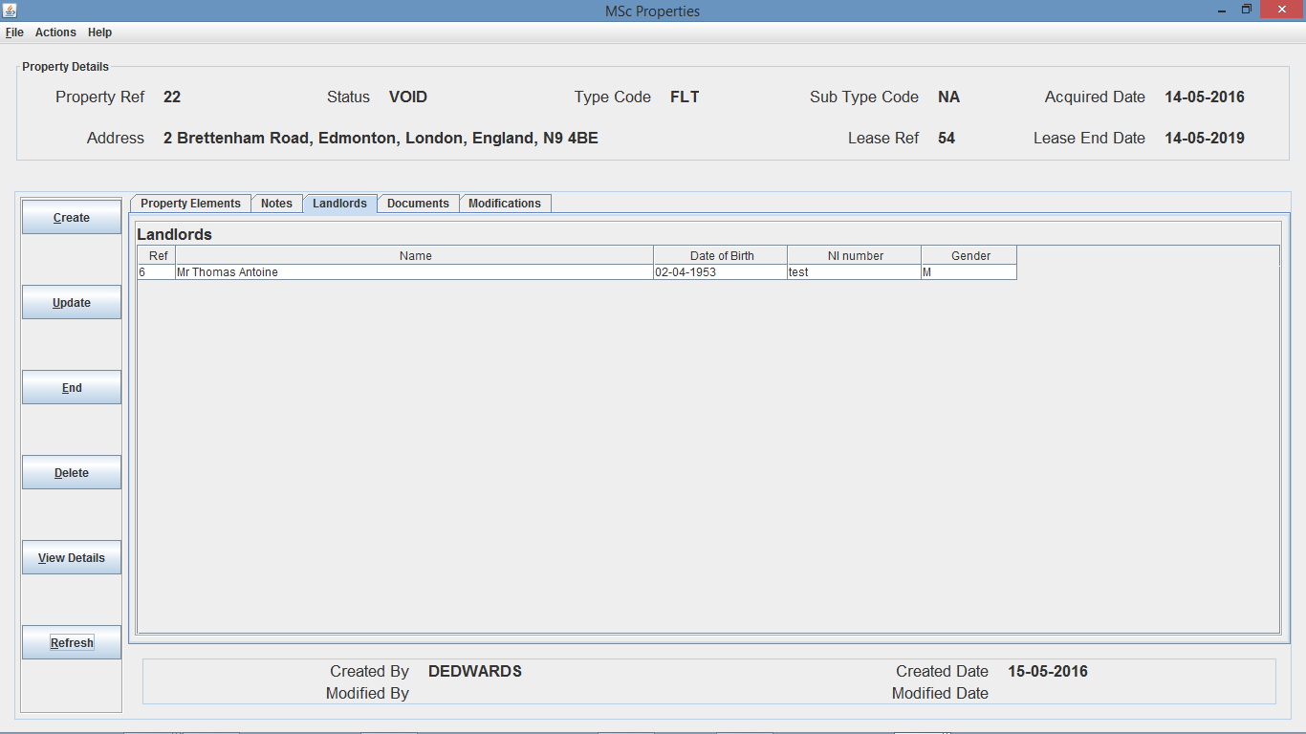

Fig. 87 – Property Details Screen on Landlord tab

N.B. Lease Ref 54 and Lease End Date 14-05-2019 was assigned to Property 22 and Landlord 6 added to Landlords list. Also now Property has a Lease, Status is amended from “NEW”, as shown in Fig. 81, to “VOID”.

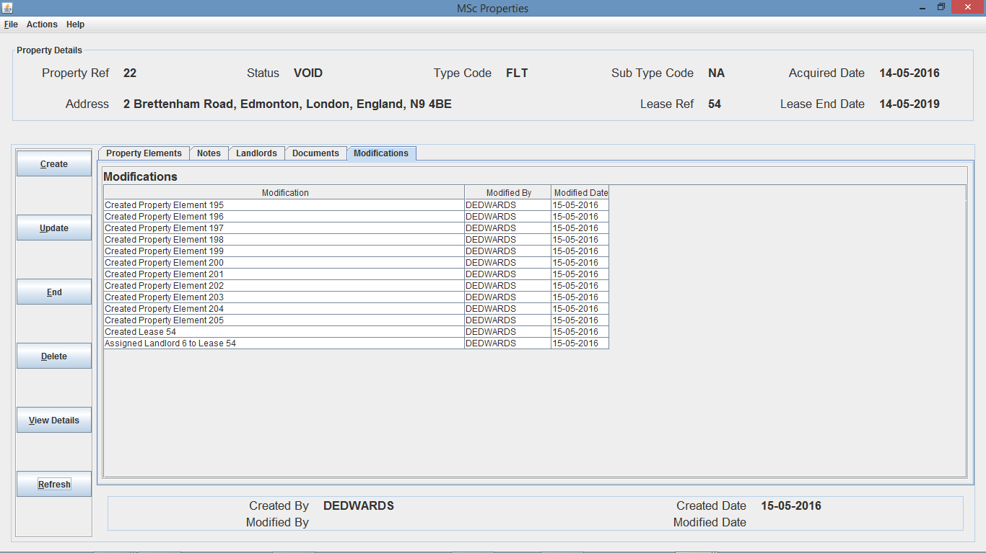

Fig. 88 – Property Details Screen on Modifications tab

N.B. Modifications have been created and assigned to Property 22.

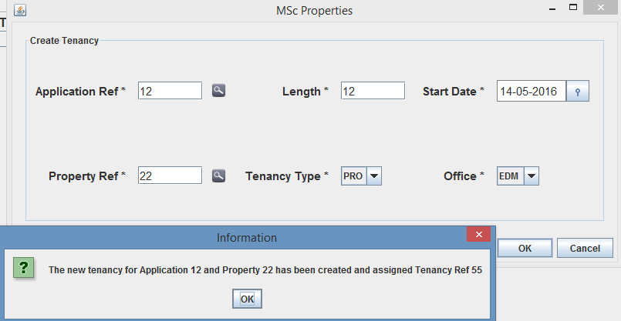

Fig. 89 – Tenancy Creation Dialog

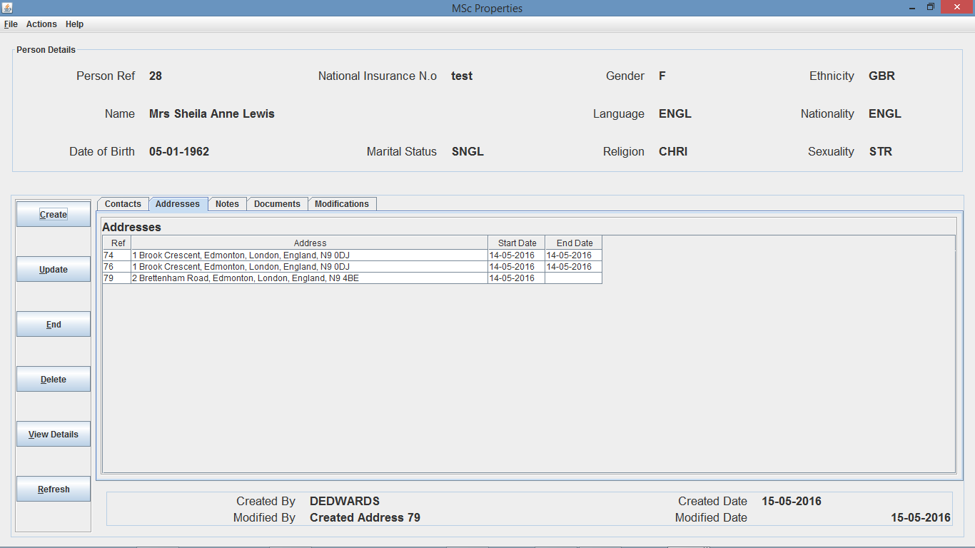

Fig. 90 – Person Details Screen - N.B. Person successfully created and details correctly stored and updated, the only issue is duplicated address because I created a Person Address when I created the person and then an application address when creating the application so 1 Brook Crescent was duplicated.

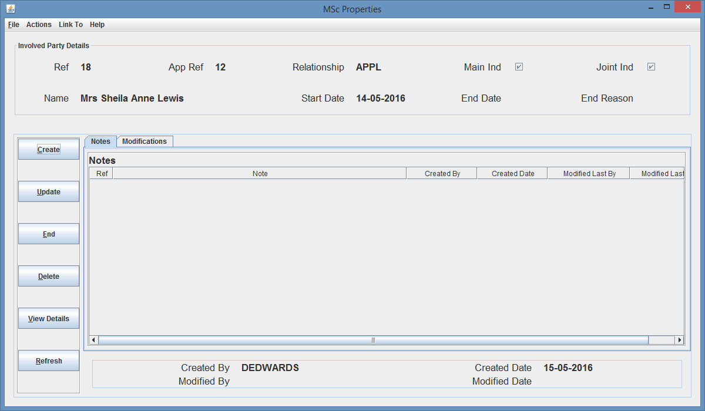

Fig. 91 – Involved Party Details Screen for Person 28

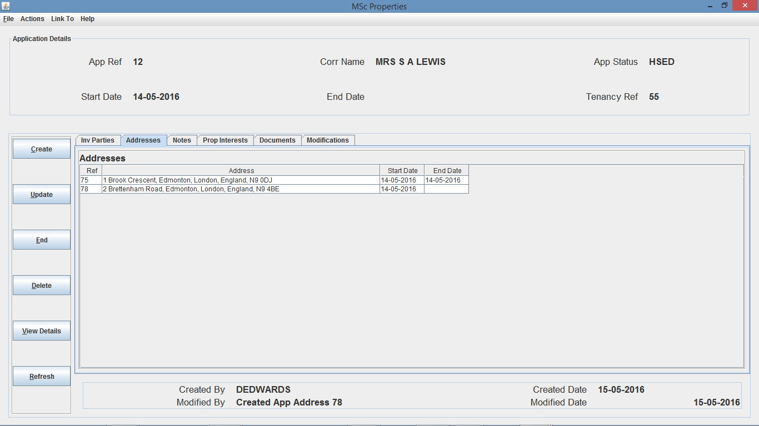

Fig. 92 – Application Details Screen - N.B. Application details have been correctly stored and updated, and due to Tenancy Ref 55 creation, the App Status was amended from “NEW” as shown in Fig. 76, to “HSED” along with Tenancy Ref 55 being assigned.

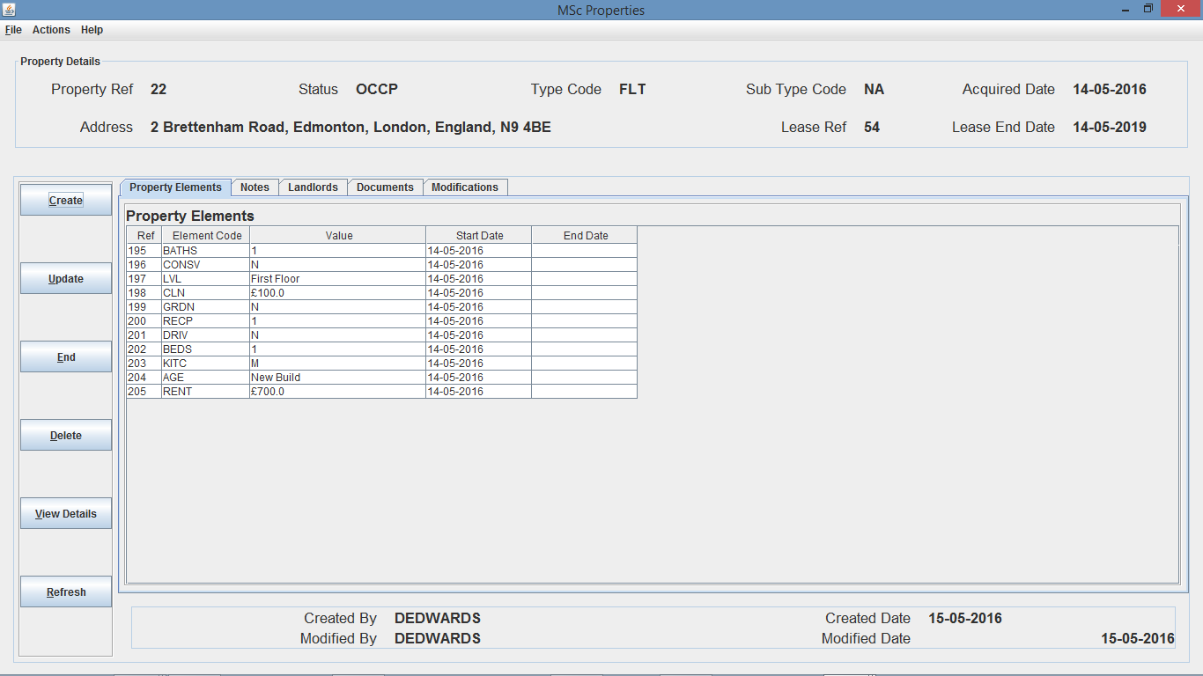

Fig. 93 – Property Details Screen - N.B. As Tenancy Ref 55 has been created for Prop Ref 22, prop status has been amended from “VOID” as shown in Fig. 78 and Fig 81, to “OCCP”.

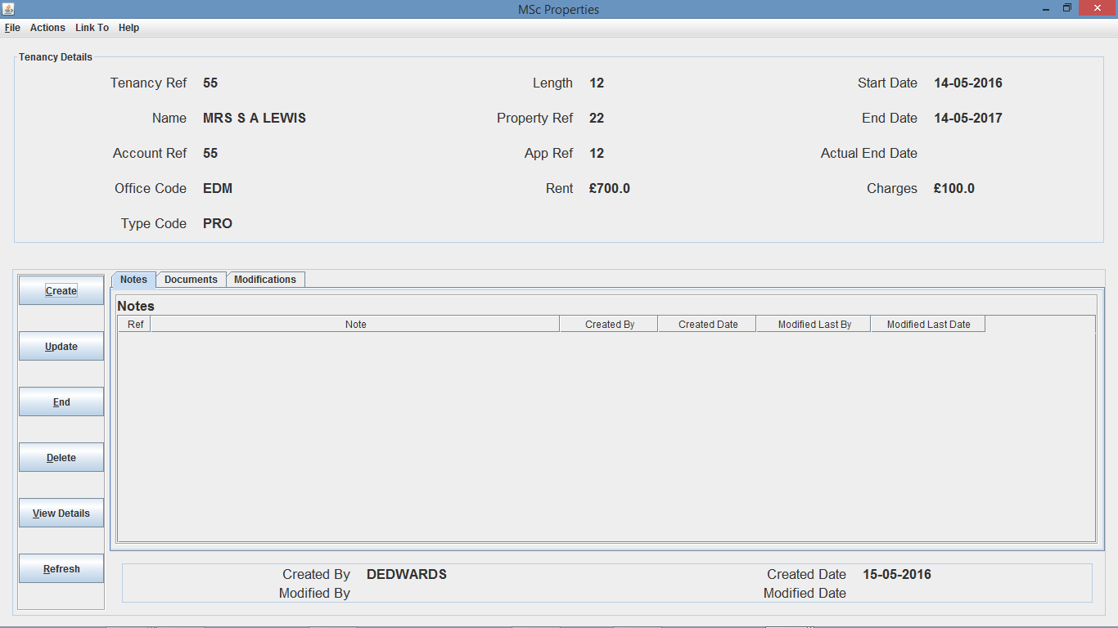

Fig. 94 – Tenancy Details Screen - N.B. Rent and Charge Property Element Values for Property 22 have been pulled through from Property and assigned to Tenancy Ref 55, Also correspondence name pulled through from Application 12. Also the End Date of 14-05-2017 is correctly calculated (12 months after start date 14-05-2016).

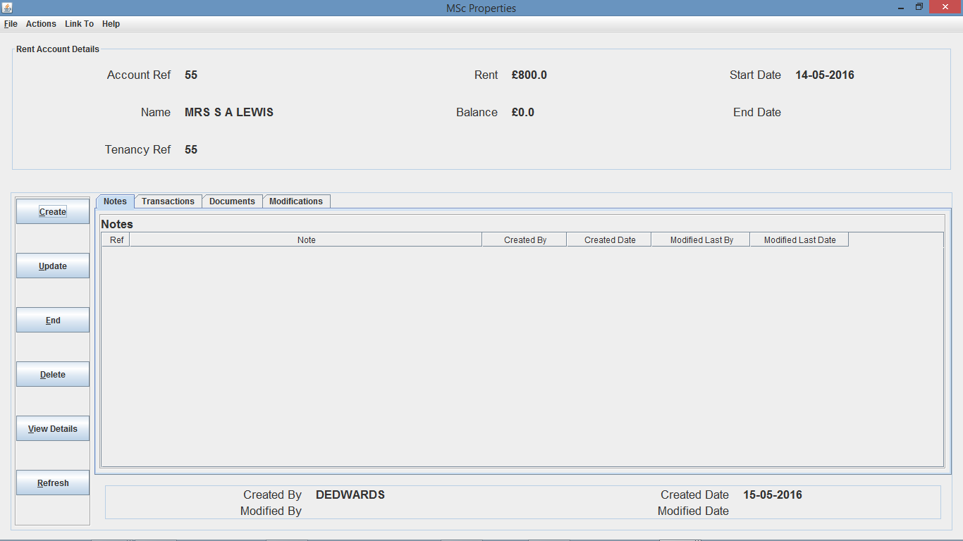

Fig. 95 – Rent Account Details Screen - N.B. Rent Account was created off the back of Tenancy creation, and Rent value correctly calculated (Property Ref 22 - rent £700 + charges £100).

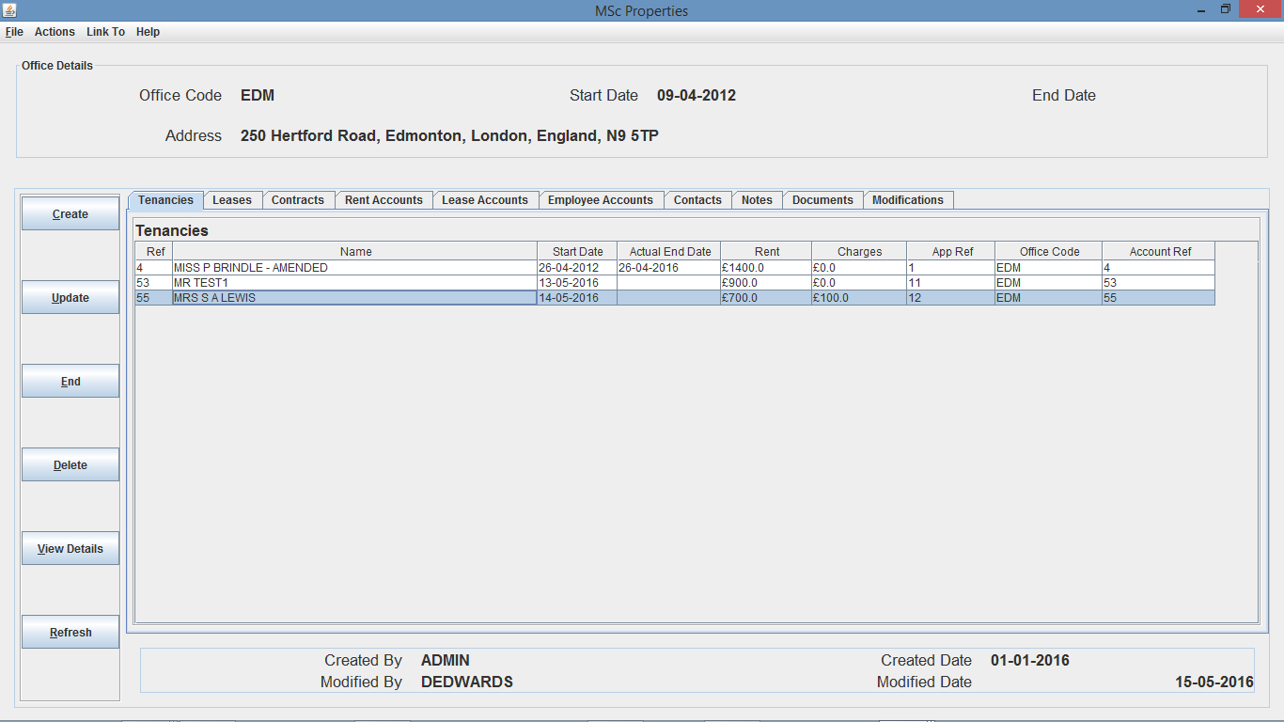

Fig. 96 – Office Details Screen - N.B. Tenancy 55 has been assigned to Office “EDM”, along with Rent Account 55.

The above tests show that the Create Tenancy method is working with the main functionality working as it should.

1. **Update Functionality**

For this test I decided to update Tenancy 53, and amend the length from 12 months to 24 months resulting in the expected end date to be amended from 13-05-2017 to 13-05-2018, and additionality amend the tenancy name from MR TEST1 to MR TEST1 – AMENDED.

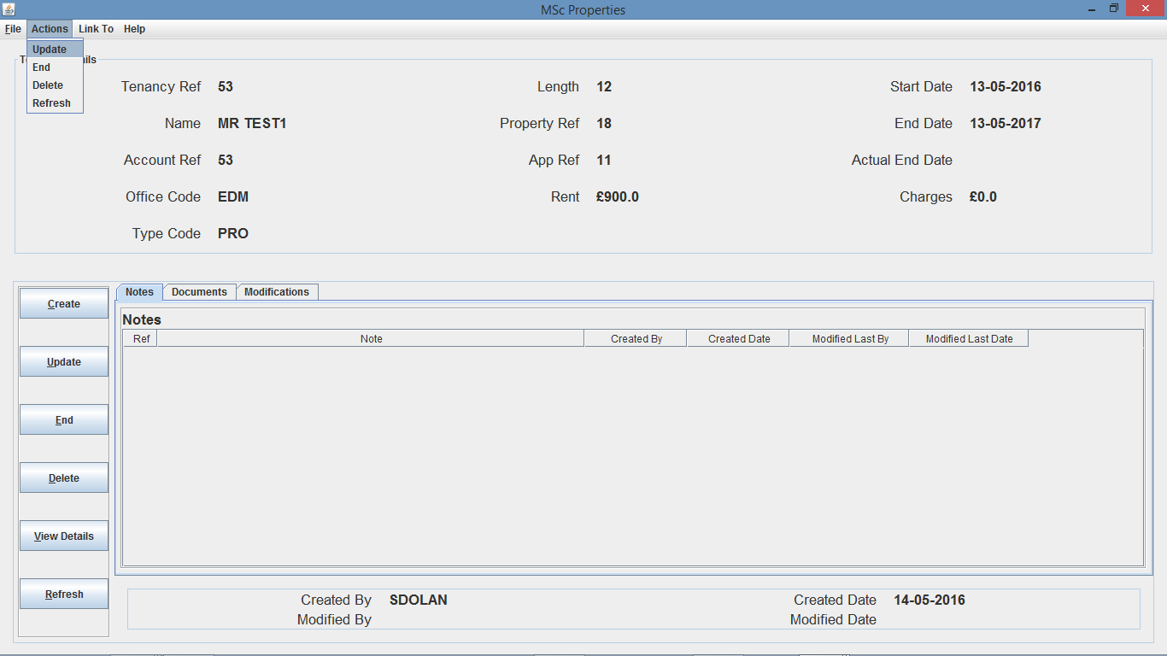

Fig. 97 – Tenancy Details Screen (prior to Tenancy Update)

As you can see from Fig. 98 once I selected Update from the Tenancy Details Action menu, an update tenancy dialog opens where I can then update the tenancy information that was populated within the data entry fields and drop downs boxes. Additionally, once I select OK and then select yes to confirm the tenancy update, a confirm dialog box is then returned confirming the update of the tenancy.

As you can see from Fig. 99 the actual outcome was the same as the expected outcome as the name was updated correctly, and the length along with the expected end date (End Date) was amended as expected.

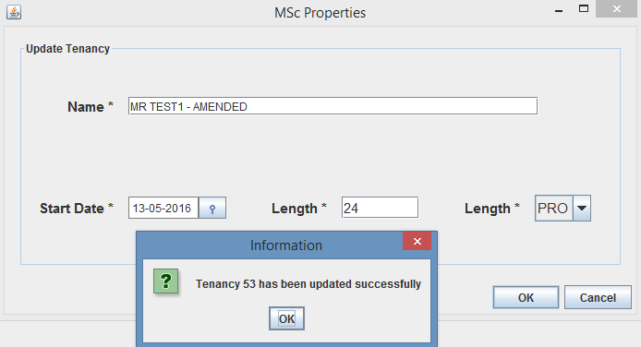Fig. 98 – Tenancy Update Dialog

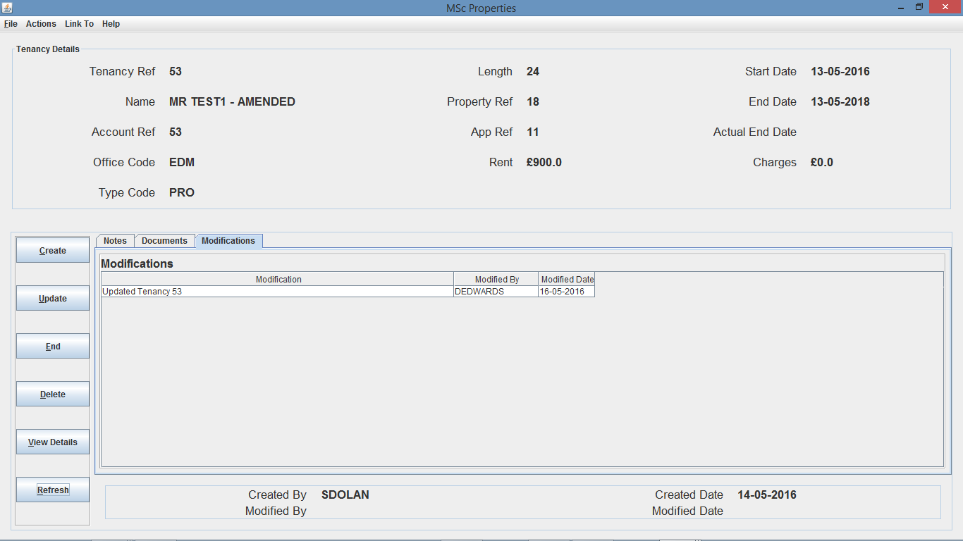

Fig. 99 – Tenancy Details Screen (after amendment) - N.B. Once I clicked Refresh from either the on screen button or the Actions menu bar, the Property Details will then update on screen, confirming the updated details or Length 24, End Date (expected end date) 13-05-2018 and Name of “MR TEST1 – AMENDED”.

The above tests show that the Update Tenancy function is working as it should by updating the tenancy details, along with the Rent Account Details shown in Fig. 100 (below).

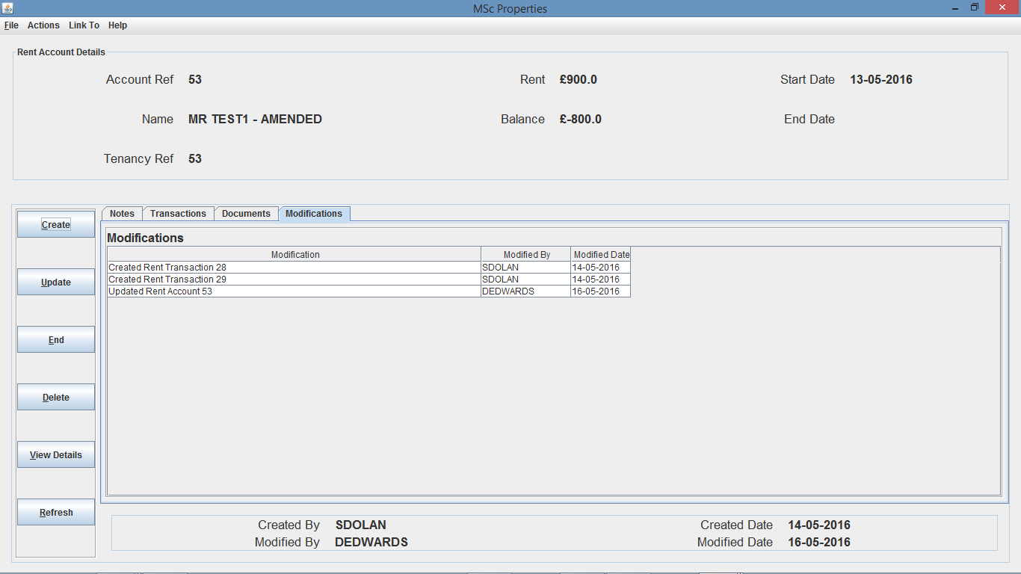

Fig. 100 – Rent Account Details

1. **Delete Functionality**

For this test I decided to update Tenancy 55 that was created earlier in the testing process. This should result in a number of the associated elements such as Application 12 and Property 22 to be rolled back to before Tenancy 55 was created, along with Rent Account 55 being deleted.

To carry out this test I navigate to Tenancy Details Screen for Tenancy 55 and use the Actions menu bar option, and select the Delete menu item, as you can see from Fig. 101.

Once I selected Delete, a Delete Tenancy dialog opens asking if I am sure I would like to delete Tenancy 55, if I select no the dialog will close and go back to the Tenancy Details screen, but if I select yes, then a Confirm dialog appears confirming deletion of Tenancy 55 as you can see from Fig. 102.

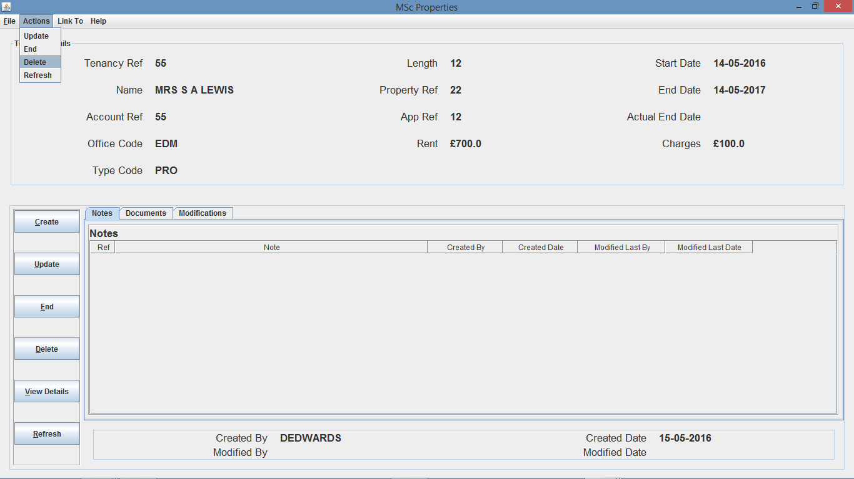

Fig. 101 – Tenancy Details Screen (with Actions menu open)

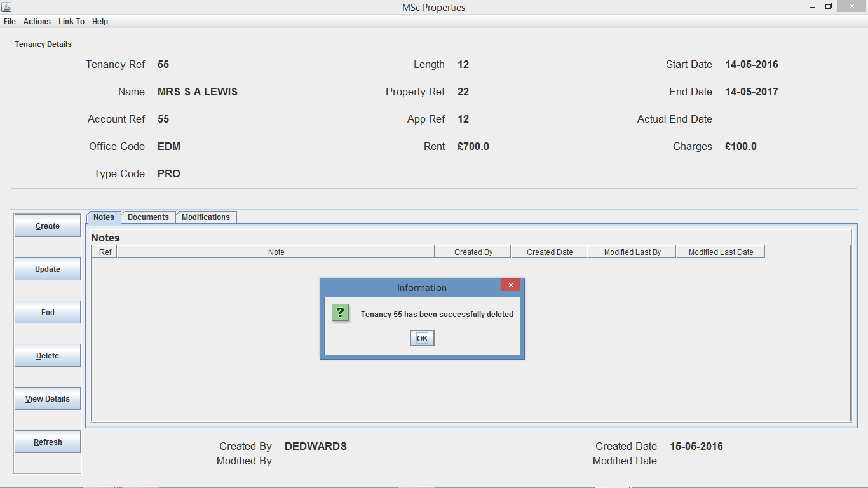

Fig. 102 – Tenancy Deletion Dialog

To confirm Tenancy 55 was deleted successfully, I then moved to the Tenancy search dialog and attempted to search for Tenancy 55. As you can see from Fig. 103 there is no Tenancy 55 being returned. I further confirmed deletion of tenancy and Rent Account 55 through the Office “EDM” Details Screen (tenancies and rent account tab).

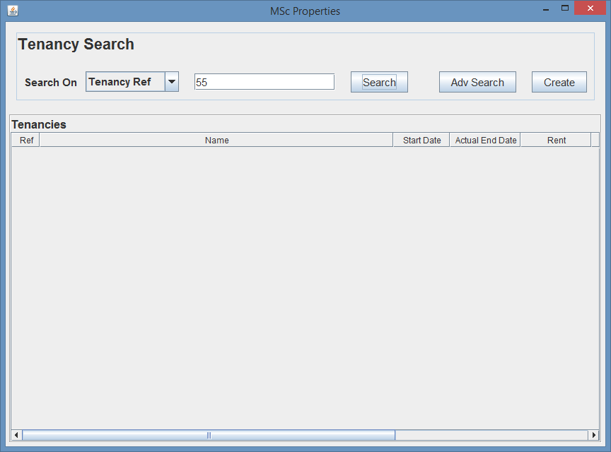Fig. 103 – Tenancy Search Screen

N.B. Tenancy Ref 55 has not returned.

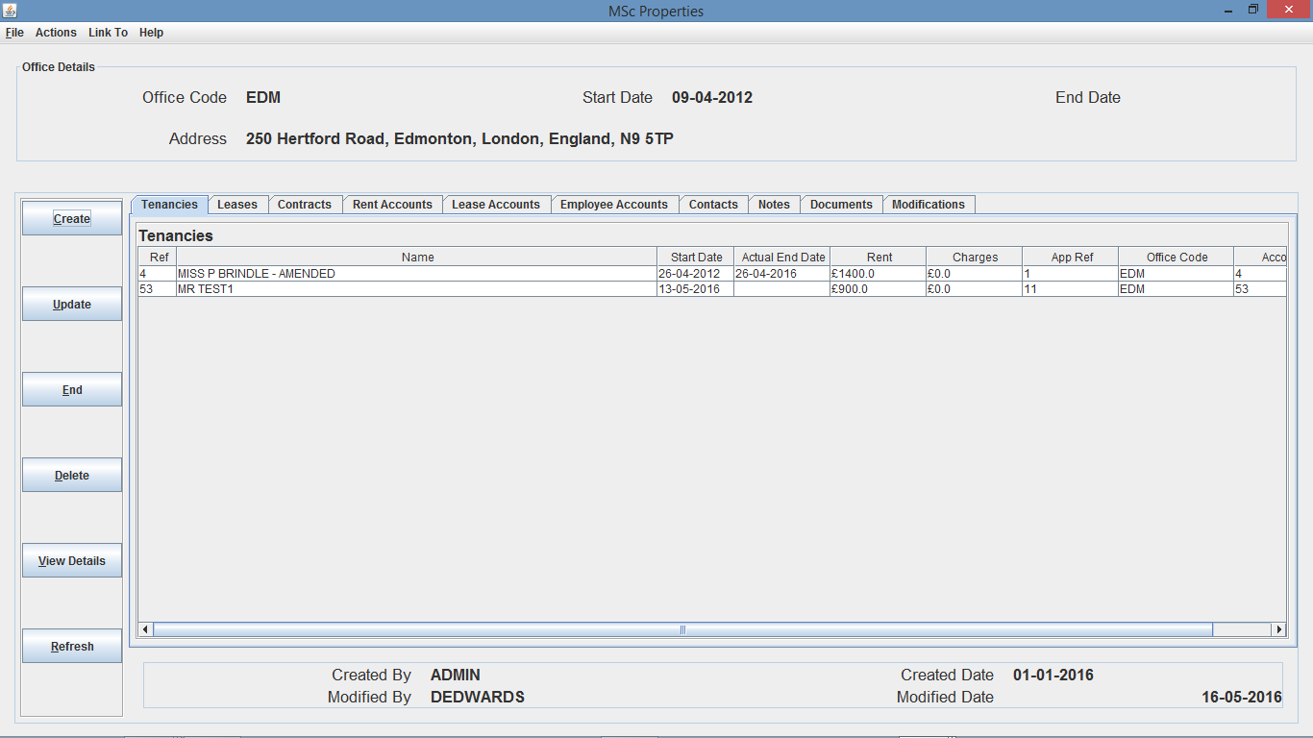

Fig. 104 – Office Details Screen (on tenancies tab)

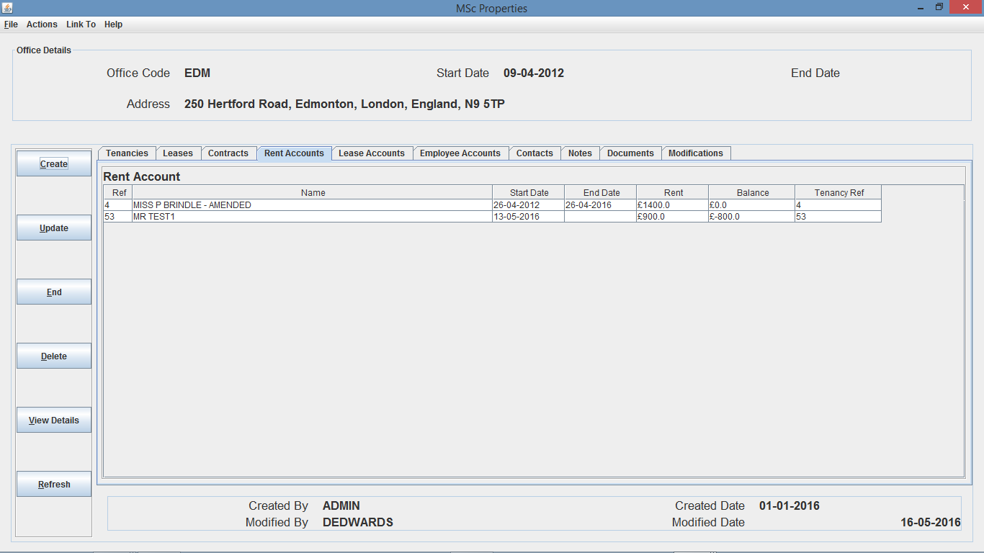

Fig. 105 – Office Details Screen (on rent accounts tab)

As you can see from Fig. 104 and Fig. 105 there is only 2 tenancies and 2 rent accounts and both Tenancy 55 and Rent Account 55 have been removed from the tenancies and rent account tables respectively for Office “EDM”.

I am now going to view Application 12 and Property 22 Details Screen as these was assigned to Tenancy 55, and therefore upon deletion of Tenancy 55 should result in the Application and Property details to be rolled back.

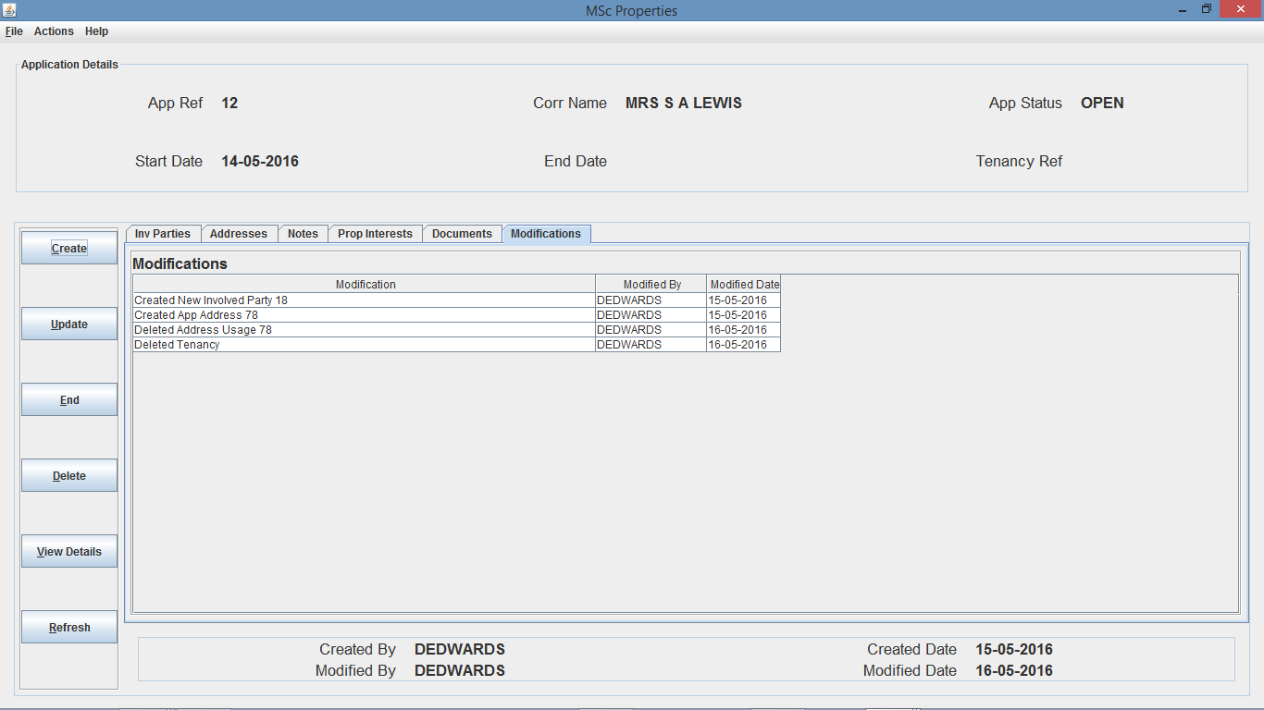

Fig. 106 – Application Details Screen (on Mods tab) - N.B. Modifications stored correctly.

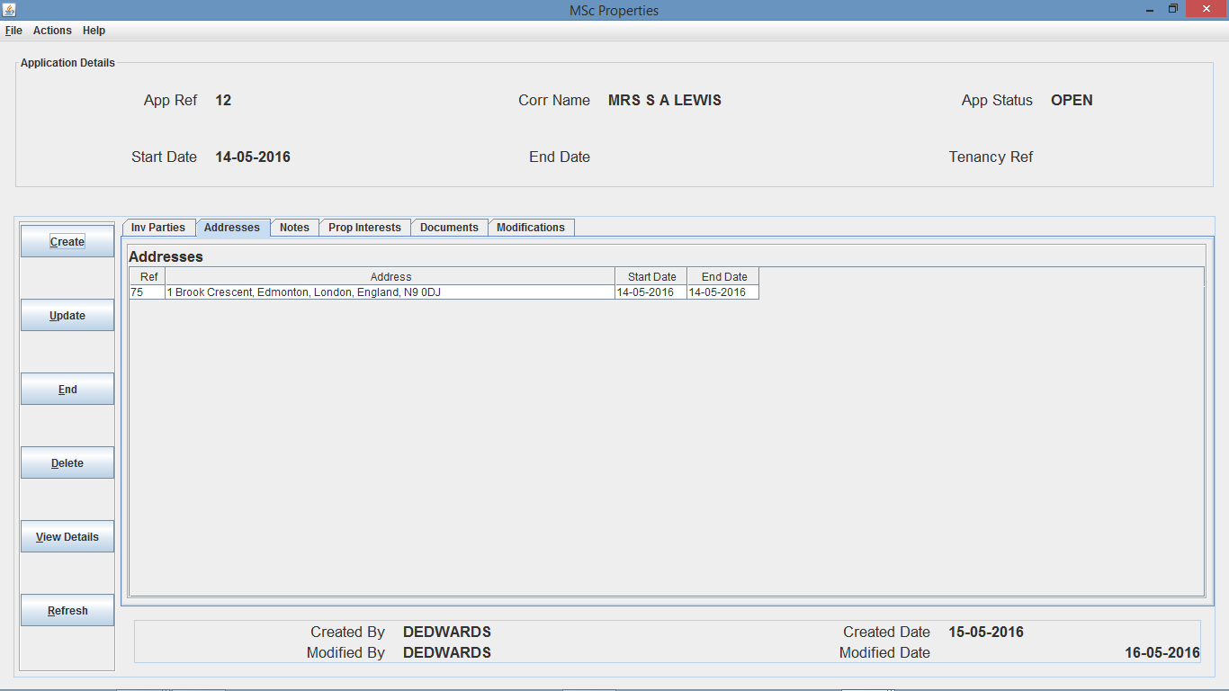

Fig. 107 – Application Details Screen (on Addresses tab) - N.B. Tenancy Ref has been deleted, App Status has been amended from “HSED” to “OPEN, and Address Usage has been deleted, allowing the previous address to be updated and the end date removed.

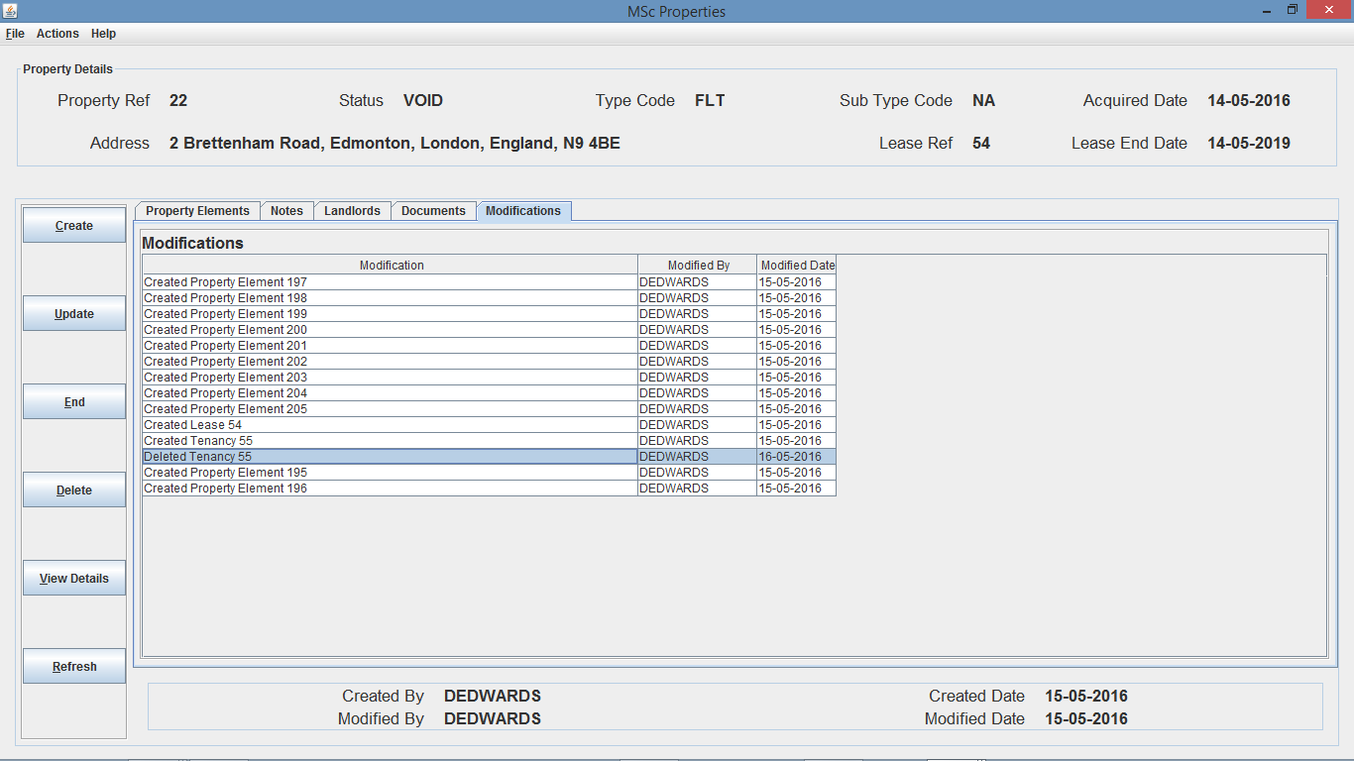

Fig. 108 – Property Details Screen - N.B. Status has been amended from “OCCP” back to “VOID” and the modifications have been created and stored against Property 22.

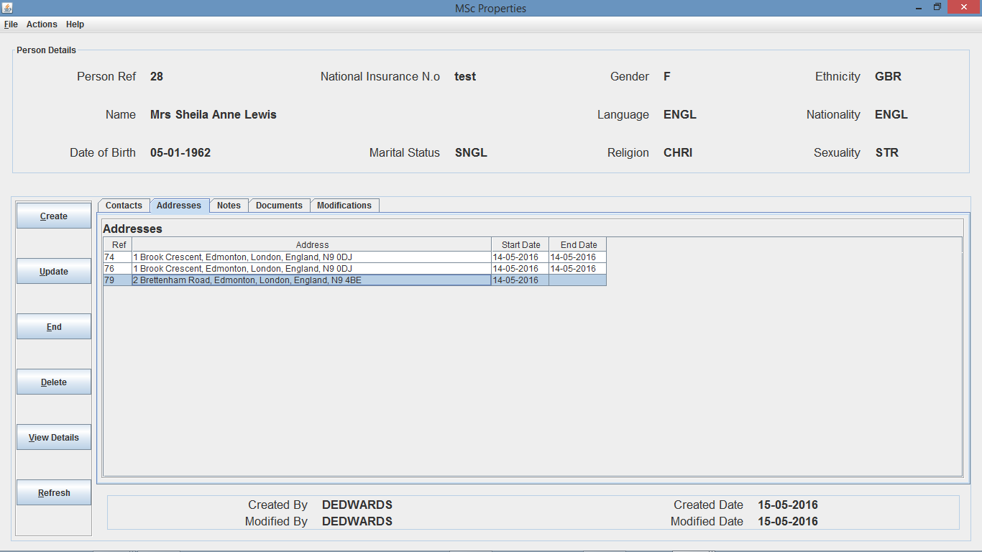

Fig. 109 – Person Details Screen - N.B. Unfortunately, the Tenancy address has not been updated, and is a bug with the roll back of person details after tenancy deletion.

My final test will be to attempt to delete a Tenancy that has been amended previously, so I decided to select Tenancy 53 as this was amended in a previous test.

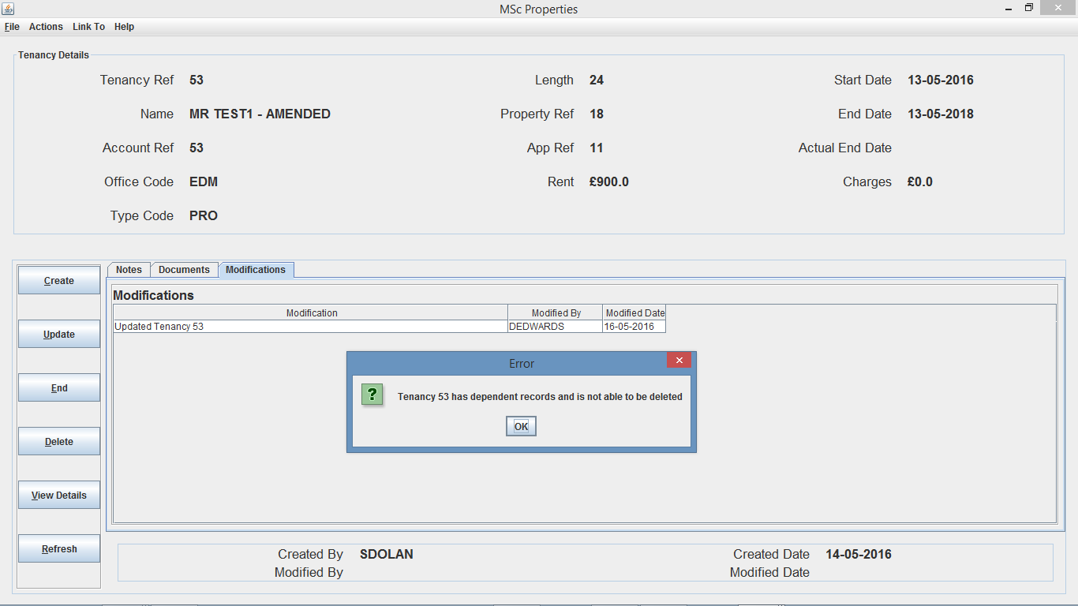

Fig. 110 – Tenancy 53 Deletion Dialog

As you can see from Fig. 110 when I attempted to delete Tenancy 53, an error dialog appeared stating that Tenancy 53 has dependent records and is not able to be deleted, this is because there are dependent modification records such as the amendment to the name and length record.

From the above tests, it shows that the Delete Tenancy function is nearly fully working as the requirements expect, however as shown in Fig. 93 the person addresses are not being updated correctly as they should.

1. **Search functionality**

As this system consists of managing a large amount of data for different types of objects such as applications, properties tenancies etc., this meant that search facility functionality was implemented to enable a user to search for system objects.

Because the system objects have a number of different data fields, an advanced search facility was implemented to enable users to search for system objects using a number of different data fields as the search criteria, but also a standard search facility was implemented to enable users to search for system objects using one data field as the search criteria.

* 1. **Standard Search**

For this test I decided to run tests on application searches for integer data, decimal data, string data, and date data and to do this I firstly run a blank advanced search on each of these to return the entire list of specific objects to determine the test data I am working with and then run some tests where I should bring back either no results, 1 result or multiple results, depending on the search criteria.

As you can see from Fig. 111 there is currently 12 applications, and I am able to perform a standard search under app ref, involved party ref and correspondence name. First I decided to perform a search under application ref, providing app ref 99, as you can see from Fig. 112 there was no results that returned, I then entered app ref -1, again no applications returned as shown in Fig. 113, next I entered app ref “text”, again no applications returned as shown in Fig. 114 and finally I entered 10, of which one app returned as shown in Fig. 115.

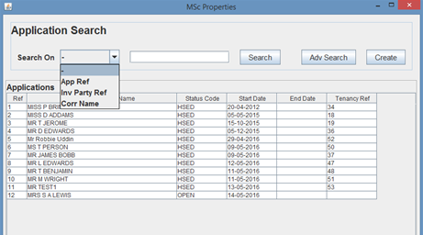Fig. 111 – Blank Advanced Search returning all Applications.

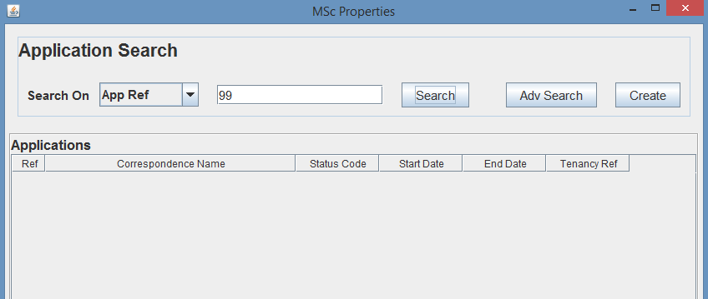

Fig. 112 – App Ref 99 Search Results

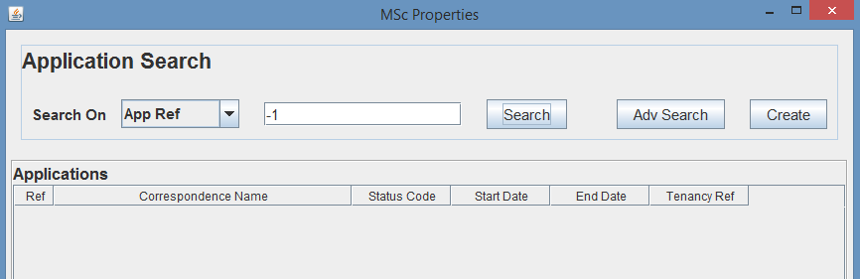

Fig. 113 – App Ref -1 Search Results

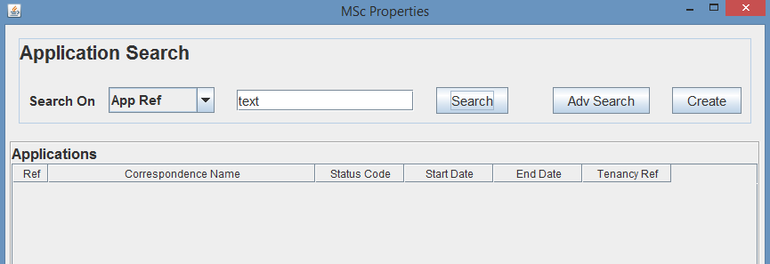

Fig. 114 – App Ref text Search Results

I then run a search on correspondence name, and because the search functionality is not case sensitive, it will allow me to search on string values that may not have identical case, but have the same characters within the string.

From the search results in Fig. 111 I decided to run a search on correspondence name, firstly entering “mr Edwards”, which should return no results, and as you can see from Fig. 115 there was no results returned. I then run a search on “Mr D EDWARds”, which should return 1 application for App Ref 4 and as you can see from Fig. 116 App Ref 12 returned, I then run another search on “mrs s a lewis”, which should return 1 application for App Ref 12, and as you can see from Fig. 117 App Ref 12 returned.

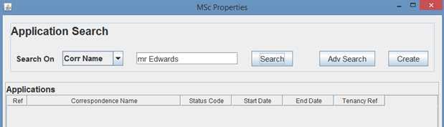

Fig. 115 – Corr Name “mr Edwards” Search Results

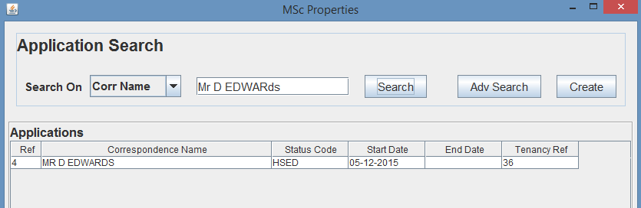

Fig. 116 – Corr Name “Mr D EDWARds” Search Results

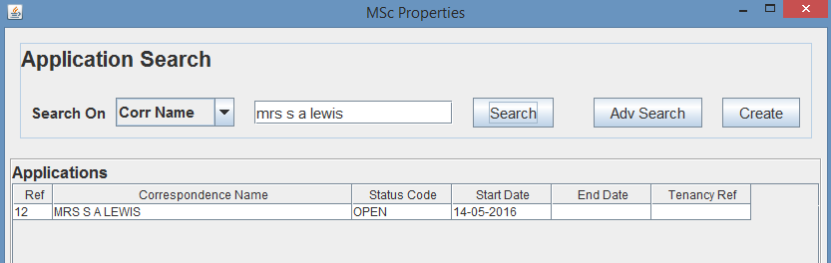

Fig. 117 – Corr Name “ms s a lewis” Search Results

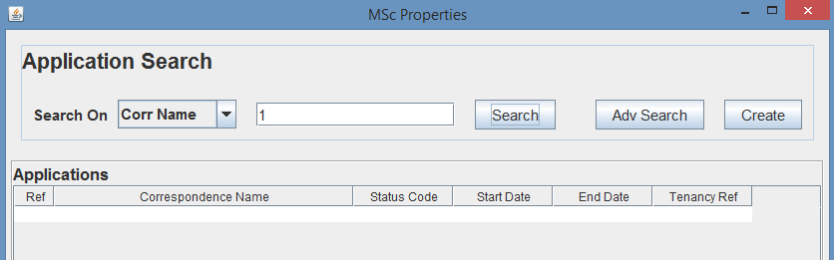

Fig. 118 – Corr Name ‘1’ Search Results

Finally, I searched on correspondence name searching for 1, which should return no results and as you can see from Fig. 118 no applications were returned.

* 1. **Advanced Search**

For this test I decided to run tests on application advanced searches for single, and multiple data search criteria’s, and to do this I firstly had to take a look at the data for each of the 12 applications to allow me to calculate the search results returned for advanced searches I will to perform for testing.

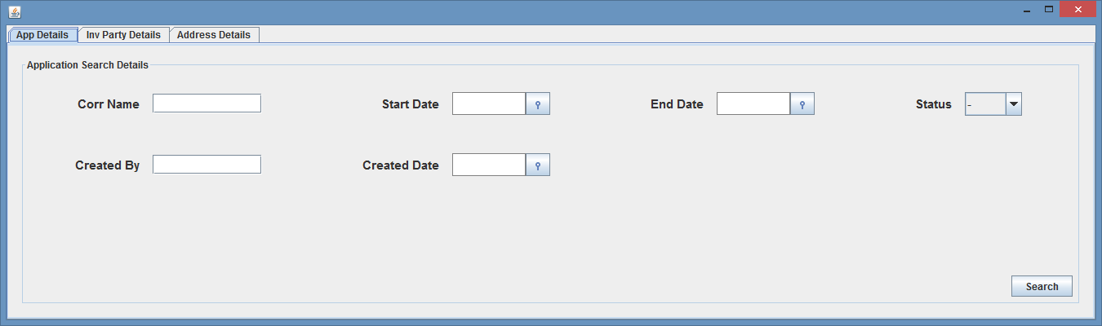Additionally, as you can see from Fig. 119, Fig. 120 and Fig. 121 there is 3 criteria (App, Involved Party and Address Details) in which an application advanced search can be performed under.

Fig. 119 – App Advanced Search Dialog (Application Details)

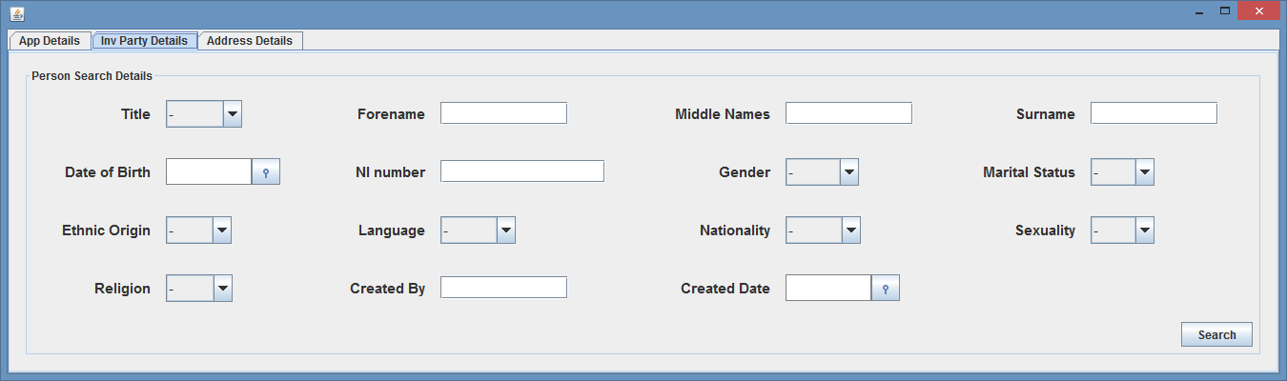

Fig. 120 – App Advanced Search Dialog (Involved Party Details)

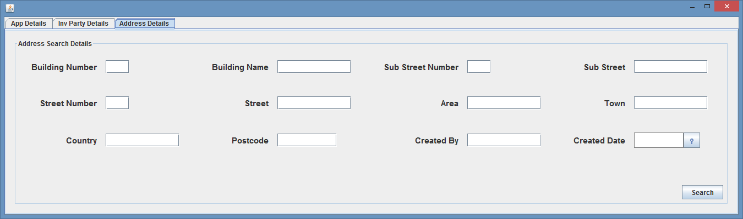

Fig. 121 – App Advanced Search Dialog (Address Details)

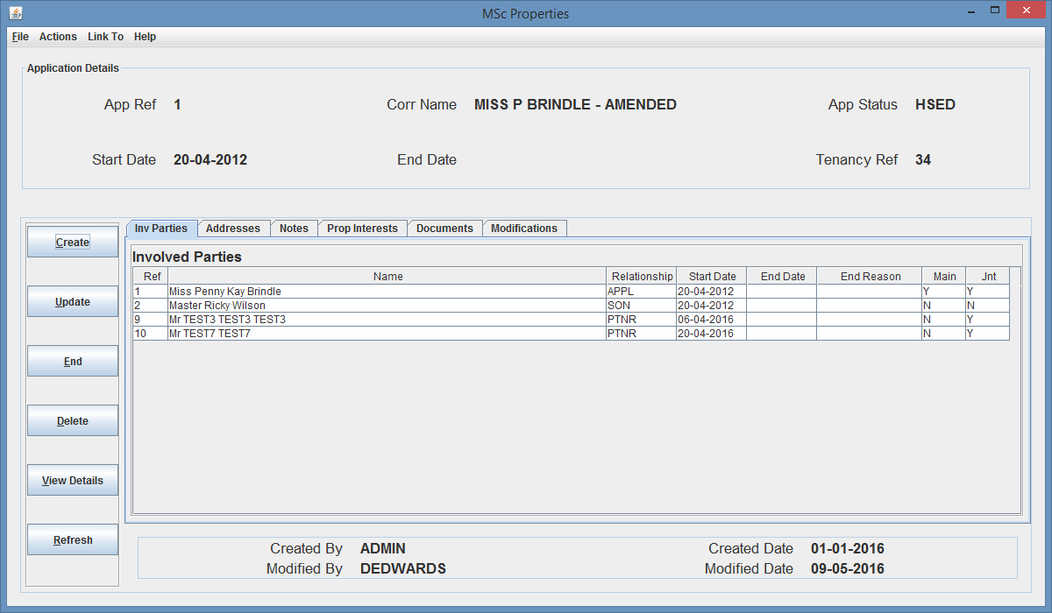

Fig. 122 – Application Details Screen (App Ref 1 on Involved Parties tab)

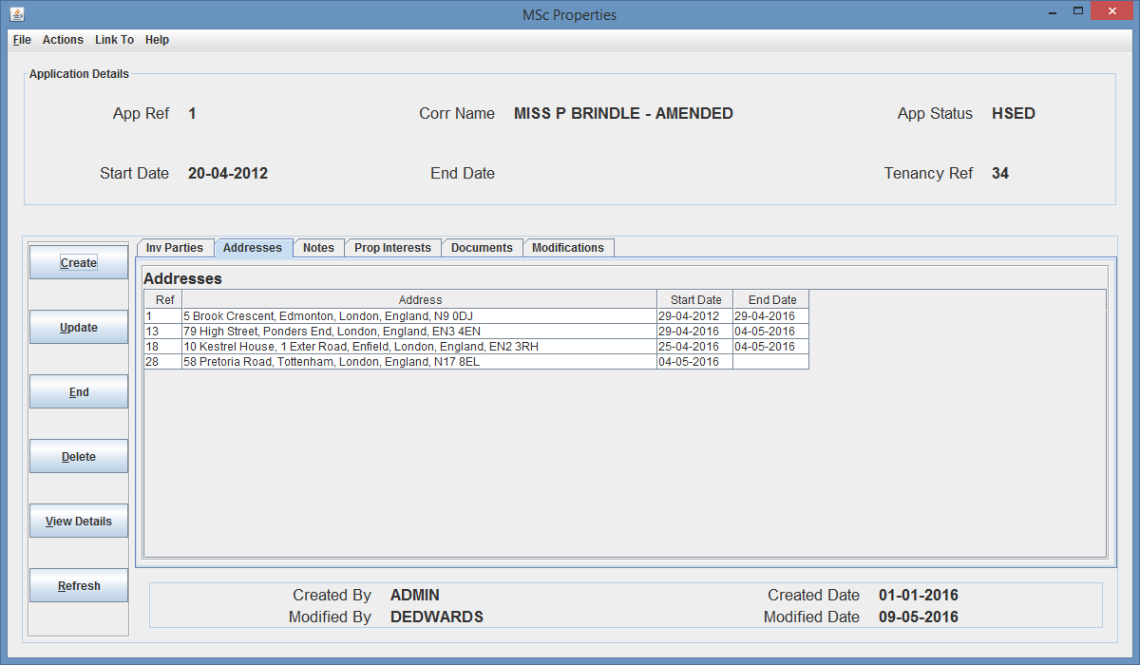

Fig. 123 – Application Details Screen (App Ref 1 on Addresses Parties tab)

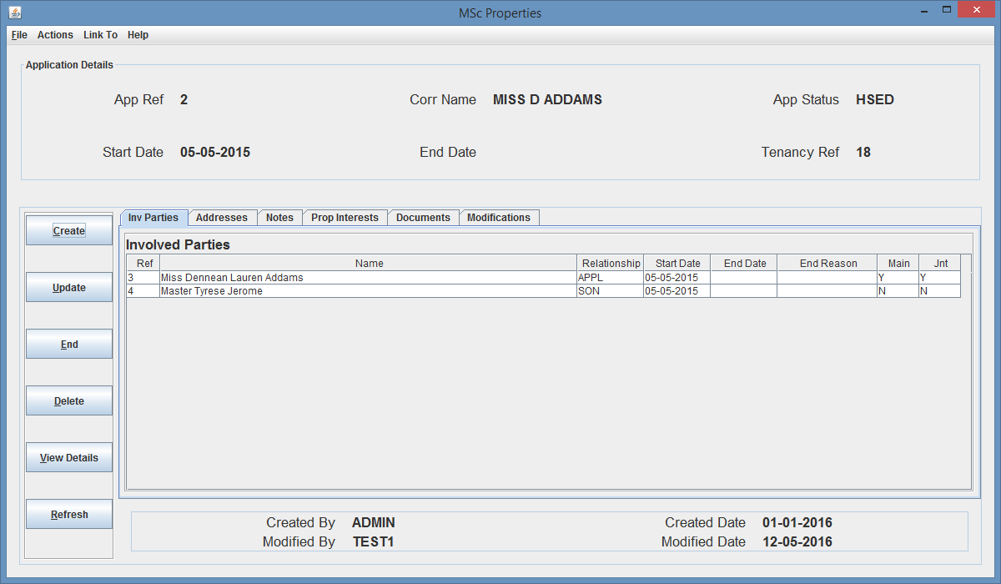

Fig. 124 – Application Details Screen (App Ref 2 on Involved Parties tab)

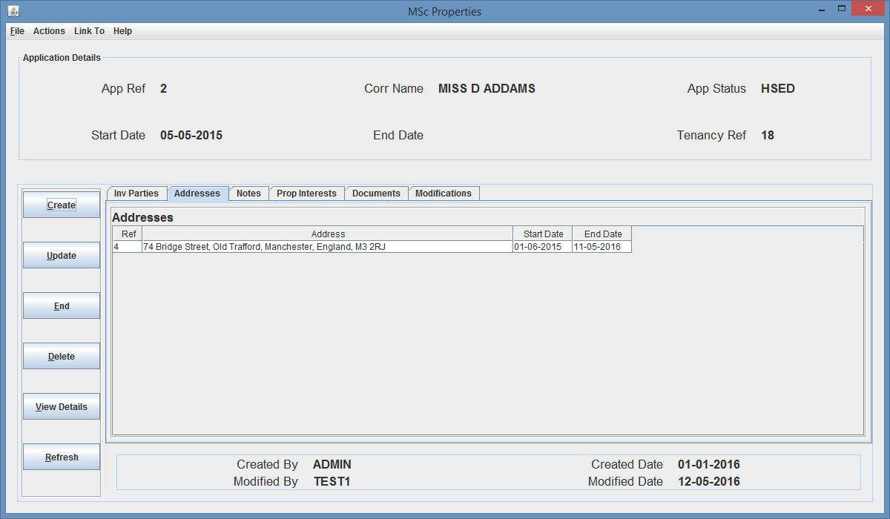

Fig. 125 – Application Details Screen (App Ref 2 on Addresses tab)

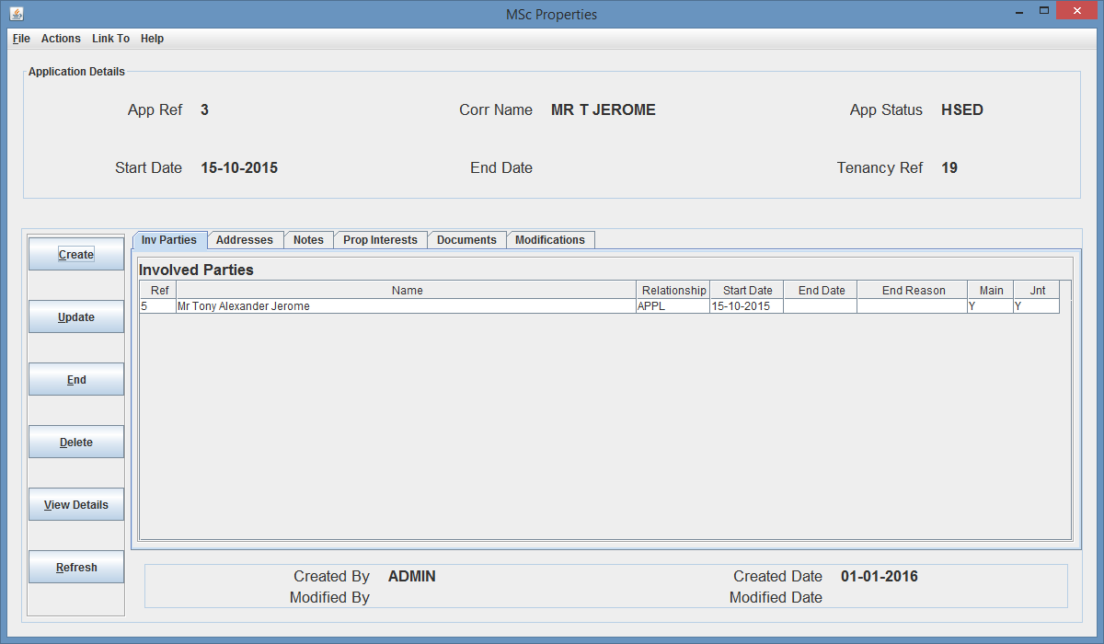

Fig. 126 – Application Details Screen (App Ref 3 on Involved Parties tab)

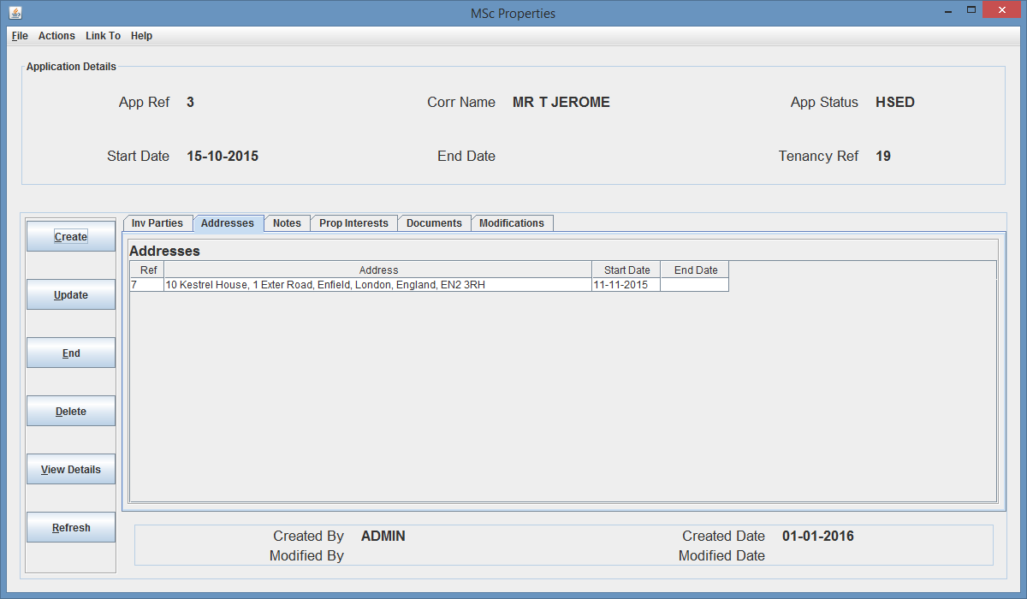

Fig. 127 – Application Details Screen (App Ref 4 on Addresses tab)

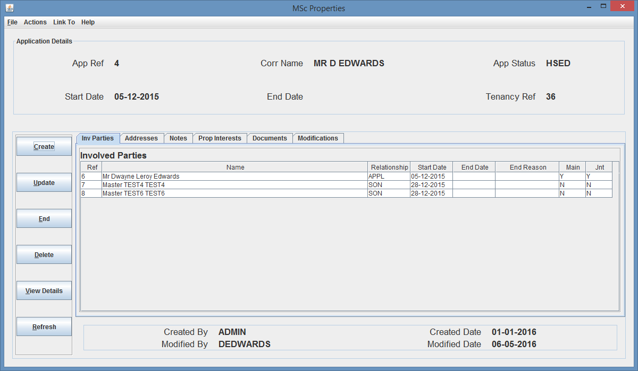

Fig. 128 – Application Details Screen (App Ref 4 on Involved Parties tab)

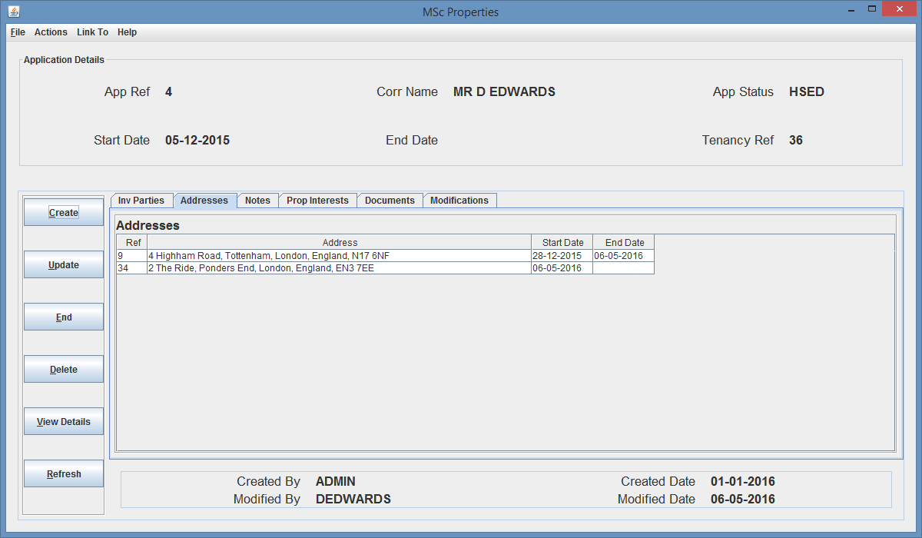

Fig. 129 – Application Details Screen (App Ref 4 on Addresses tab)

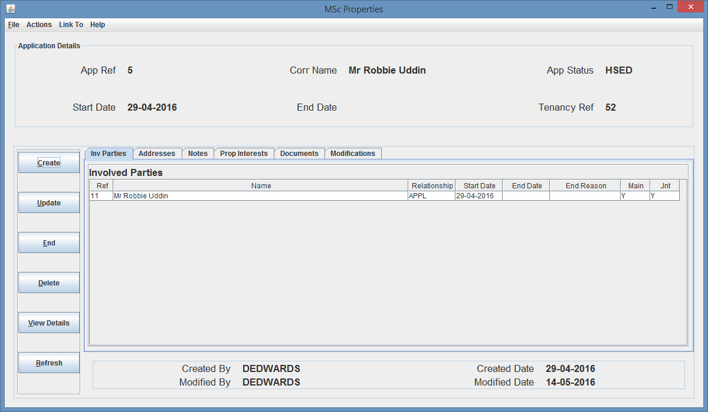

Fig. 130 – Application Details Screen (App Ref 5 on Involved Parties tab)

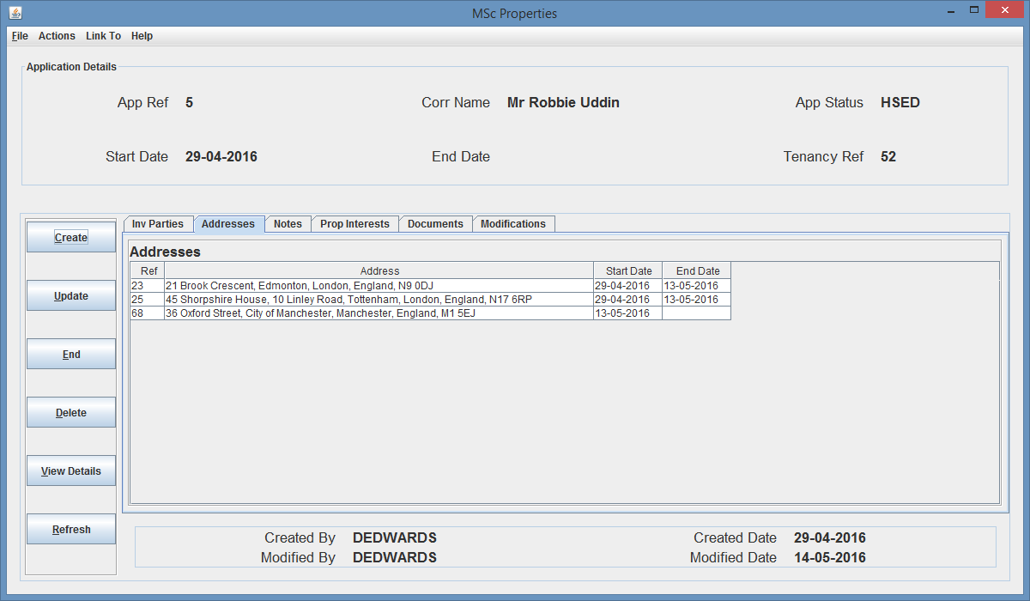

Fig. 131 – Application Details Screen (App Ref 5 on Addresses tab)

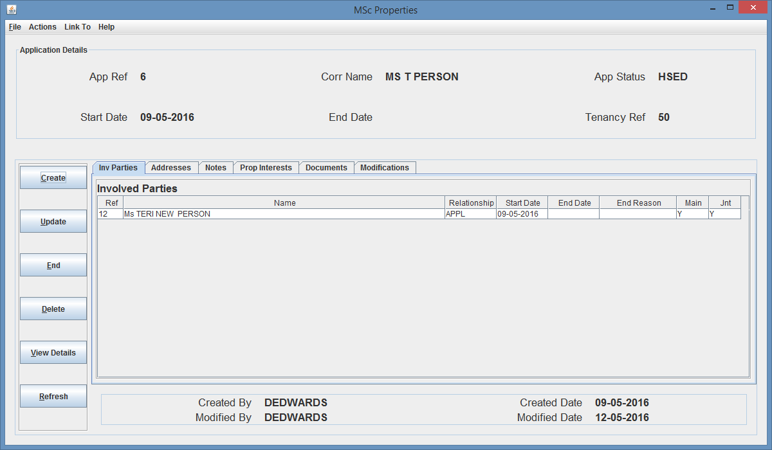

Fig. 132 – Application Details Screen (App Ref 6 on Involved Parties tab)

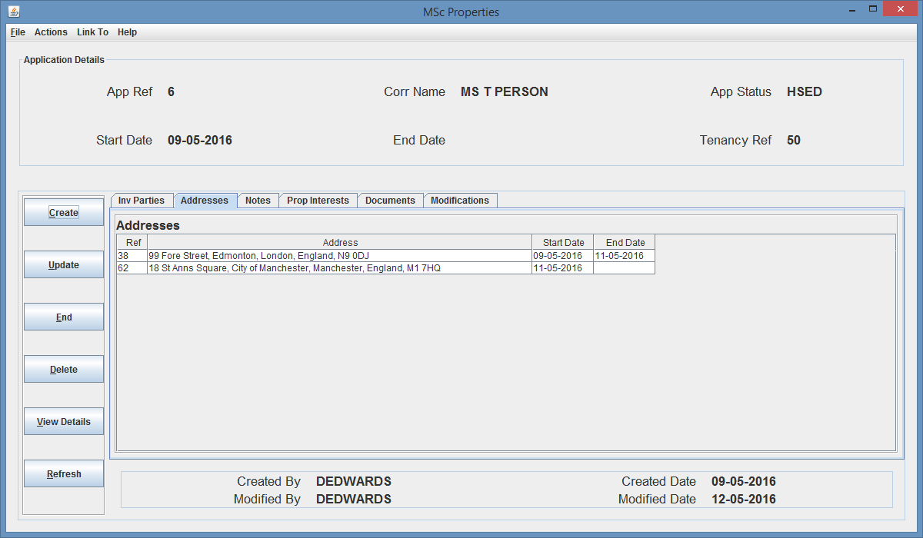

Fig. 133 – Application Details Screen (App Ref 6 on Addresses tab)

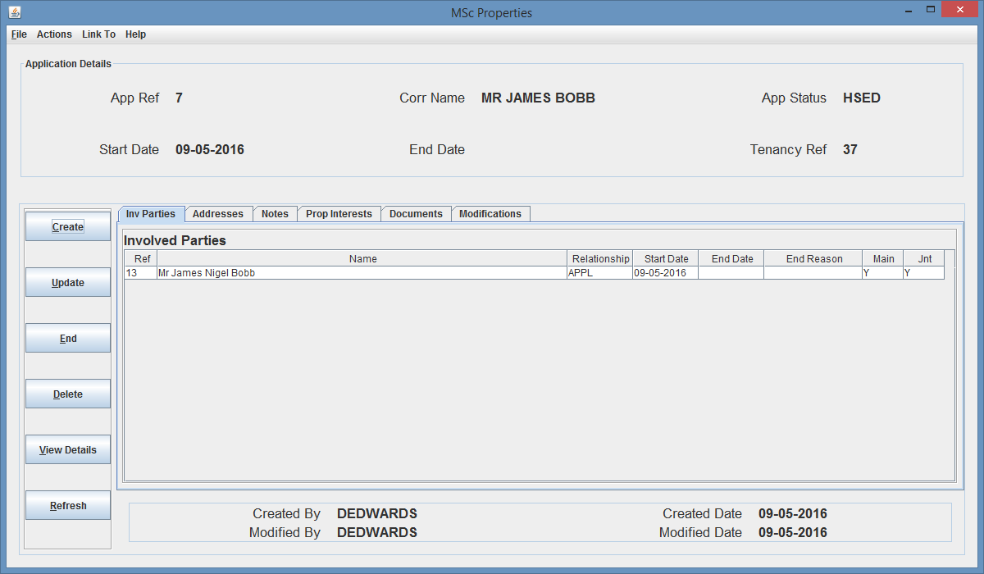

Fig. 134 – Application Details Screen (App Ref 7 on Involved Parties tab)

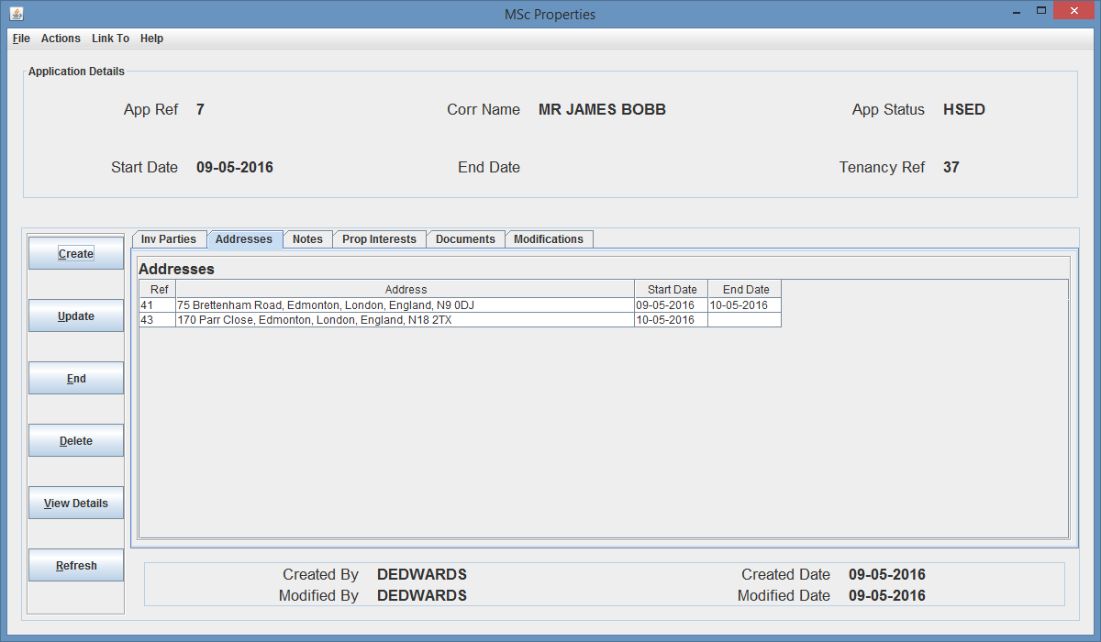

Fig. 135 – Application Details Screen (App Ref 7 on Addresses tab)

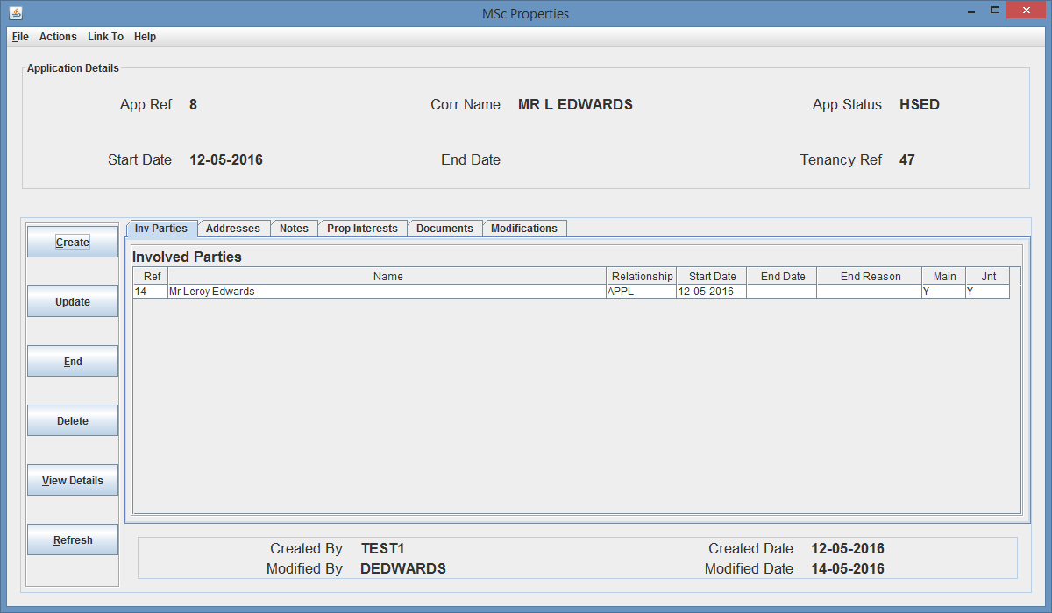

Fig. 136 – Application Details Screen (App Ref 8 on Involved Party tab)

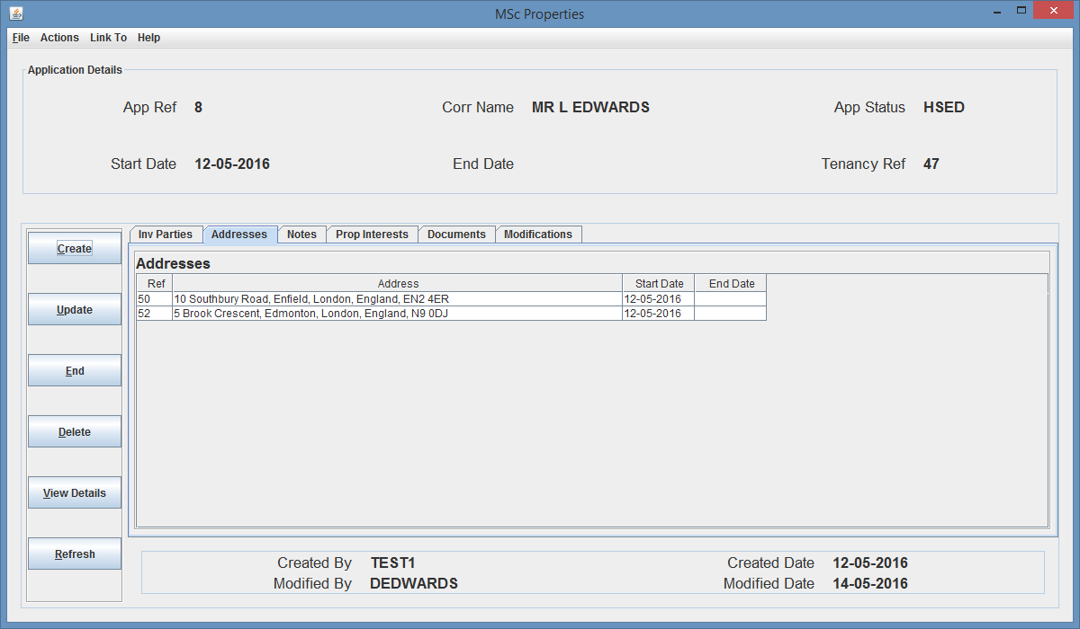

Fig. 137 – Application Details Screen (App Ref 8 on Addresses tab)

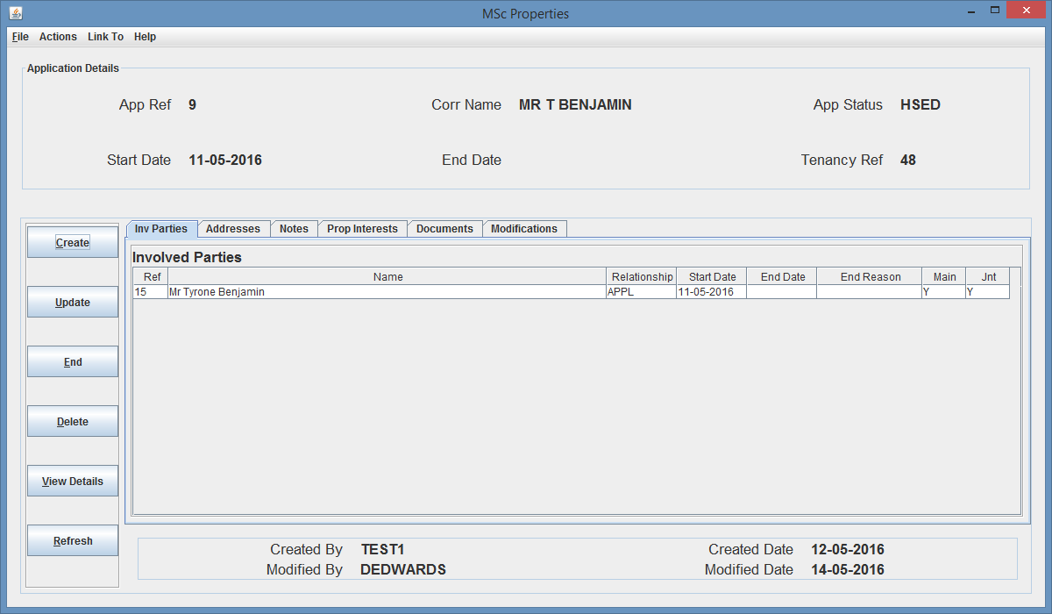

Fig. 138 – Application Details Screen (App Ref 9 on Involved Party tab)

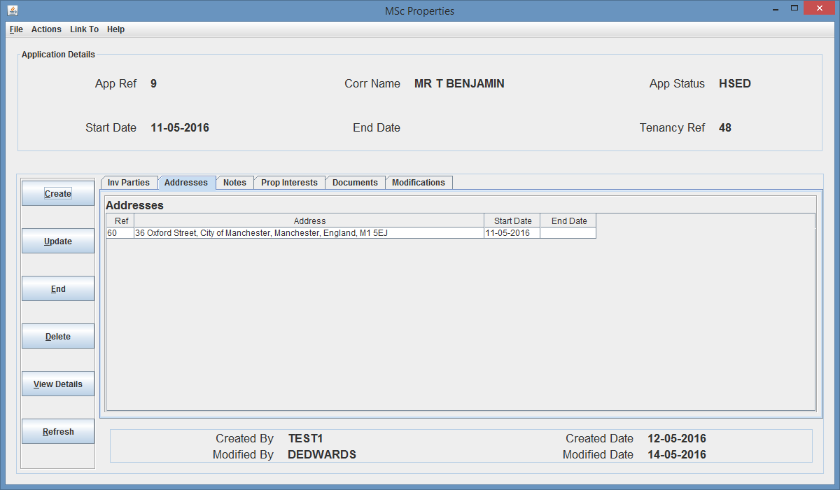

Fig. 139 – Application Details Screen (App Ref 9 on Addresses tab)

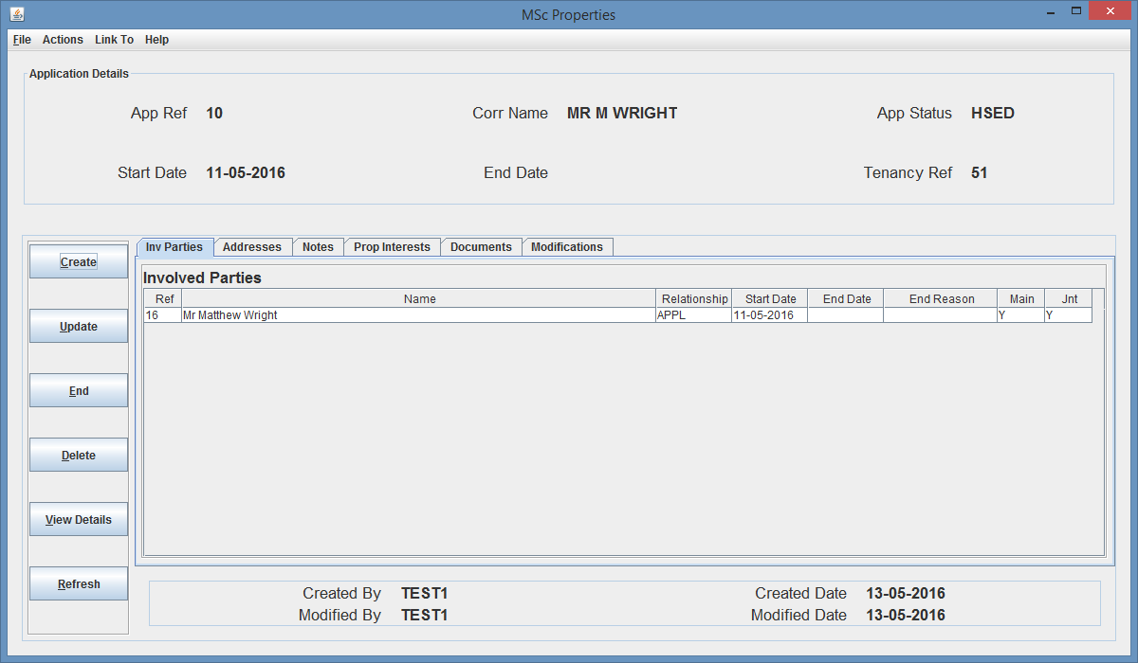

Fig. 140 – Application Details Screen (App Ref 10 on Involved Party tab)

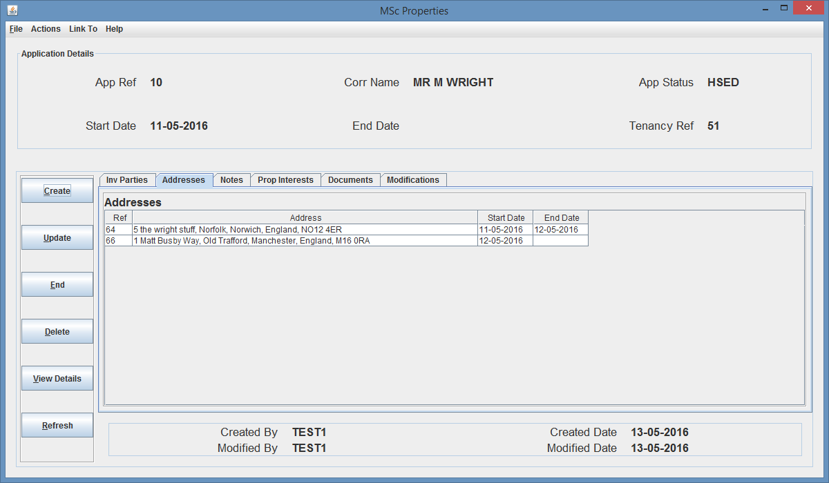

Fig. 141 – Application Details Screen (App Ref 10 on Addresses tab)

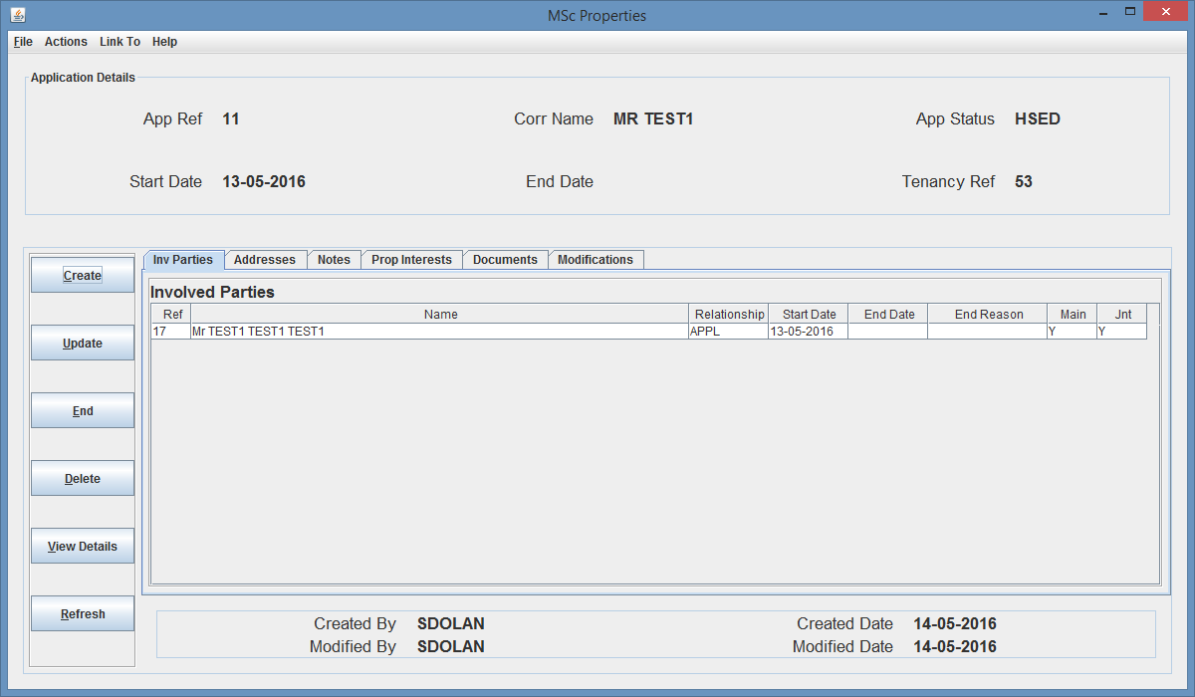

Fig. 142 – Application Details Screen (App Ref 11 on Involved Party tab)

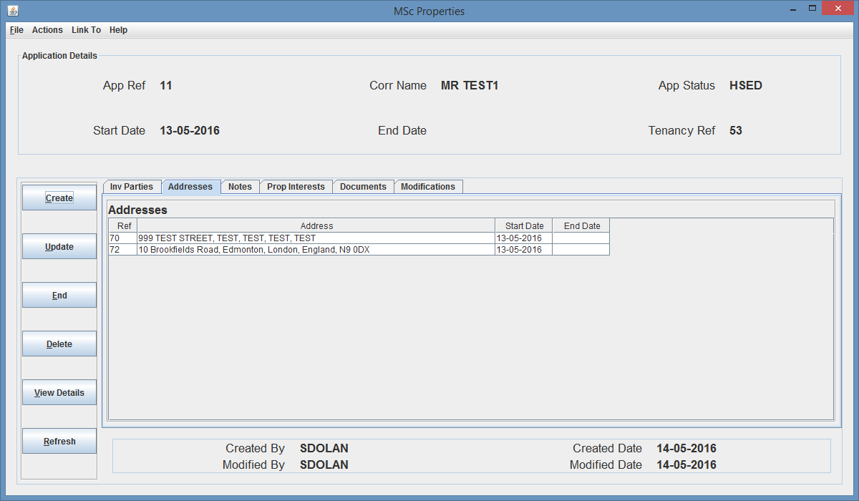

Fig. 143 – Application Details Screen (App Ref 11 on Addresses tab)

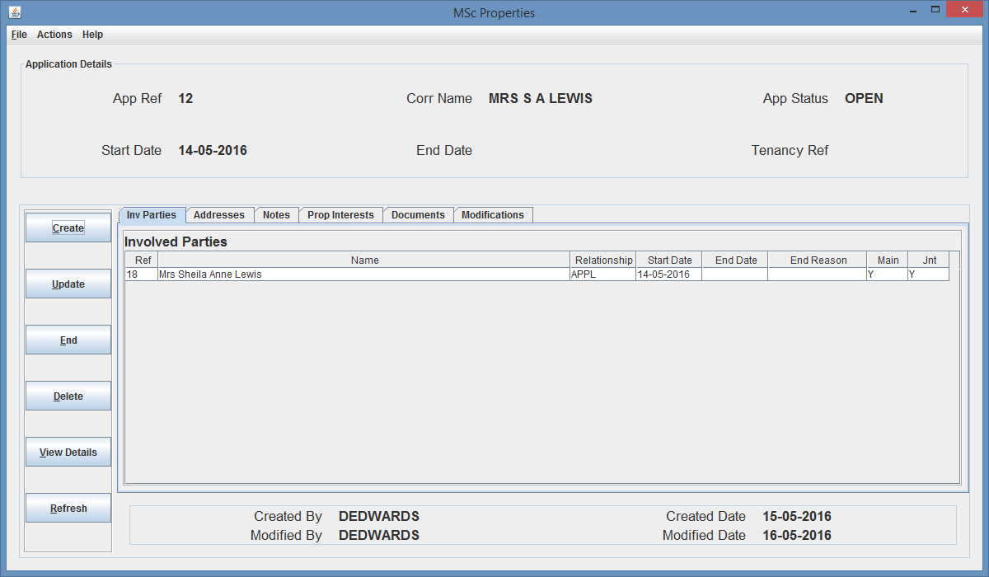

Fig. 144 – Application Details Screen (App Ref 12 on Involved Party tab)

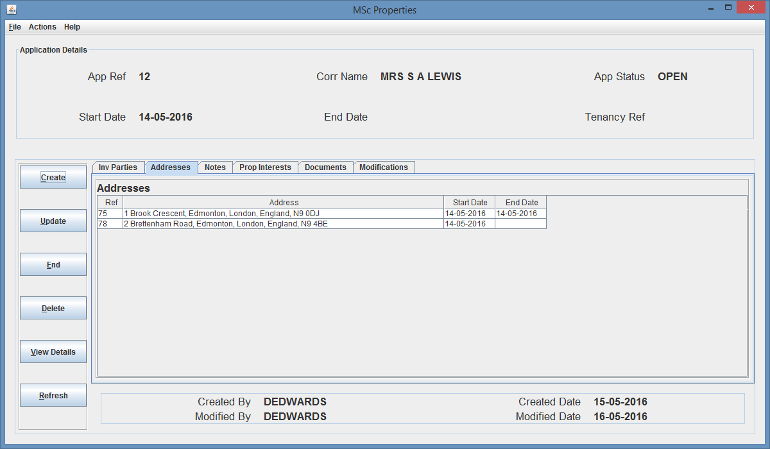

Fig. 145 – Application Details Screen (App Ref 12 on Addresses tab)

From analyzing the above figures I came up with the below test plan for the advanced search functionality test.

|  |  |  |  |  |
| --- | --- | --- | --- | --- |
| Test | Test Criteria | Test Value | Expected Outcome | Actual Outcome |
| 1 | Application Details | App Start Date: 09-05-2016 | Applications Returned: App Ref 6 and 7 | Applications Returned: App Ref 6 and 7  (Fig. 146) |
| 2 | App Start Date: 09-05-2016 Corr Name: ms p person | NO RESULTS | NO RESULTS  (Fig. 147) |
| 3 | App Start Date: 09-05-2016 Corr Name: ms t person | Applications Returned: App Ref 6 | Applications Returned: App Ref 6  (Fig. 148) |
| 4 | Status: HSED: CreatedBy: TEST1 Created Date: 12-05-2016 | Applications Returned: App Ref 8 and 9 | Applications Returned: App Ref 8 and 9  (Fig. 149) |
| 5 | Status: OPEN | Applications Returned: App Ref 12 | Applications Returned: App Ref 12  (Fig. 150) |
| 6 | Created By: DEDWARDS Created Date: 09-05-2016 | Applications Returned: App Ref 6 and 7 | Applications Returned: App Ref 6 and 7  (Fig. 151) |
| 7 | Created By: ADMIN | Applications Returned: App Ref 1, 2, 3 and 4 | Applications Returned: App Ref 1, 2, 3 and 4  (Fig. 152) |
| 8 | Created By: TEST1 | Applications Returned: App Ref 9, 10 and 8 | Applications Returned: App Ref 9, 10 and 8  (Fig. 153) |
| 9 | Created Date: 01-01-2016 | Applications Returned: App Ref 1 to 4 | Applications Returned: App Ref 1 to 4  (Fig. 154) |
| 10 | Blank Search | Applications Returned: App Ref 1 to 12 | Applications Returned: App Ref 1 to 12  (Fig. 155) |

|  |  |  |  |  |
| --- | --- | --- | --- | --- |
| Test | Test Criteria | Test Value | Expected Outcome | Actual Outcome |
| 11 | Involved Party Details | Surname: EDWARDS | Applications Returned: App Ref 4 and 8 | Applications Returned: App Ref 4 and 8  (Fig. 156) |
| 12 | Surname: 2 | NO RESULTS | NO RESULTS  (Fig. 157) |
| 13 | NI number: test | Applications Returned: App Ref 6, 8, 9 and 12 | Applications Returned: App Ref 6, 8, 9 and 12  (Fig. 158) |
| 14 | NI number: AA 11 22 33 A | Applications Returned: App Ref 1 | Applications Returned: App Ref 1  (Fig. 159) |
| 15 | Title: MR Language: ENGL createdBy: DEDWARDS | Applications Returned: App Ref 7 | Applications Returned: App Ref 7  (Fig. 160) |
| 16 | Language: ENGL Sexuality: STR Religion: PNTS | Applications Returned: App Ref 7, 8 and 9 | Applications Returned: App Ref 7, 8 and 9  (Fig. 161) |
| 17 | Title: MRS | Applications Returned: App Ref 12 | Applications Returned: App Ref 12  (Fig. 162) |
| 18 | Title: OTHER | NO RESULTS | NO RESULTS  (Fig. 163) |
| 19 | Language: GRMN | Applications Returned: App Ref 6 | Applications Returned: App Ref 6  (Fig. 164) |
| 20 | Blank Search | Applications Returned: App Ref 1 to 12 | Applications Returned: App Ref 1 to 12  (Fig. 165) |

|  |  |  |  |  |
| --- | --- | --- | --- | --- |
| Test | Test Criteria | Test Value | Expected Outcome | Actual Outcome |
| 21 | Address Details | Area: edmonton | Applications Returned: App Ref 1, 5, 6, 7, 8, 11, and 12 | Applications Returned: App Ref 1, 5, 6, 7, 8, 11, and 12  (Fig. 166) |
| 22 | Area: ENFIELD | Applications Returned: App Ref 3 and 1 | Applications Returned: App Ref 3 and 1  (Fig. 167) |
| 23 | Town: LonDon | Applications Returned: App Ref 1, 3, 4, 5, 6, 7, 8, 11 and 12 | Applications Returned: App Ref 1, 3, 4, 5, 6, 7, 8, 11 and 12  (Fig. 168) |
| 24 | Town: Manchester | Applications Returned: App Ref 2, 5, 6, 9 and 10 | Applications Returned: App Ref 2, 5, 6, 9 and 10  (Fig. 169) |
| 25 | Town: Londin | NO RESULTS | NO RESULTS  (Fig. 170) |
| 26 | Street Number 1: | Applications Returned: App Ref 1, 3, and 10 | Applications Returned: App Ref 1, 3, and 10  (Fig. 171) |
| 27 | Town: London streetNumber: 2 createdBy: ADMIN | Applications Returned: App Ref 4 | Applications Returned: App Ref 4  (Fig. 172) |
| 28 | Town: London streetNumber: 2 | Applications Returned: App Ref 4 and 12 | Applications Returned: App Ref 4 and 12  (Fig. 173) |
| 29 | Town: England Area: Edmonton Created By: DEDWARDS | Applications Returned: App Ref 5, 6, 7, 11, and 12 | Applications Returned: App Ref 5, 6, 7, 11, and 12  (Fig. 174) |
| 30 | Blank Search | Applications Returned: App Ref 1 to 12 | Applications Returned: App Ref 1 to 12  (Fig. 175) |

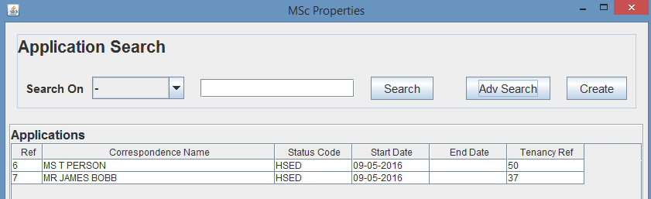

Fig. 146 – Test 1 Search Results

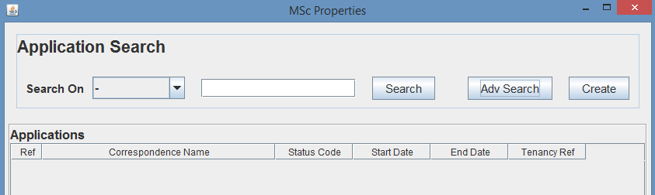

Fig. 147 – Test 2 Search Results

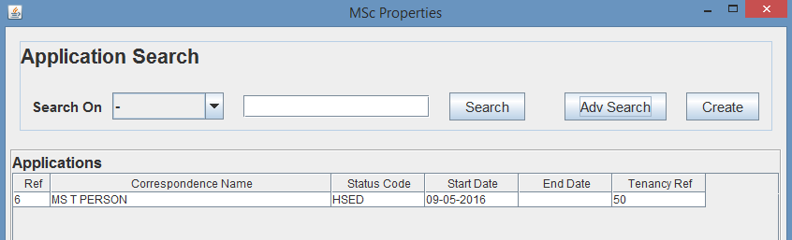

Fig. 148 – Test 3 Search Results

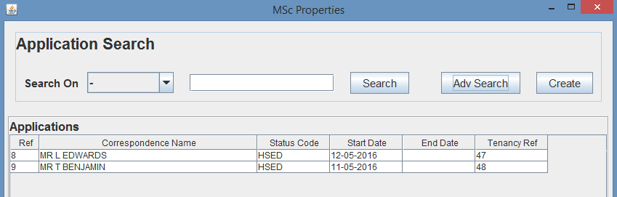

Fig. 149 – Test 4 Search Results

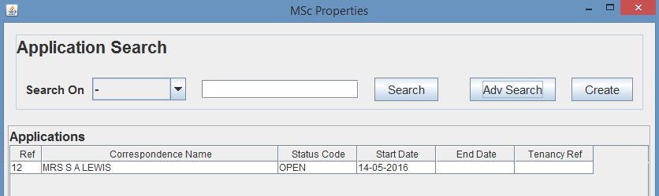

Fig. 150 – Test 5 Search Results

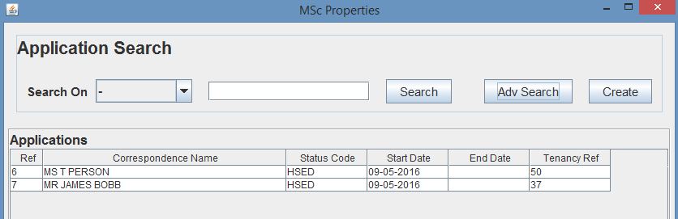

Fig. 151 – Test 6 Search Results

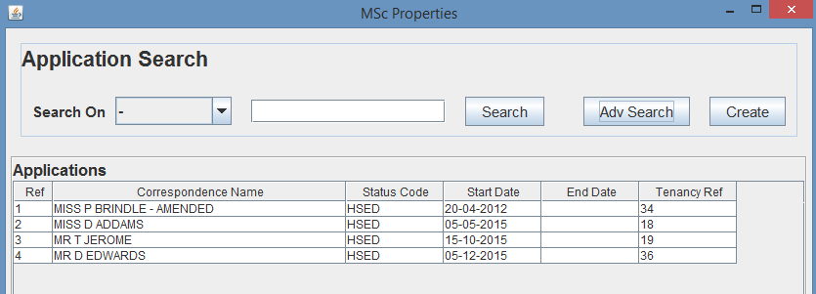

Fig. 152 – Test 7 Search Results

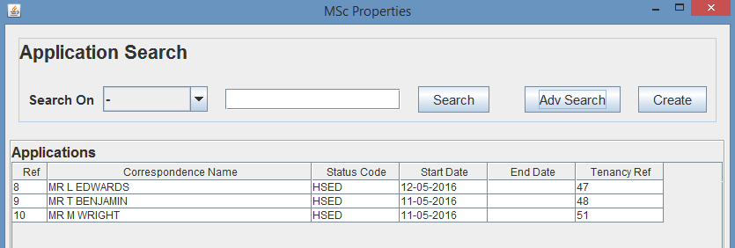

Fig. 153 – Test 8 Search Results



Fig. 154 – Test 9 Search Results

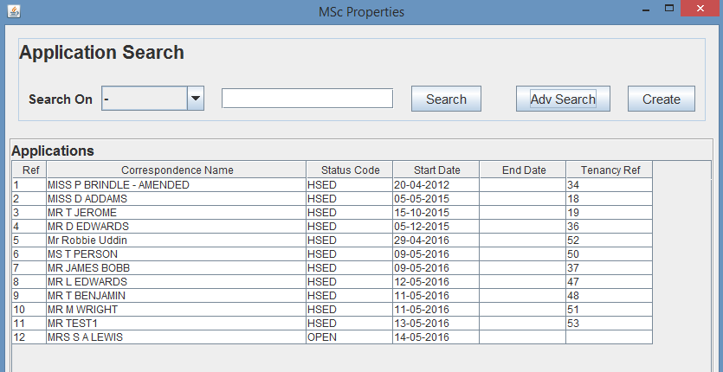

Fig. 155 – Test 10 Search Results

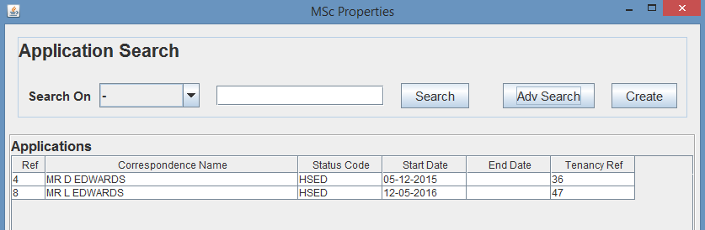

Fig. 156 – Test 11 Search Results

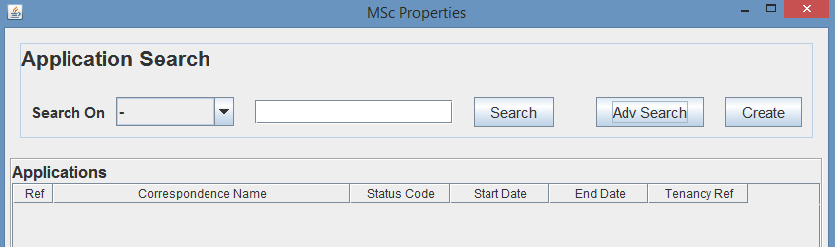

Fig. 157 – Test 12 Search Results

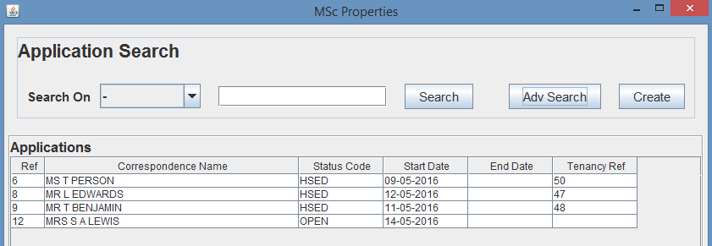

Fig. 158 – Test 13 Search Results

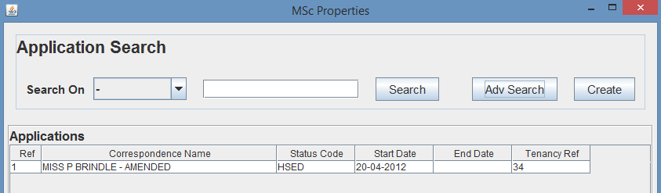

Fig. 159 – Test 14 Search Results

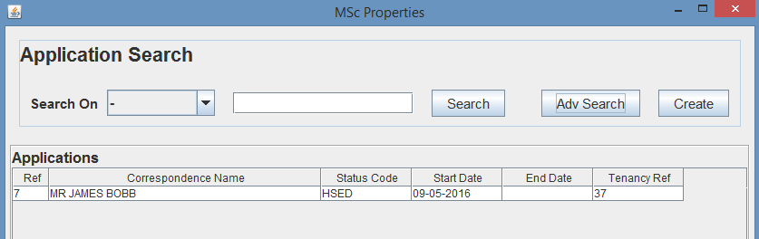

Fig. 160 – Test 15 Search Results

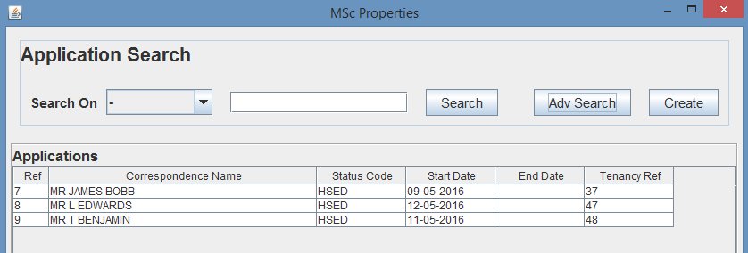

Fig. 161 – Test 16 Search Results

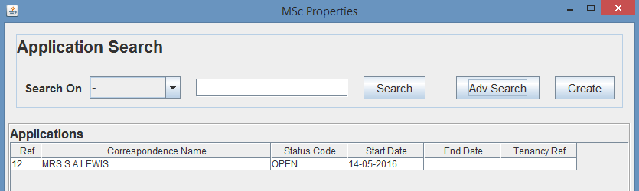

Fig. 162 – Test 17 Search Results

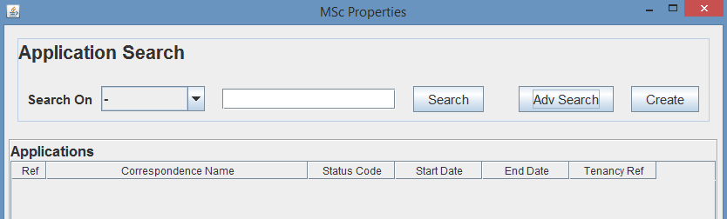

Fig. 163 – Test 18 Search Results

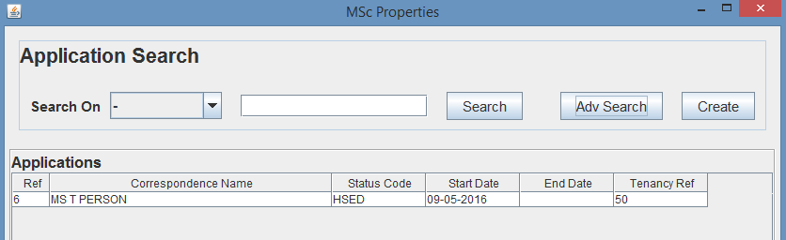

Fig. 164 – Test 19 Search Results

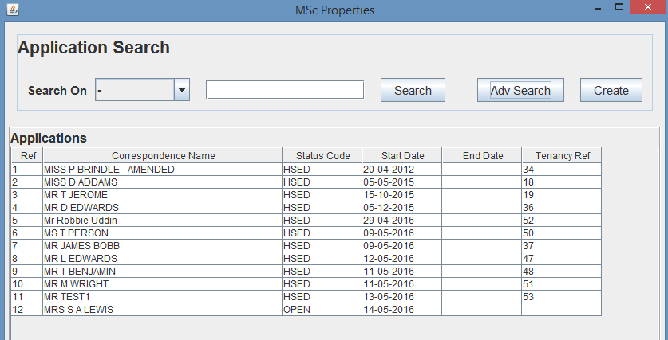

Fig. 165 – Test 20 Search Results

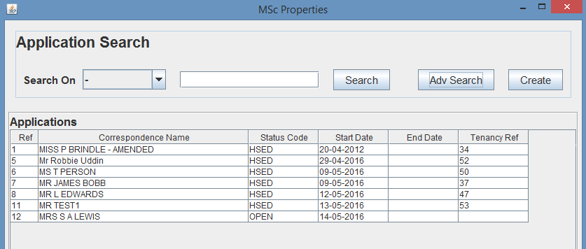

Fig. 166 – Test 21 Search Results

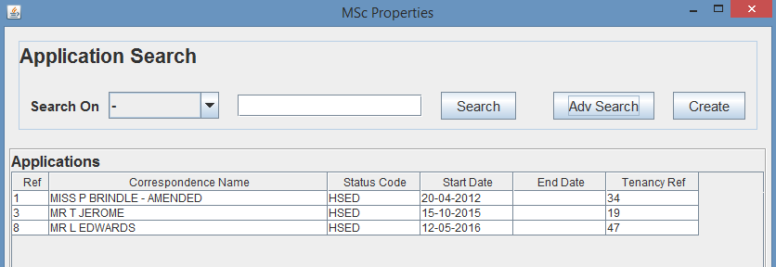

Fig. 167 – Test 22 Search Results

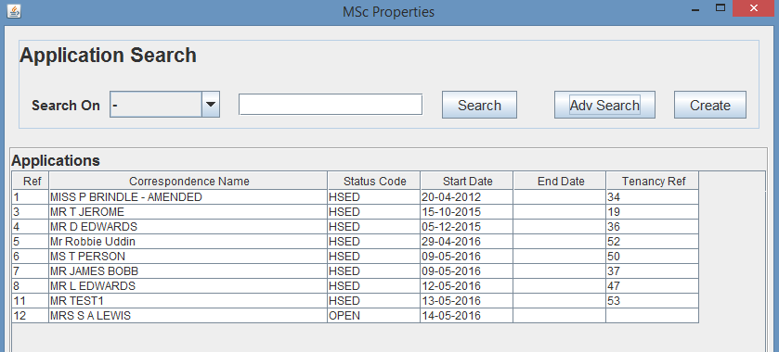

Fig. 168 – Test 23 Search Results

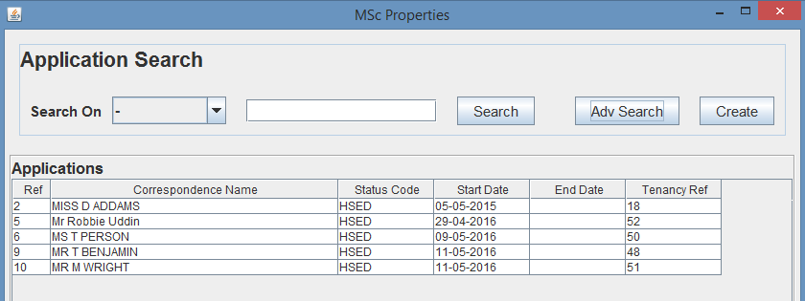

Fig. 169 – Test 24 Search Results

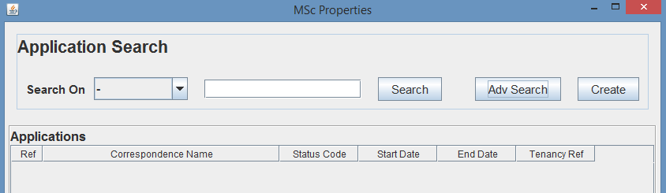

Fig. 170 – Test 25 Search Results

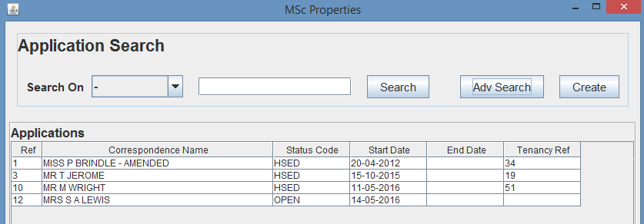

Fig. 171 – Test 26 Search Results

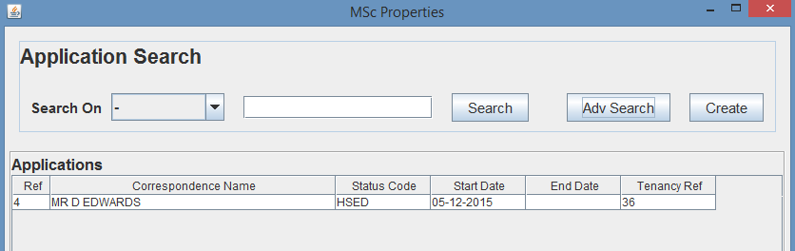

Fig. 172 – Test 27 Search Results

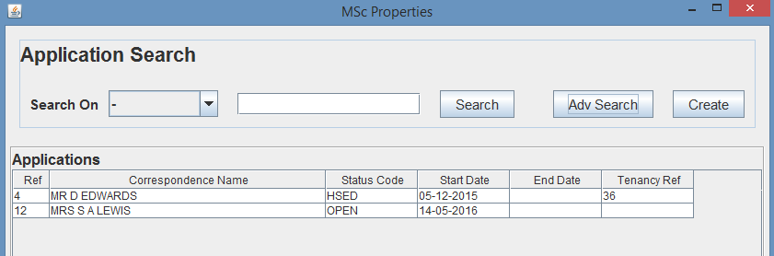

Fig. 173 – Test 28 Search Results

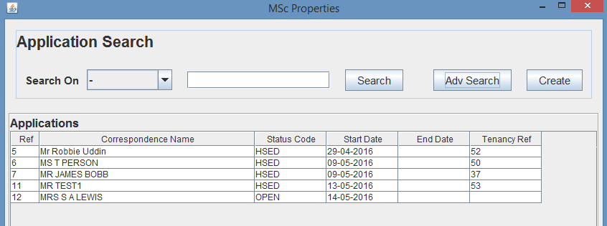

Fig. 174 – Test 29 Search Results

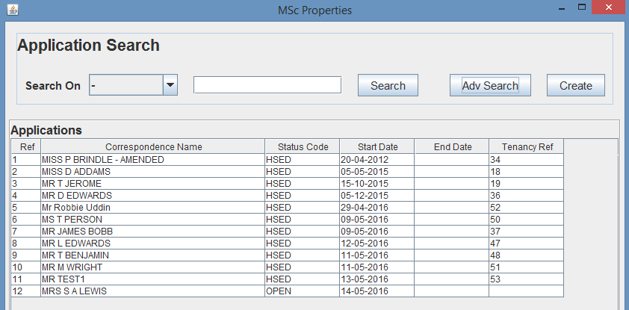

Fig. 175 – Test 30 Search Results

As you can see from the above testing, both the standard and advanced search functionality is working as it should, returning the expected results, meaning that the search functionality is working as expected.

1. **Reporting Functionality**

As explained within the report, one of the system functions is to be able to run reporting functionality on ‘MSc Properties’ data, producing reports of collated information, depending on supplied parameter values, such as employee, office from date and between dates.

As you can see from Fig. 226, the reporting functionality was implemented and provides a number of reporting options such as get tenancies, leases or contracts by employee or office, get expenditure, revenue or profit for an office or overall, and generating reports for and employee, office, or overall, for tenancies, leases and contracts and corresponding account transactions for any given date period.

When a user selects a report type from the reporting panel on the left of the screen, the reporting data entry panel should open in the panel on the right of the screen. Depending on the report type selected, will determine what data needs to be entered, and additionally, will prevent data entry into fields that are not required for that report type. For example, the get tenancies by employee data entry form must only allow the from date, to date and employee ref, whereas the generate report data entry form must only allow the from date and to date.

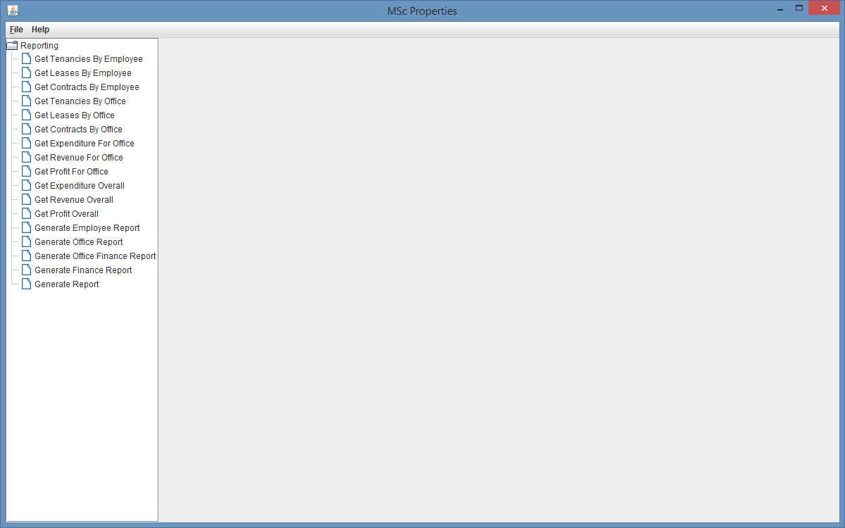

Fig. 226 – Reporting Screen

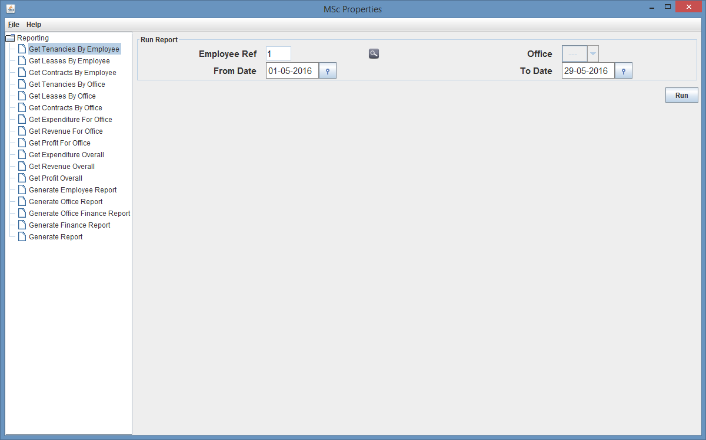

Fig. 227 – Reporting Screen – Get Tenancies By Employee Report

As you can see from Fig. 227, the office drop down box is greyed out meaning the user is unable to select an office, but the user is able to search for an employee, select the from date and select the to date. Once the user clicks run, the system should calculate the tenancies the employee has created of which their start dates are between (inclusive) the dates entered.

As you can see from Fig. 228, the tenancies created by the employee entered, with start dates between the given dates, however the user should now be able to select another report and although the new data entry form opens, the data entry form is not preventing incorrect data from being input and additionally, when the report is run, the correct data is not passed back as you can see from Fig. 229 and Fig. 230.

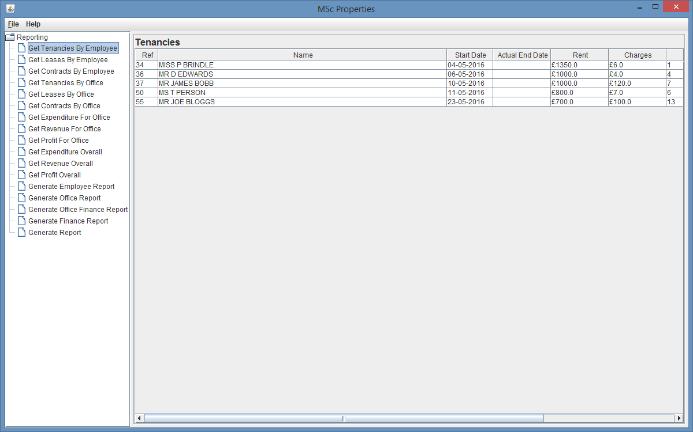

Fig. 228 – Reporting Screen Results

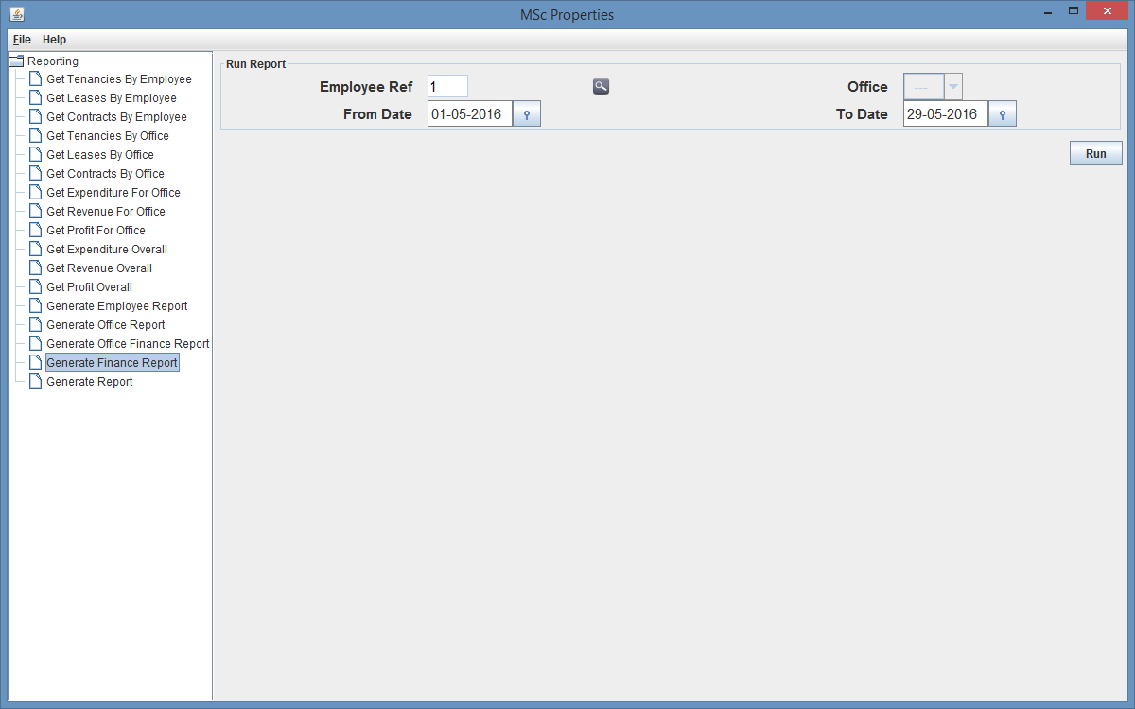

Fig. 229 – Reporting Screen – After Report has already been run, trying to run a different report – Generate Finance Report

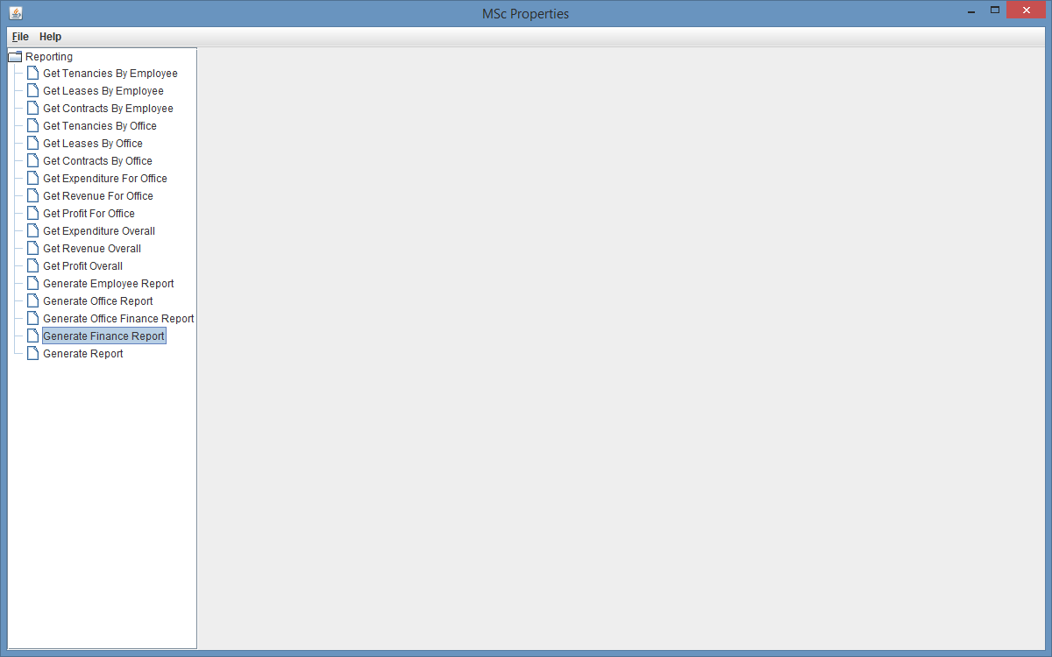

Fig. 230 – Reporting Screen – After trying to run Generate Finance Report

Although there are some errors with the reporting functionality graphical user interface. If the user goes back to the home screen and opens another reporting screen, the user is still able to run any of the reports and they bring back the correct results as shown below.

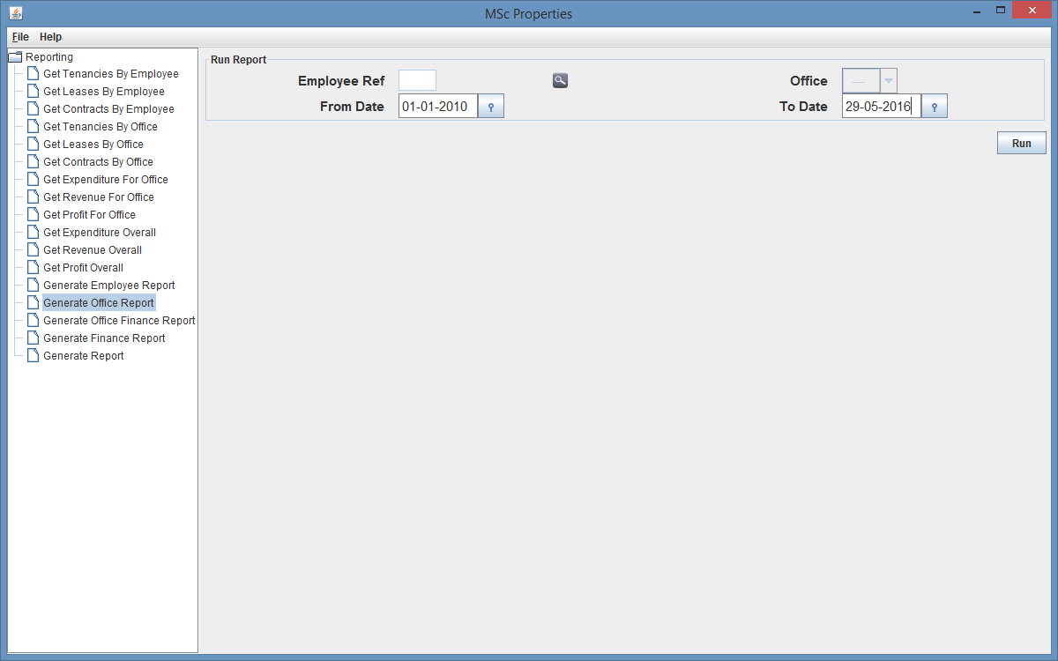

Fig. 231 – Generate Office Report

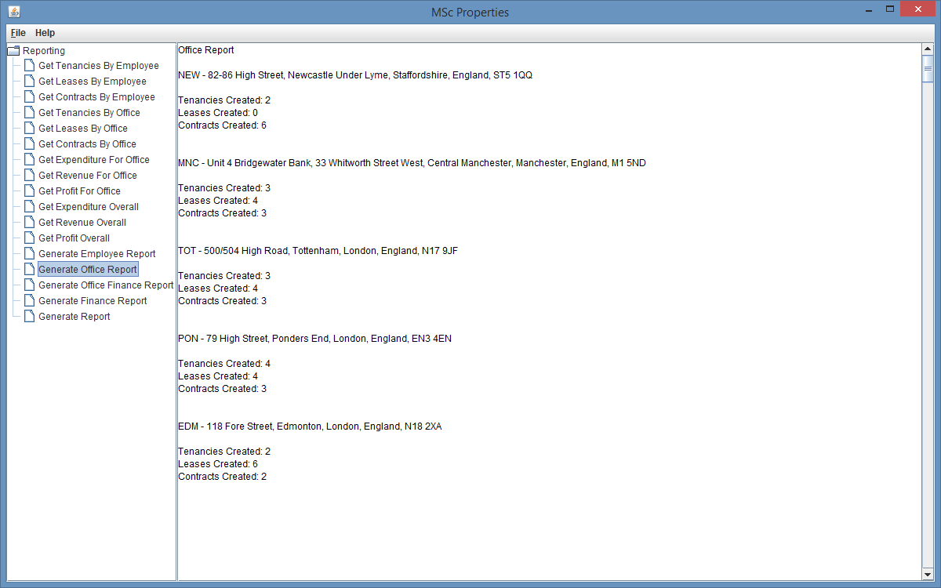

Fig. 232 – Generate Office Report Results

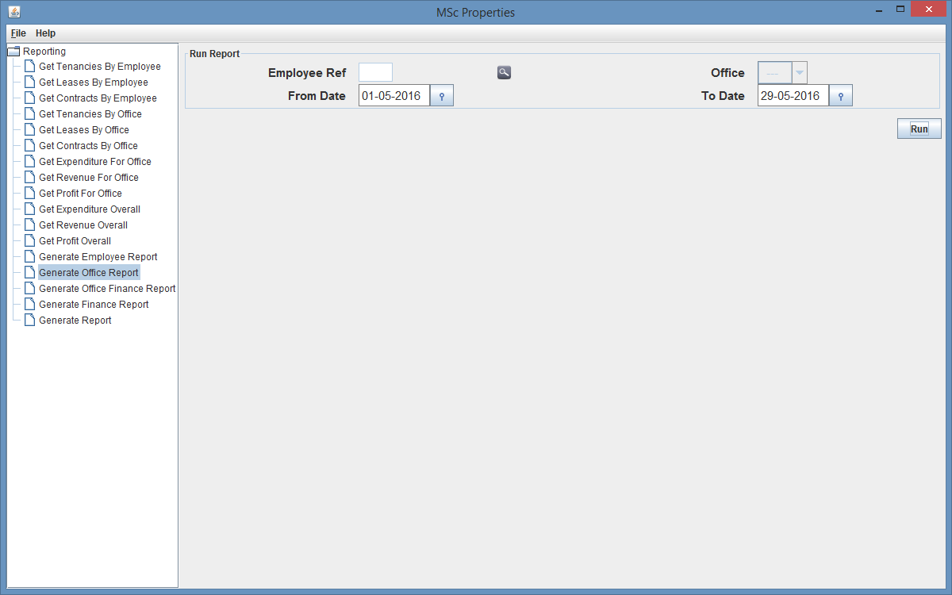

Fig. 233 – Generate Office Report

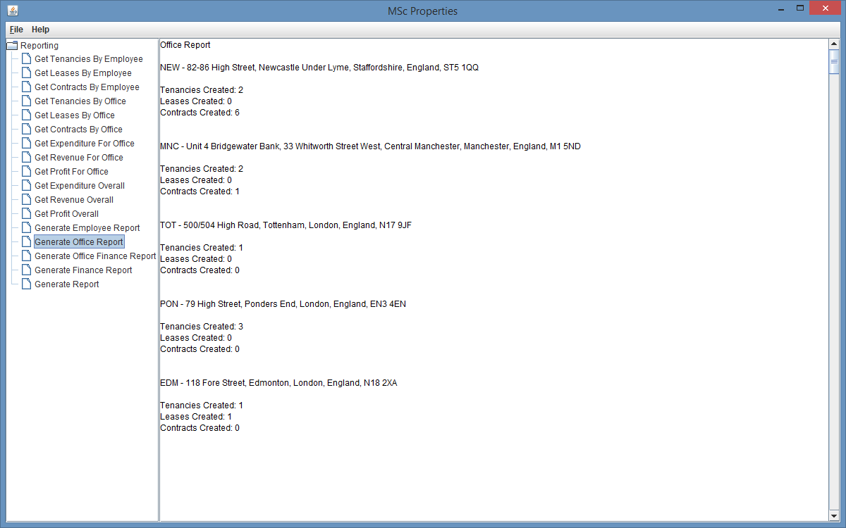

Fig. 234 – Generate Office Report Results

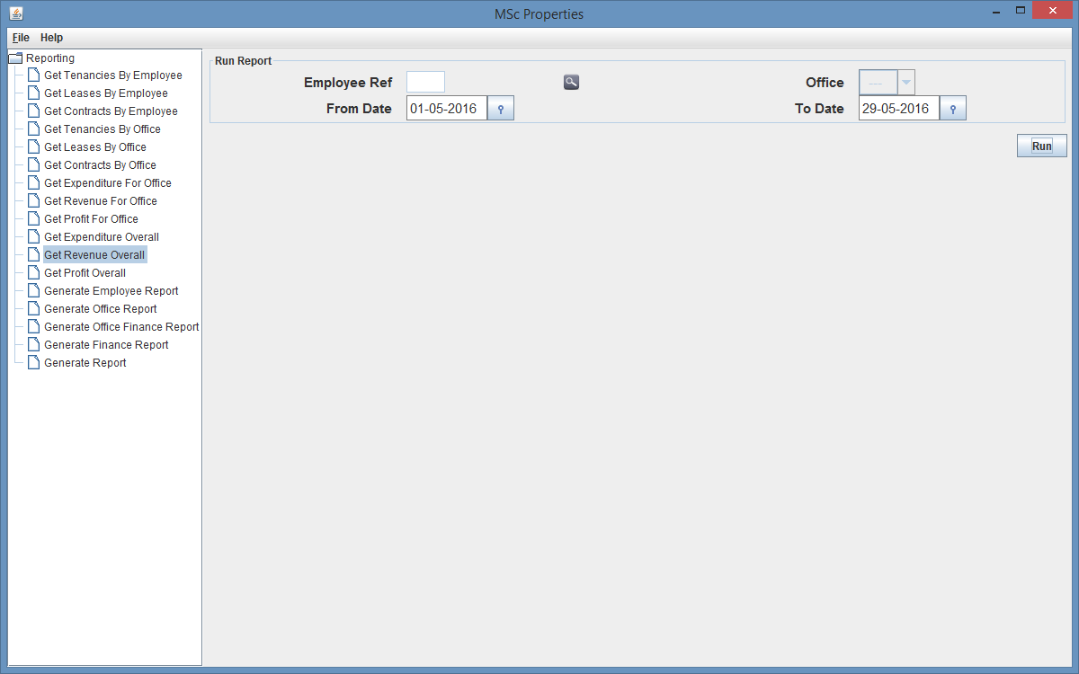

Fig. 235 – Get Revenue Overall

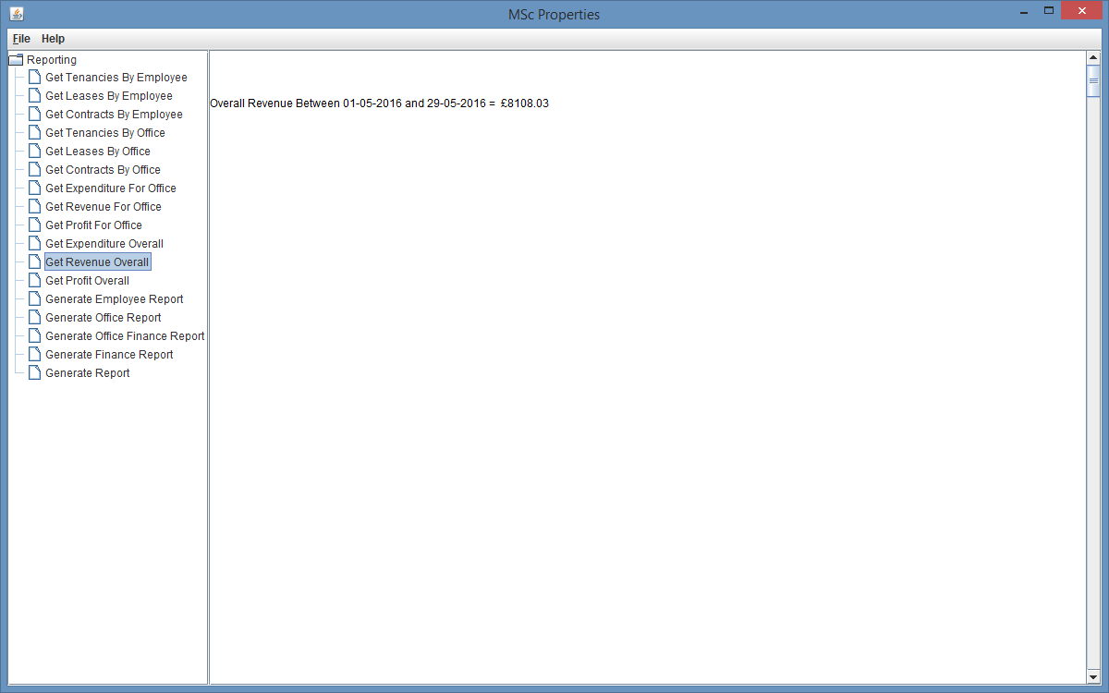

Fig. 236 – Get Revenue Overall Results

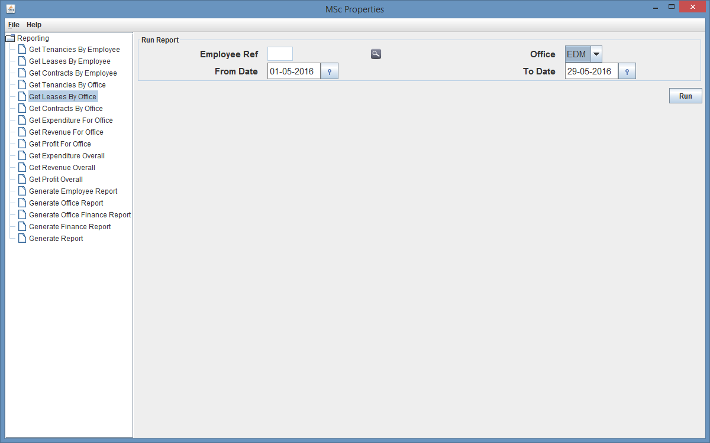

Fig. 237 – Get Leases By Office

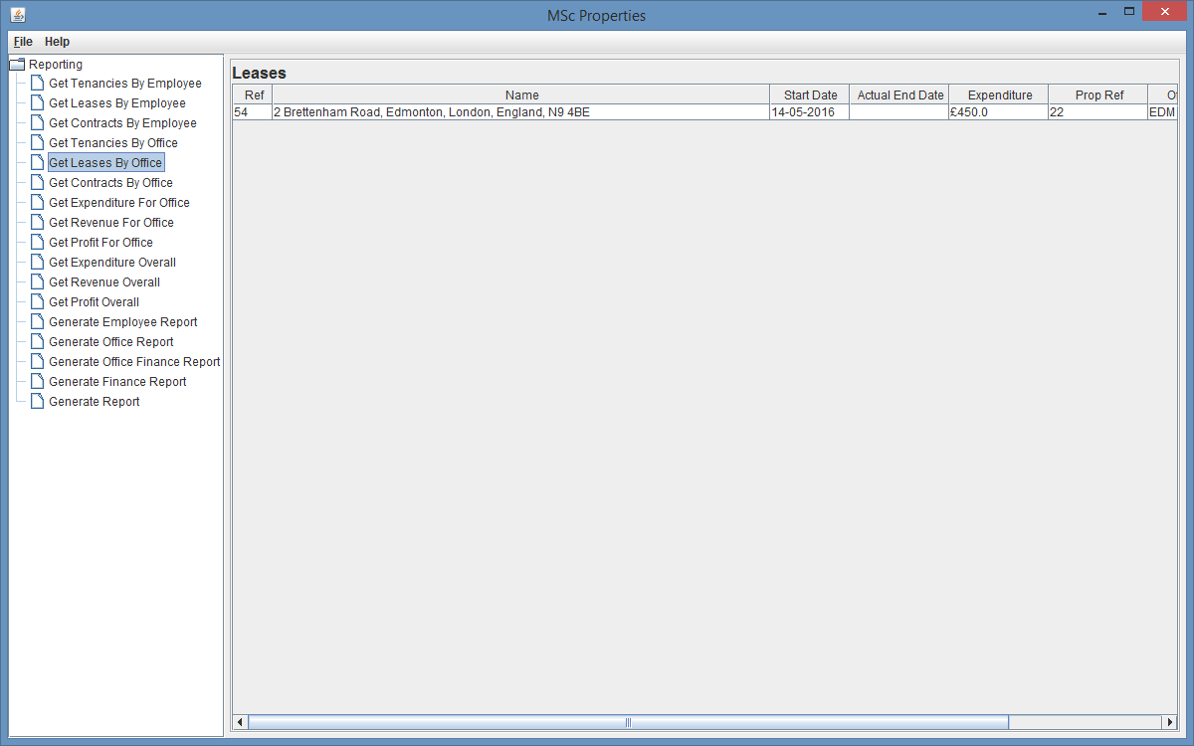

Fig. 238 – Get Leases By Office Results

So although there are some issues with the reporting functionality graphical user interface, the user is still able to run each report and get the required results so the distributed system us still enable to speed up the process of running reports, however could have some improvements with the graphical user interface.

1. **Document Management functionality**

As this system consists of document management functionality that deals with the creation of documents, storing documents at a physical location on the server, the retrieval of documents for viewing by a client from a remote location, and finally version control for the amendment of documents.

To carry out this testing I decided to create a document for a Contract object, and then log in with a different user who has the privileges to view the document, and attempt to open the document to ensure I am able to retrieve the document from the server. To ensure this has occurred correctly, upon creating the document I will have a look at the server document repository to ensure the document was created correctly.

I will then go on to update the document, and as the document management system will be able to handle any document types, I will update the document and supply a document with a different document type, to ensure that the system is able to handle the document changing document type. I will also ensure that the updated document manages all versions of the document, ensuring that I am able to view all previous versions at all time.

Lastly I am then going to ensure that the system is handling temporary files on the client side correctly, by deleting any temporary files created on the client side, after the client has ended the application. To do this I will open a version of a document, then view the client side repository for temporary files, and ensure that upon ending the application the temporary files are deleted from the temporary files repository.

As you can see from Fig. 176 there is currently no documents created for Lease 5, and this is also reflected at the server document repository as shown in Fig. 177.

For me to create a document for Lease 5, I have to navigate to the Lease Details screen and select the Documents tab and click the Create button, which opens a create Document dialog. I then click the search icon to search for a File which opens a file chooser dialog, where I am able to select a document to be assigned to Lease 5, once I have selected a file, I can then supply a comment. Once I have entered the required information and select OK, a confirmation dialog appears asking me to confirm creation of document for Lease 5, once I select OK a confirmation dialog will appear confirming the creation of the Document, as shown in Fig. 180.

Additionally, there is a file filter that can be applied to the file chooser to restrict the documents that are being shown, which was tested and working successfully as shown in Fig. 178 and Fig. 179.

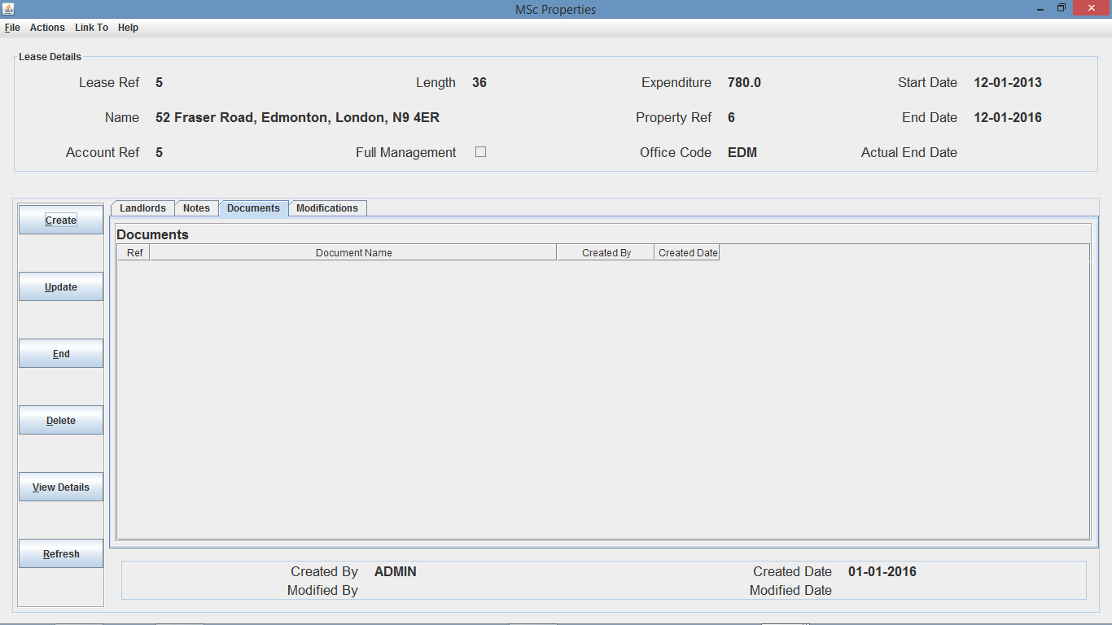

Fig. 176 – Lease Details (on Documents tab)

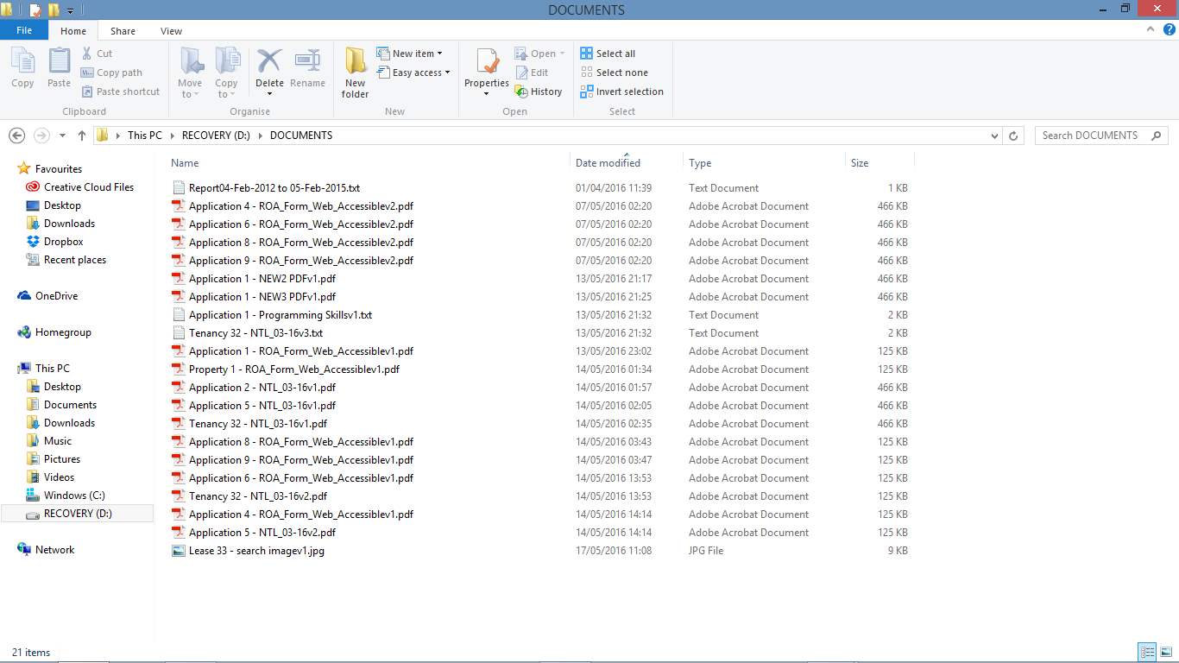

Fig. 177 – Documents Repository (Server Side)

Fig. 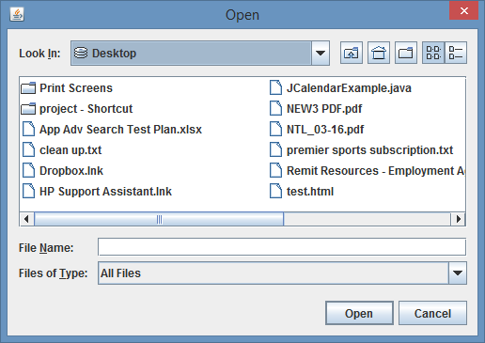178 – File Chooser Dialog

N.B. All Files are being returned due to no filter placed on the Files of Type field.

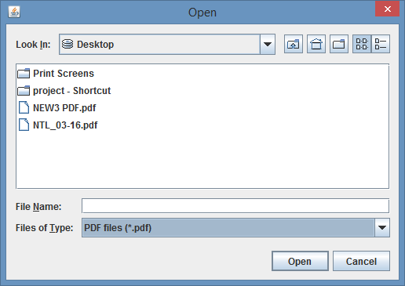Fig. 179 – File Chooser Dialog

N.B. All PDF Files are being returned due to the PDF file filter placed on the Files of Type field.

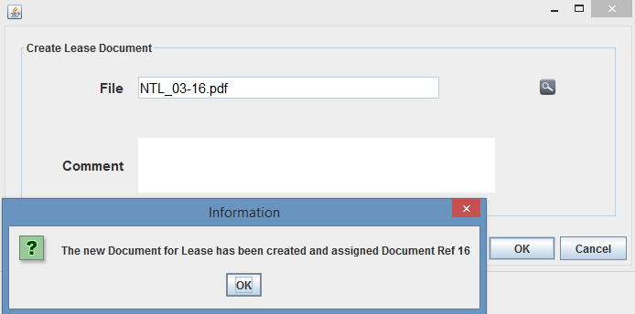

Fig. 180 – Document Creation Dialog

Once I refresh the Lease Details screen, the document will then appear in the Documents table as shown in Fig. 181. I will then be able to view the document, by right clicking on the document and selecting view document, which will open up a dialog, where I can select the version from a drop down menu, with this document there would only be 1 version as this was the only document developed.

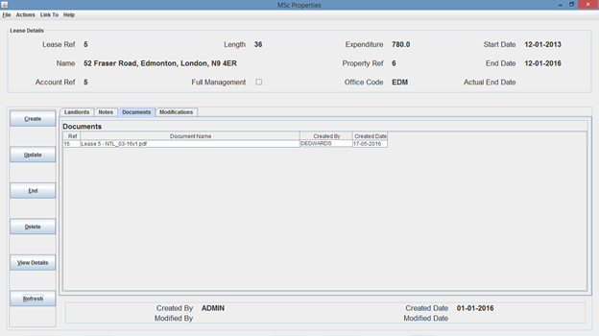

Fig. 181 – Lease Details screen (after document creation)

As you can see from Fig. 181. The document is assigned the object type and object ref along with the file name that the document I selected from the file chooser dialog was called, and then the version number as the document name, so in this instance the document has been called “Lease 5 – NTL_03-16v1.pdf”, which is also shown in Fig. 182 of the document repository server side.

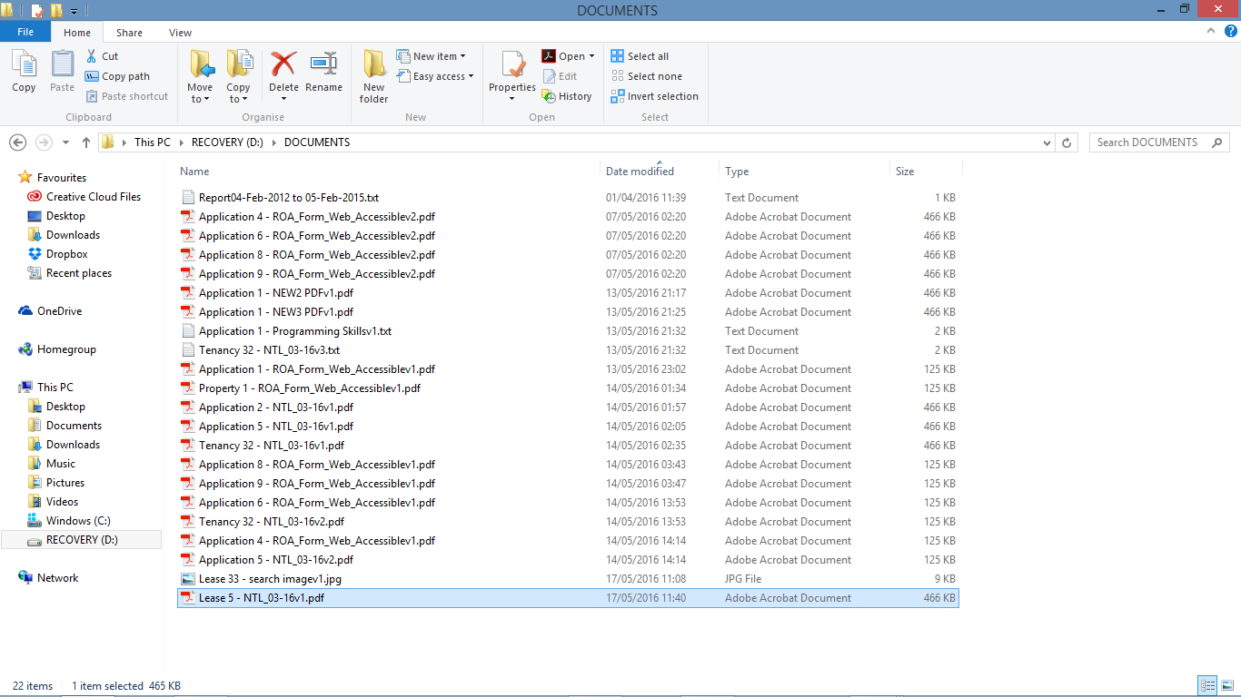

Fig. 182 – Documents Repository (Server Side) – after document creation

The above test shows that a client is able to create a document from a remote location, which is then passed to the server and stored locally at the server, as you can see from Fig. 182.

I am now going to log in as a different user and attempt to view the document I have just created. As explained in the report and above, the view document functionality should create a temporary file locally with the client, which enables the client to view this document. As you can see from Fig. 183, when the newly logged in user right clicks on the document and selects View Document, this will open a dialog for me to select the version of the document I require to open, with the version drop down box preventing me from selecting a version that is not available, as shown in Fig. 183.

Once I select a version and select OK, this will then close the dialog and open the document with the default application defined to open the document, depending on the document file extension, as shown in Fig. 184.

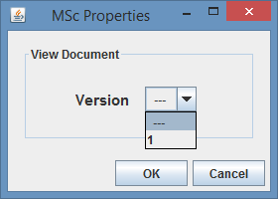Fig. 183 – View Document Dialog

N.B. As there is only 1 version of the document, as shown in Fig. 181, preventing incorrect input.

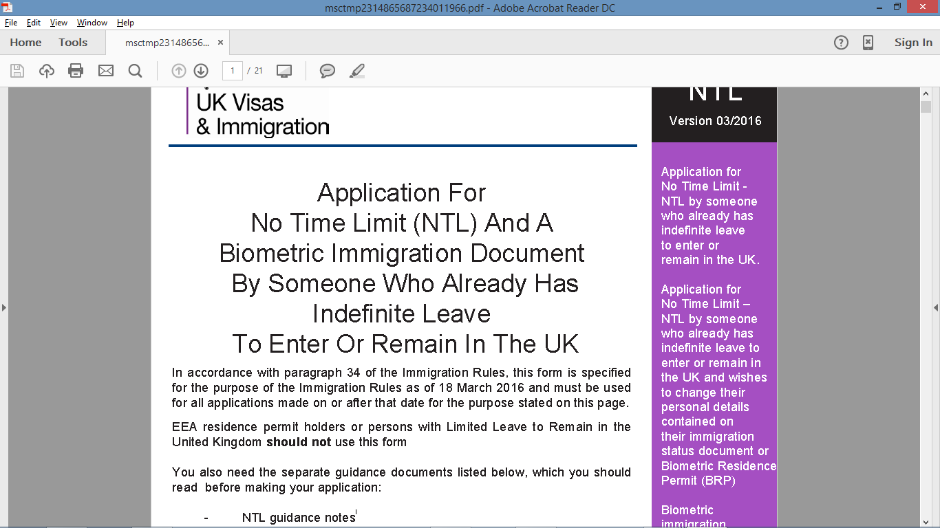

Fig. 184 – Opening of Lease 5 – NTL_03-16v1.pdf

As you can see from Fig. 184 the document has been opened using the default application to open PDF files, and as you can see from both Fig. 184 and Fig. 185, there has been a temporary file created at the client document repository called “msctmp2314865687234011966.pdf”.

This test shows that I am able to retrieve the document from the server, and open it locally on the client side, with the default application on the client side machine. I am now going to close the application down, expecting the temporary file to be deleted after the application is shut down.

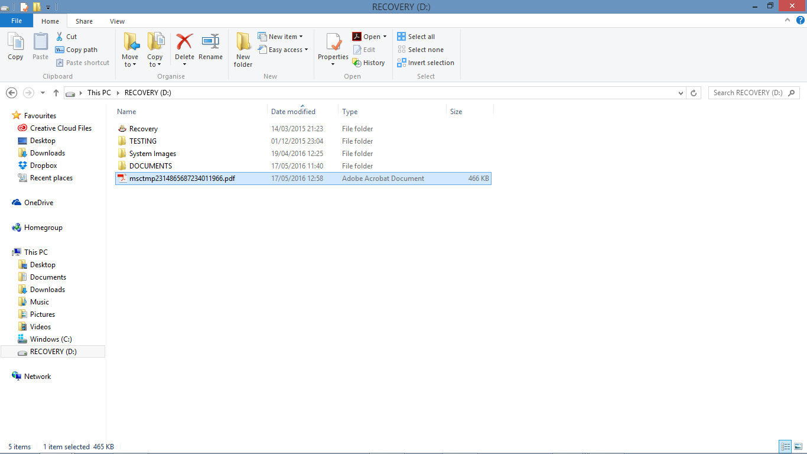

Fig. 185 – Documents Repository (Client Side) – after document opened

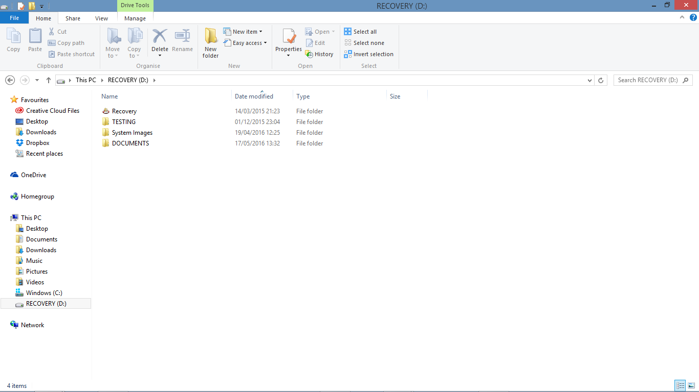

Fig. 186 – Documents Repository (Client Side) – after system shut down

N.B. As shown in Fig. 186 the temporary file created on the client side was deleted as expected upon system shutdown.

My final tests for the document management functionality will be to create a new version of the document, ensuring that the system manages the versions of the documents, allowing a user to view any of the versions of the documents, additionally, the system will be able to cope with a change in document type, meaning that a document that has been assigned a PDF file, will be able to be amended and assigned a JPG file (or any other document type) as the version 2 of the document, and the system will still be able to retrieve either of the 2 versions, even though the document types are different.

To carry out this testing I decided to update document 17 “Lease 5 – NTL_03-16v1.pdf”, assigning a TXT file as the new version, meaning that the document name should change to “Lease 5 – NTL_03-16v2.txt”, as the document file type would have changed from PDF to TXT and the version would be incremented to version 2.

To update the document, I navigated to the Documents table, on the Lease Details Screen, and right clicked the document to update and clicked Update Document, this then opens an Update Document Dialog, where you can search for the file to assign to the document and amend the document comment, and then click OK, and confirm the update as shown in Fig. 187. Once the document has been created, I need to click refresh to view it within the Documents table on the Lease Details Screen, and as shown in Fig. 188, once the screen has been refreshed the document name is amended to show the new document name of “Lease 5 – NTL_03-16v2.txt”.

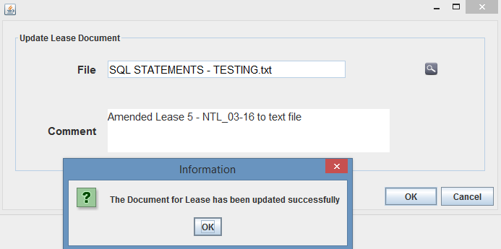

Fig. 187 – Update Lease Document Dialog

Fig. 188 – Lease Details Screen (after document amended)

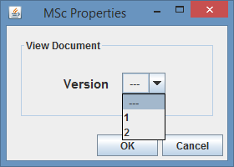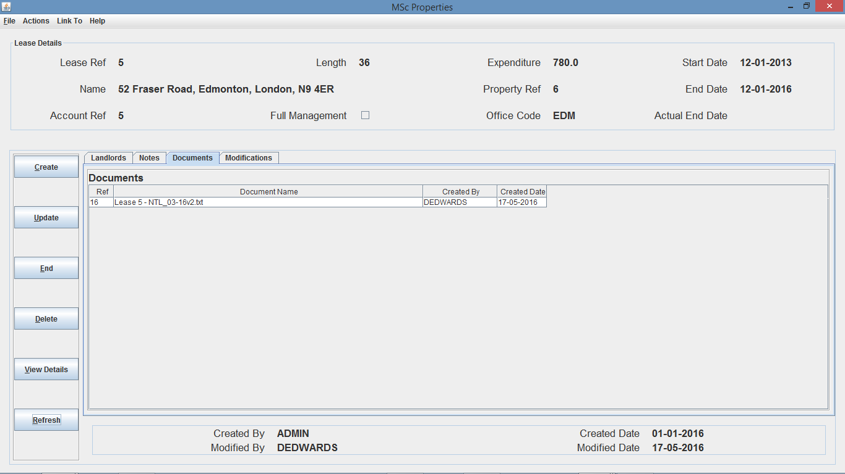

Fig. 189 – View Document Dialog

Similar to the first test, I then logged in as a different user to attempt to view the document, and as shown in Fig. 189 the version drop-down menu options increased from 1 to 2 due to the additional version, as shown in Fig. 190 the text document was opened with no errors.

N.B. If I select version 1, then the system will open up version 1 of the document (PDF file), whereas if I select version 2 then the system will open version 2 of the document (TXT file).

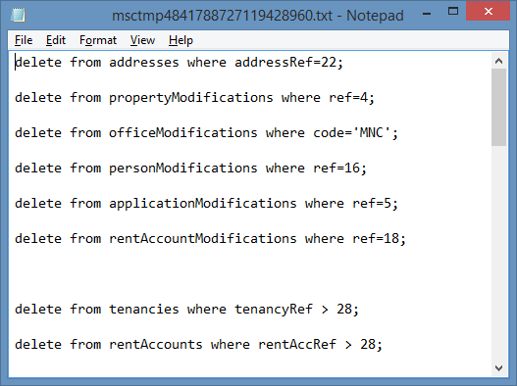

Fig. 190 – Opening of Lease 5 – NTL_03-16v2.txt

As you can see from Fig. 190 the document has been opened using the default application to open TXT files, and as you can see from both Fig. 190 and Fig. 191, there has been a temporary file created at the client document repository called “msctmp4841788727119428960.txt” and additionally you will notice from Fig. 191 that the previous temporary file “msctmp2314865687234011966.txt” was deleted once I shutdown the application after creating version 1 of document 16 for Lease 5.

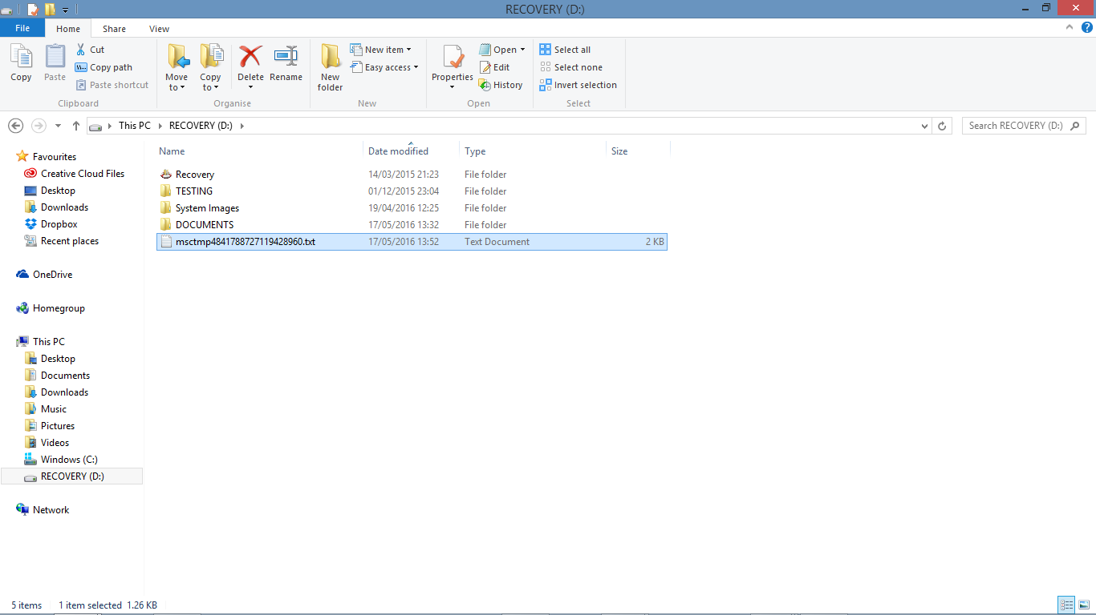

Fig. 191 – Documents Repository (Client Side) – after document v2 opened

To further test this I decided to create another version of the document, but for a JPG file, so once the document is updated the document should hold a reference to all 3 versions, v1 being the PDF file, v2 being the TXT file, and v3 being the newly updated jpg file.

So after following the previous steps as shown in the pictures below, the document now consists of the 3 different versions, and a user is able to view any of the different previous versions, and the document name has been updated again to “Lease 5 – NTL_03-16v3.jpg”.

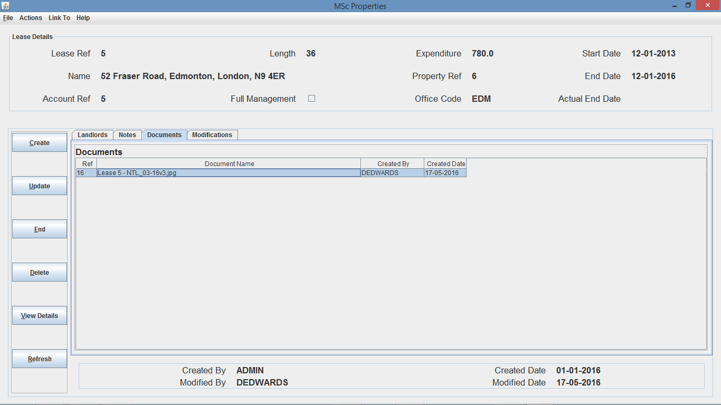

Fig. 192 – Lease Details Screen (after document amended v3)

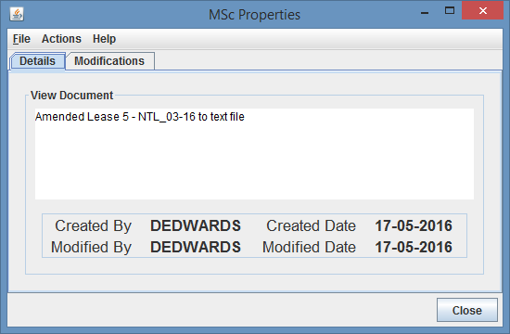

Fig. 193 – Document Details (on Details tab)

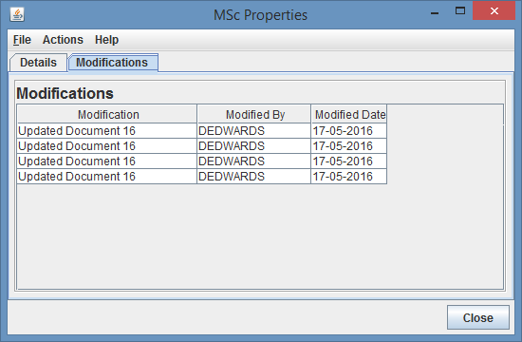

Fig. 194 – Document Details (on Mods tab)

N.B. Each Update to the application has been saved in the modifications table

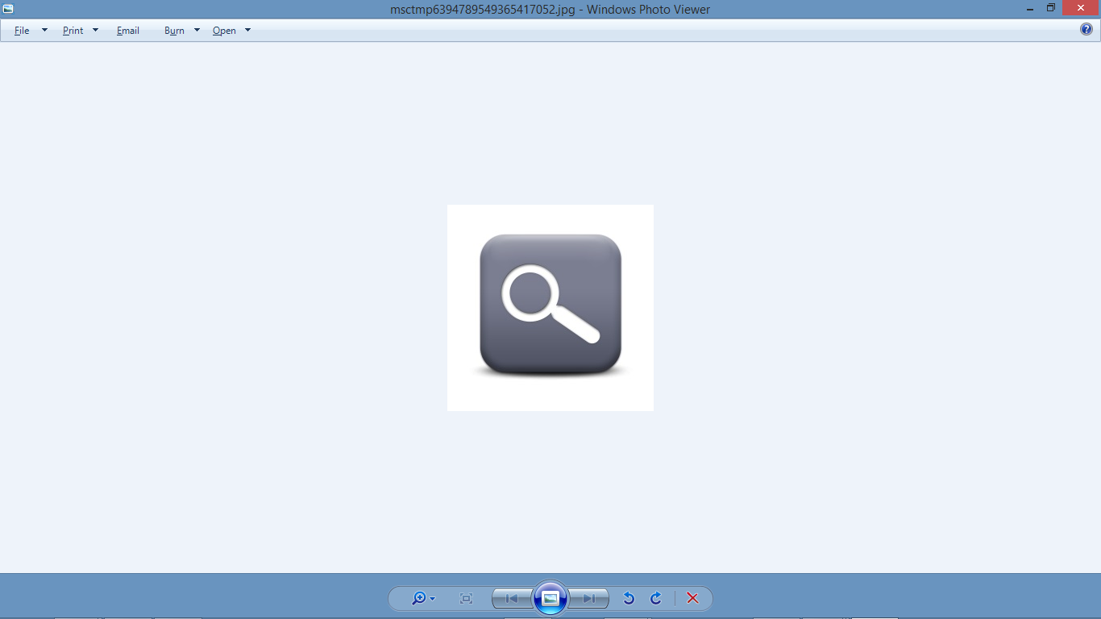

Fig. 195 - Fig. 190 – Opening of Lease 5 – NTL_03-16v3.jpg

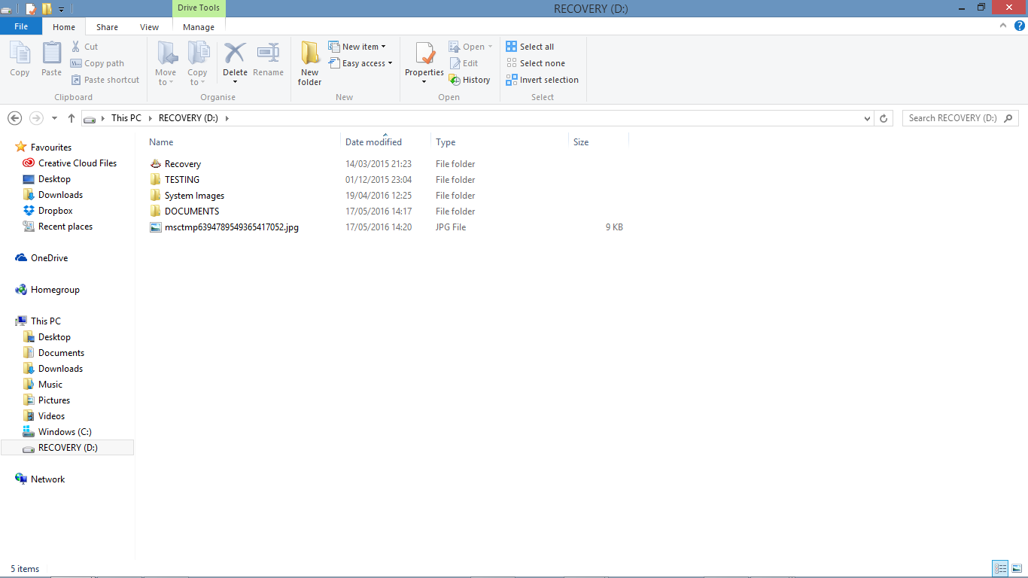

Fig. 196 – Documents Repository (Client Side) – after document v2 opened

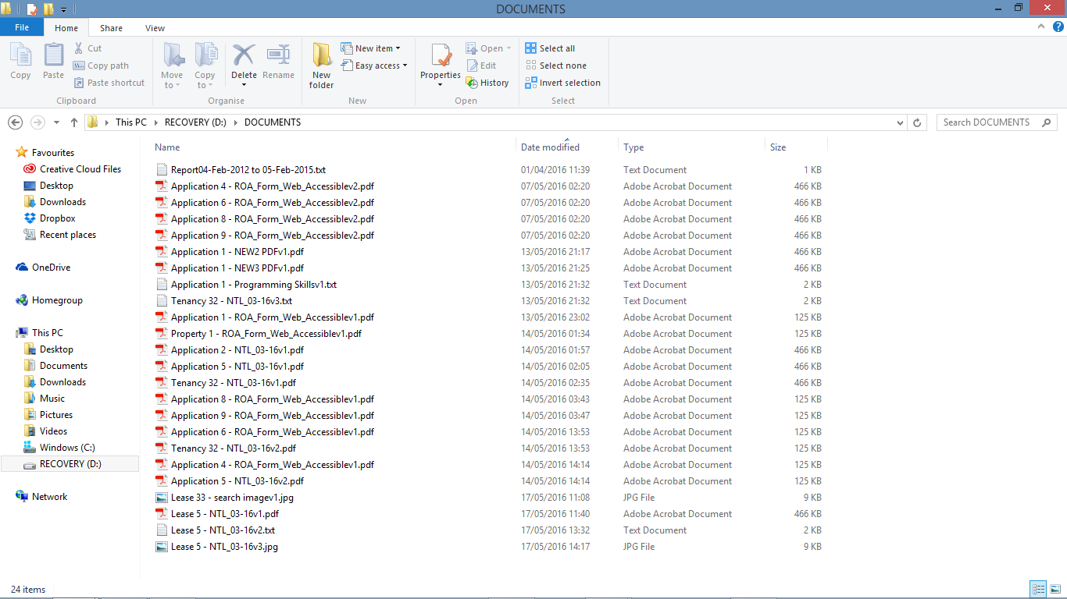

Fig. 197 – Documents Repository (Server Side) – after document creation

Lastly I was still able to open any 3 of the versions, just by selecting the required version to view from the view document dialog.

The above tests confirm that the document management functionality is working as required, allowing users to create a document for a system object, such as a Lease, resulting in a version of the document being uploaded to the server and stored locally on the server. The document is then able to be amended, with a user providing a new version of a document, whether or not the new document has a different file type to the existing document file type, and all versions are then managed with a version being stored locally on the server. Furthermore, a user is then able to download a version of the document, which a temporary file is stored locally on the client for the client to perform an action on that file, with the temporary file being deleted upon system shutdown at the end of the user’s session.

1. **Advertise Business Services through Website**

As this system consists of producing a website to advertise business services through the Internet, I will have to test the website ensuring that the services I wish to advertise through the website are being advertised correct, additionally, the website is connecting to the MySQL database and retrieving up-to-date information at all times.

As outlined in the report, I developed 5 main webpages, which are Home, Rent, Let, Careers and About us.

The Home page will be the starting point for the webpage, and will give a brief outline of the services provided to potential customers, with links to allow the customer to navigate from the home page to different pages and a quick search form for property searches.

The Rent page has some brief information about renting, a full search form for property searches, and a service request form for renting.

The Let page has some brief information about letting, and a service request form for letting.

The Careers page has some brief information about careers with MSc Properties and a list of different vacancies.

The About Us page has some brief information about MSc Properties and an office drop down to link to the office details.

* 1. **Quick Search**

As you can see from Fig. 199, when I use the quick search form from the home page, the webserver links to the view properties page (with the list of properties that are available for renting), defined by the search criteria. The properties returned was returned using the search criteria in Fig. 198.

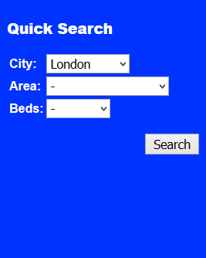Fig. 198 – Home PHP file - Quick Search Form

N.B. As you can see from Fig. 198 and Fig. 199, when I select ‘London’ from the ‘City’ drop down box and click “Search”, I should expect only properties from London and that are VOID and available for rent come back on the properties search results screen.

Additionally, as you can see from Fig. 201 (the list of properties within the system), there should only be 9 VOID properties from London return within the property search results screen from the website.

As you can see from Fig. 199 and Fig. 200, only 9 properties are returned which is showing me that the search functionality is working correctly.

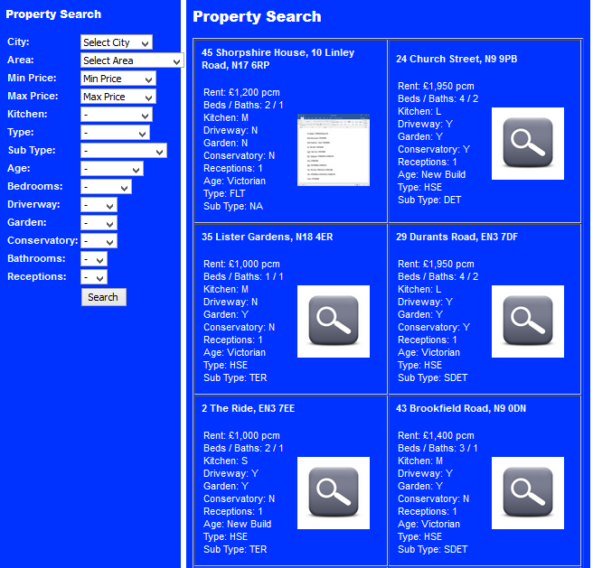

Fig. 199 – Search Results part 1

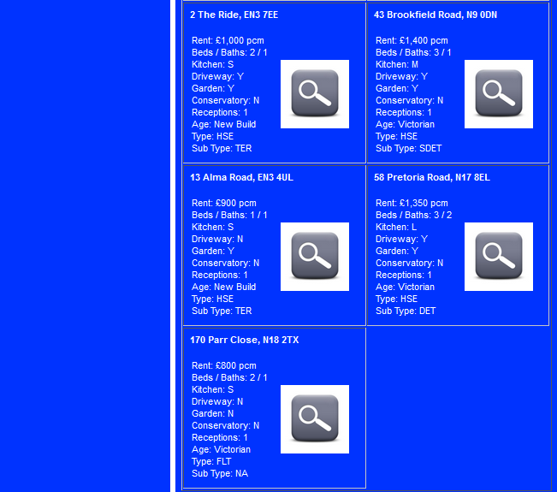

Fig. 200 – Search Results part 2

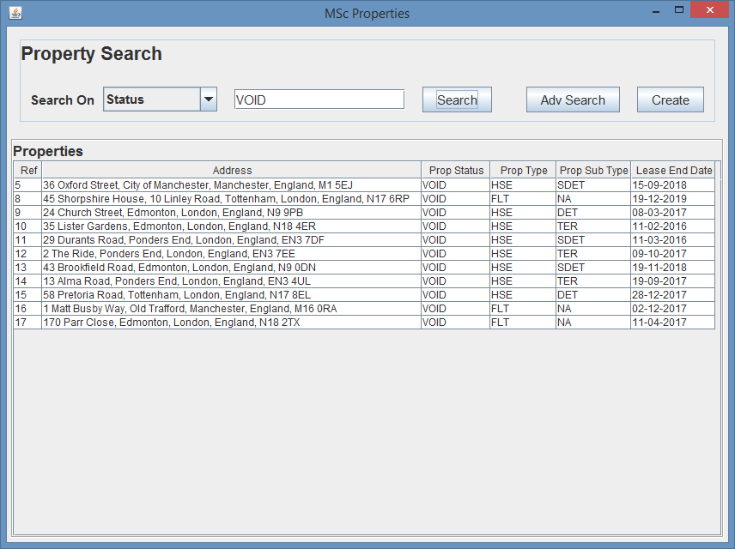

Fig. 201 – Search Results Through System

As you can see from the combination of Fig. 199, Fig. 200, and Fig. 201, the correct properties have been returned, and additionally, as you can see from Fig. 202, the property details returned for the property are correct, so the web server is communicating with the MySQL Server to get the required property details, and then formatting them together within a table as they should be.

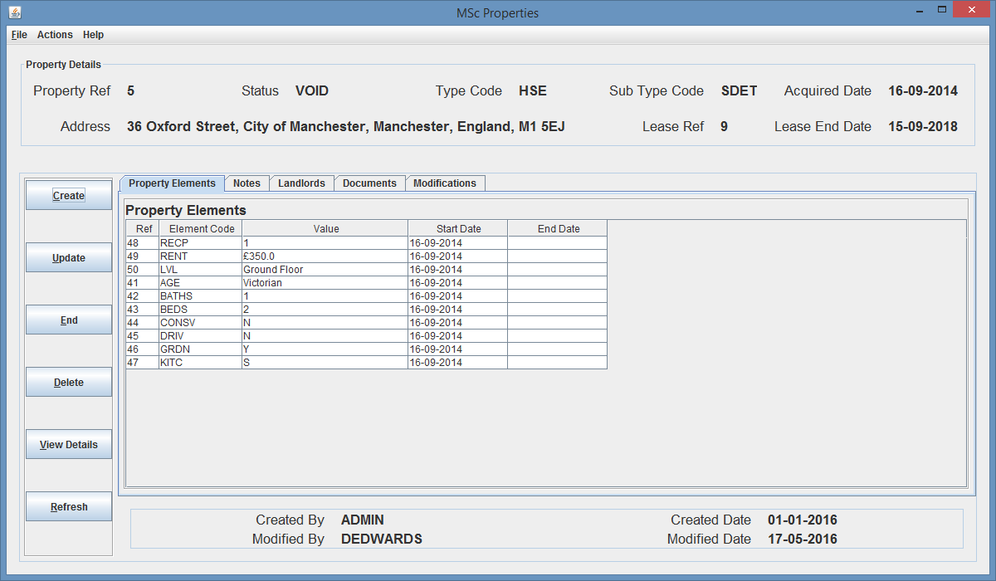

Fig. 202 – Property Details Screen (Property Ref 5)

I then run a few more searches as shown below, which highlight that different searches are working correctly as they should.

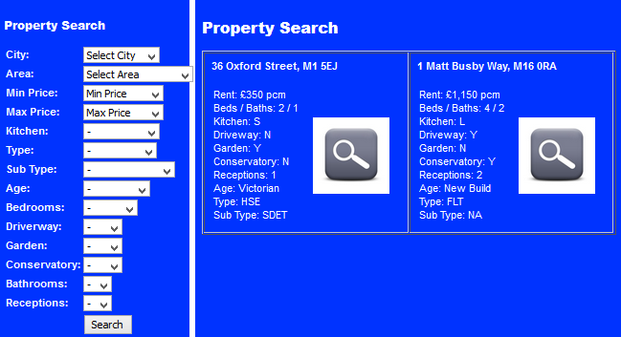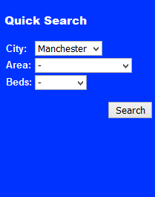

Fig. 202 – Quick Search Fig. 203 – Search Results

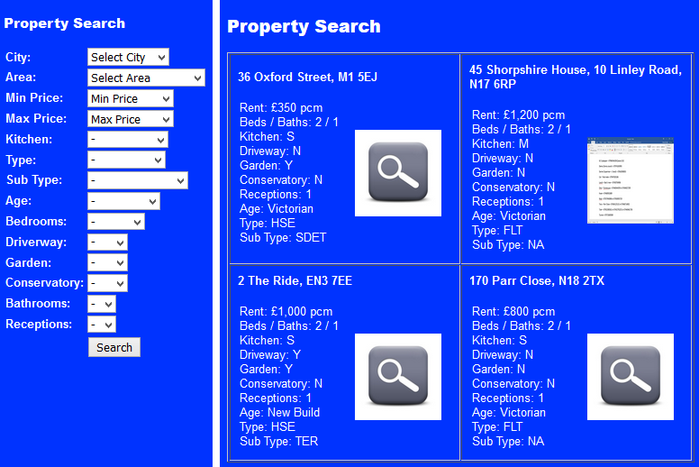

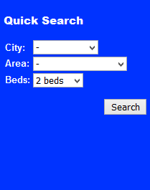

Fig. 204 – Quick Search Fig. 205 – Search Results

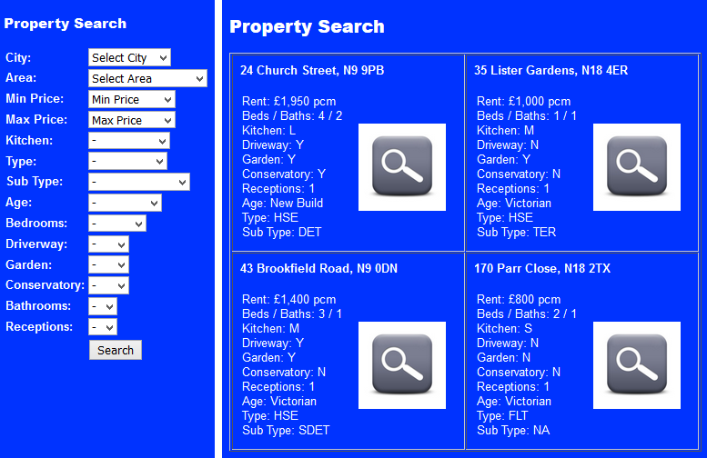

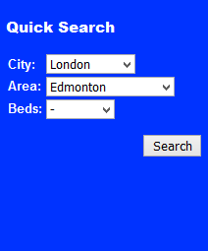

Fig. 206 – Quick Search Fig. 207 – Search Results

As you can see from Fig. 202 to Fig. 207, the quick search functionality is working as expected and is able to perform searches using single and multiple search criteria and is returning the expected results.

Finally, as you can see from Fig. 208, Fig. 209, and Fig. 210, shows that the drops down boxes are being populated with the expected drop down values.

By implementing this quick search functionality, it enables potential customers

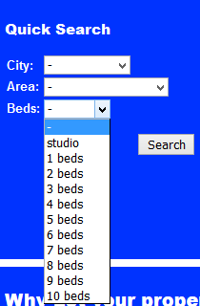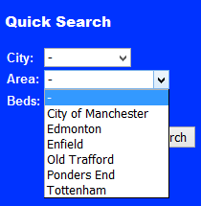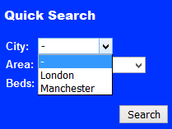

Fig. 208 – Quick Search

Fig. 209 – Quick Search

Fig. 208 – Quick Search

* 1. **Full Search**

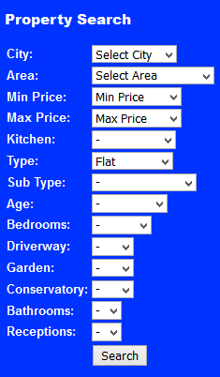As you can see from Fig. 209, I use the full search from the rent or view properties page, which returns the properties defined by the search criteria similarly to the quick search, however the full search has additional search criteria.

Fig. 209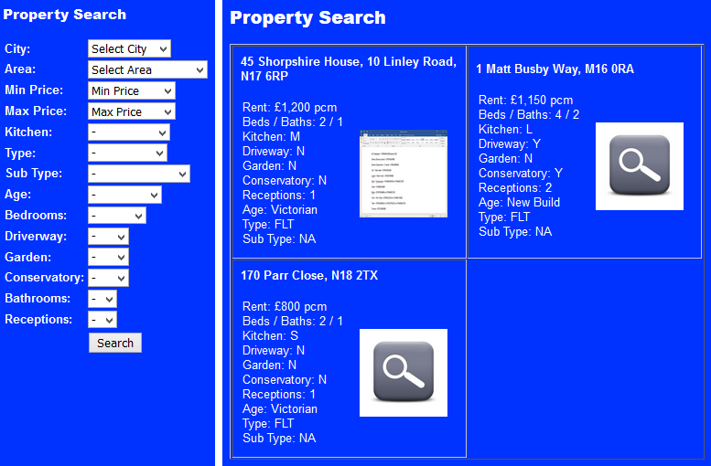 – Full Search Fig. 210 – Search Results

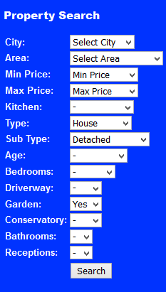

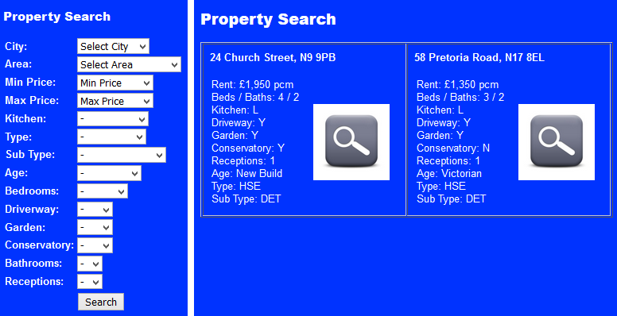

Fig. 212 – Search Results

Fig. 211 – Full Search

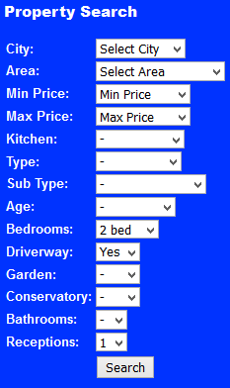

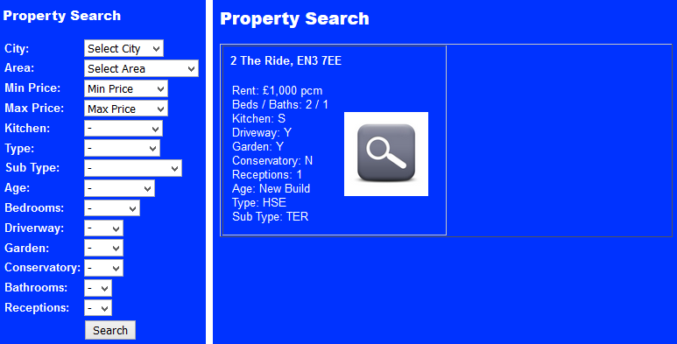

Fig. 214 – Search Results

Fig. 213 – Full Search

As you can see from Fig. 209 to Fig. 214, the full search functionality is able to perform searches, using single and multiple pieces of data, which are producing the expected results and returning the required properties.

* 1. **Locate an Office**

Additionally, to performing searches on properties and advertising MSc Properties VOID property details, the website should advertise the different office details, such as contact information, and address location.

As you can see from Fig. 215 and Fig. 216, the drop down box on either the Home page or the About Us page, within the Locate an Office region, is returning all of the properties from the MySQL server, and when a potential customer selects an office and clicks View Office, the webserver is linking to the Office Details page and shows the office contact details and address details as expected, as shown in Fig. 217 to Fig. 219.

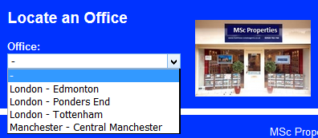Fig. 215 – Locate an Office Drop Down Box

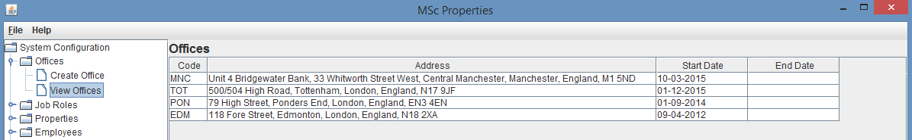

Fig. 216 – System Configuration Screen – View Offices

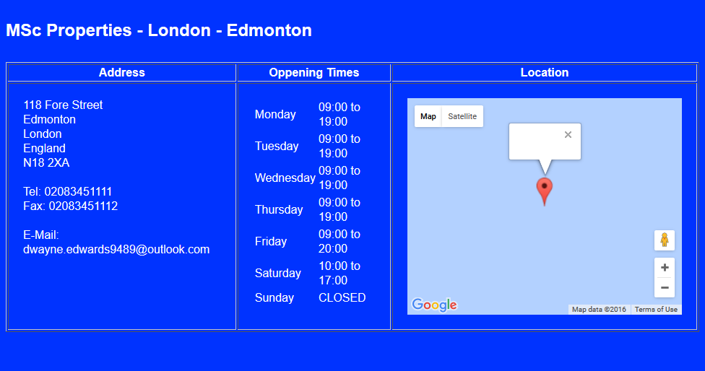

Fig. 217 – Office Details Page

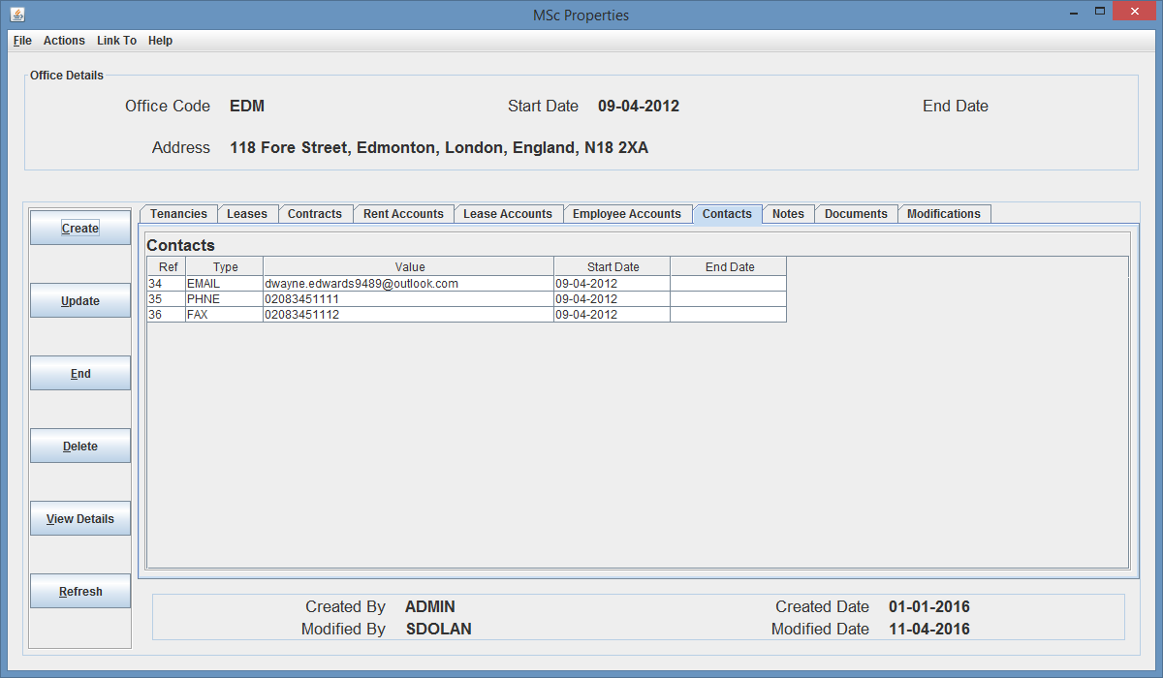

Fig. 218 – Office Details Screen (on Contacts tab)

As you can see from Fig. 217 and Fig. 218, the returned office results are correct, and therefore the office details functionality is working as expected, however the only issue is with the Google Maps functionality I am using from <http://embedgooglemaps.com/en/>, as I am able to get the google map working if I hardcode the longitude and latitude values required to ensure the google map location is correct, however when I pass the longitude and latitude values from the server and pass them to the JavaScript code using the document.getElementByID(variable name), but when I do this, the google map is displayed at the wrong location.

* 1. **Careers**

The final area I am going to test before moving on to the testing of the service requests functionality, is going to be the careers page. The careers page should return the current ‘MSc Properties’ vacancies, and as shown in Fig. 219, the careers page has a brief description of the different MSc Properties career paths as well as a list of vacancies.

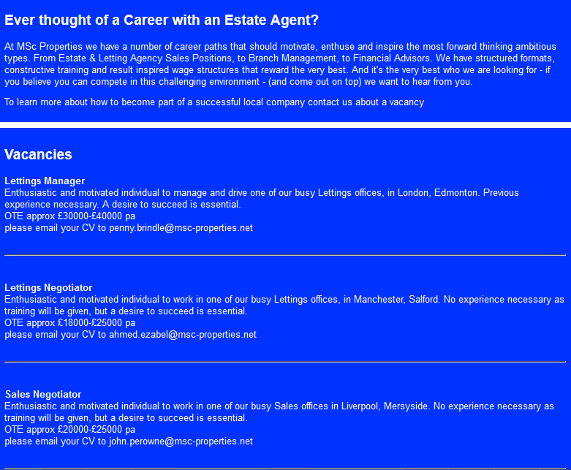

Fig. 219 – Careers Page

1. **Service Requests through Website**

The final testing area will be the testing surrounding the service requests for potential customers, to an office of MSc Properties for renting or letting a property. As explained in the report, I adopted a mailing functionality, which should send an email to the selected office, enabling the office of MSc Properties to be notified via email of a potential customer, and provide MSc Properties with the necessary information to follow up a service request. As explained, there is two types of service requests, one for Renting and is on the Rent page, and one for Letting and is on the Let page.

* 1. **Renting Service Request**

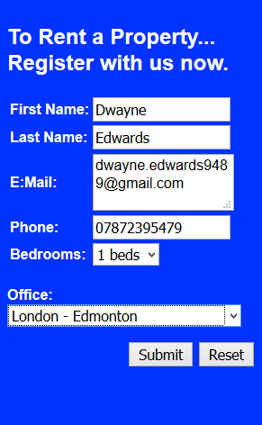As you can see from Fig. 220, I have a form within the Rent page, which allows the user to enter contact information and some basic information about what property they want to rent. Upon the user clicking OK, an email should be sent and a confirmation page should be presented.

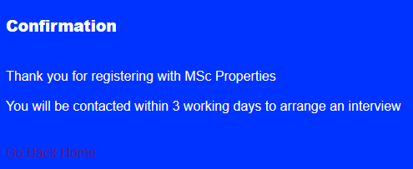

Fig. 221 – Renting Service Request Confirmation

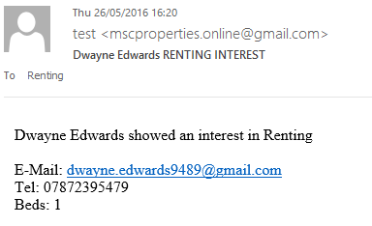

Fig. 220 – Renting Service Request Form

Fig. 222 – Email Notification

As you can see from Fig. 220 to Fig. 222, upon entering potential customer information and clicking Submit, the user is passed to a confirmation page outlining that the registration process has been successful and the process, with a link to go back to the home page. Then if I check the Edmonton office’s email address inbox, there is an email that has arrived, outlining the potential customers details and being sent from the ‘MSc Properties online email address’.

As you can see from Fig. 218 (above), the email address for the Edmonton Office is [dwayne.edwards9489@outlook.com](mailto:dwayne.edwards9489@outlook.com) and this is the email address inbox I have checked to retrieve the service request.

* 1. **Letting Service Request**

As you can see from Fig. 223, I have a form within the Let page, which allows the user to enter contact information and information about what property they want to let. Upon the user clicking OK, an email should be sent and a confirmation page should be presented.

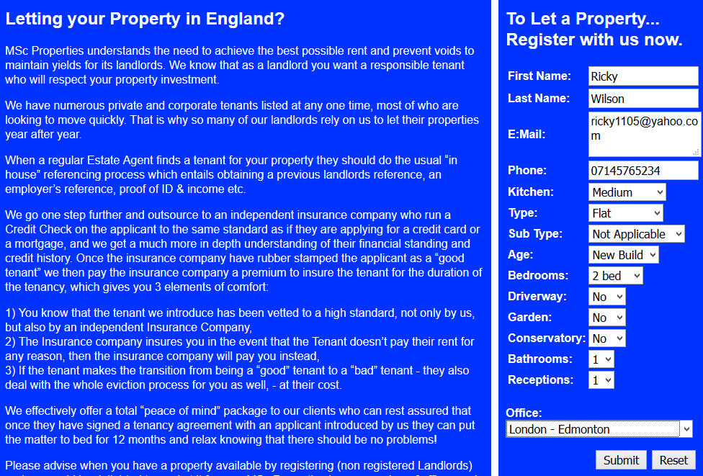

Fig. 223 – Letting Service Request Form

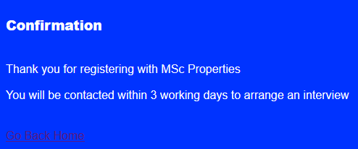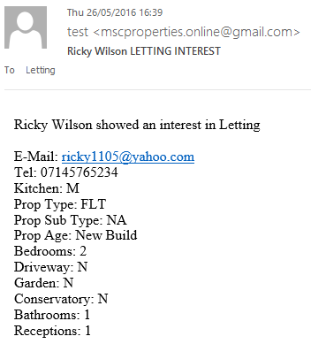

Fig. 224 – Letting Service Request Confirmation

Fig. 225 – Email Notification

As you can see from Fig. 223 to Fig. 225, upon entering potential customer information and clicking Submit, the user is passed to a confirmation page outlining that the registration process has been successful and what the process will be, with a link to go back to the home page. And again, if I check the Edmonton office’s email address inbox, there is an email that has arrived, outlining the potential customers details and being sent from the ‘MSc Properties online email address’.